***Developing Player Movement Design Patterns in Multiplayer Video Games***

**Richard Lannigan**

**11205335**

**Games Computing BSc (Hons)**

**The University of Lincoln**

**29/04/2014**

i

***Developing Player Movement Design Patterns in Multiplayer Video Games***

**Richard Lannigan**

ii

**Acknowledgements**

Dr Ben Kirman: Project Supervisor

Mr Tom Feltwell: School of Computer Science Technician - Assisted in setting up the LANs.

Mr Christopher Dye: Games Computing BSc Student - Assisted in setting up and running the LANs.

LAN and questionnaire participants.

iii

**Abstract**

The main aim of this dissertation is to develop a set of patterns that designers can incorporate into their level designs, in order to elicit certain actions from the player. These actions would take the form of how a player might move around a multiplayer map, what paths they would take and for what reason. Although there has been a lot of work into movement patterns in single player levels and game patterns in general, there has not been much in the area of multiplayer level movement patterns. This project will address this and provide a useful insight into thoughts and techniques of gamers participating in online multiplayer matches.

This dissertation consists of three main stages; research of existing work on player movement patterns and multiplayer movement flow types. Visual analysis, play testing and questionnaires to develop a proposed pattern set. Finishing with an evaluation and conclusion of the both the finalised pattern set and the dissertation as a whole.

This project resulted in evaluations of the visual identification process, questionnaire results on player behaviour in multiplayer games, and of the iterative approach taken to the development of a testing level. As a result, a complete set of 13 design patterns was created listing various behaviours related to player movement and actions in multiplayer video games. This list is specifically aimed at the design and creation of multiplayer levels in video games.

iv

**Contents (with page numbers)**

1. Tables and figures………………………………………………………..vii
2. Introduction

1.1. Dissertation Overview………………………………………………...2

1.2. Terminology…………………………………………………………..4

2. Background

2.1. Multiplayer map movement flows……………………………………7

2.2. Player Movement patterns…………………………………………...13

3. Methodology

3.1. Project Management…………………………………………………24

3.2. Aims and Objectives………………………………………………...24

3.3. Software Development Life Cycle…………………………………..25

3.4. Software Used……………………………………………………….26

3.5. Visual Identification…………………………………………………28

3.6. Alternative Processes………………………………………………..31

3.7. Questionnaire………………………………………………………..32

3.8. Play testing…………………………………………………………..33

3.9. Level Design…………………………………………………………34

3.10 Participant Recruitment and Ethical Procedures……………………38

4. Evaluation

4.1. Visual Identification…………………………………………………39

4.2. Questionnaire………………………………………………………..43

4.3. Play Testing…………………………………………………………54

5. Conclusion

5.1. Final Pattern Set……………………………………………………..66

5.2. Dissertation Review…………………………………………………75

5.3. References…………………………………………………………...78

v

5.4. Ludography …………………………………………………………82

5.5. Image References……………………………………………………84

6. Appendices and Annexes

A. Critical Reflection…………………………………………………….88

B. Visual Identification Raw Data……………………………………….90

C. Questionnaire and Raw Answers……………………………………..96

D. Gantt Chart…………………………………………………………..103

E. Consent Form………………………………………………………..106

vi

**List of Tables and Figures**

Figure 1.1: Images of the “spotting” mechanic featured in the Battlefield series. The left image (Prima) shows a player in the process of spotting an enemy and the right image (Battlefield Wikia) shows a player shooting at a spotted enemy. (pg.5)

Figure 1.2: Image of a heatmap from the map ‘The Pit’ from Halo 3 (Bungie, 2007), featuring the death locations of players (Cool Infographics, 2009b). (pg.6)

Figure 2.1: Overview of the map “Rust” featured in Call of Duty: Modern Warfare 2 (2009). (pg.8)

Figure 2.2: Overview of the map “The Pit” featured in Halo 3 (2007). (pg.9)

Figure 2.3: Overview of the ‘Rush’ gametype on the map “Operation Metro” featured in Battlefield 3 (EA Digital Illusions, 2011). (pg.10)

Figure 2.4: Diagram of symmetrical linear design when both teams are equal and the main point of engagement is in the middle. (pg.11)

Figure 2.5: Diagram of asymmetrical linear design when one team is better than the other (red) or the game type has an attacking team (red) and a defending team (blue). (pg.11)

Figure 2.6: Images of various locations in the Call of Duty: Black Ops 2 map “Studio”. They show an alien invasion set (top left, Destructoid, 2013), a medieval castle back drop (top right, Expansive dlc, 2013), a ‘Pirates’ style dock (bottom left, FPS General, 2013) and a Western style tavern (bottom right, Treyarch, 2013). (pg.12)

Figure 2.7: Screenshots of the map “Valhalla” from Halo 3. (pg.15)

Figure 2.8: Images of the red base (Halo Wikia, 2007b) and blue base (Halo Wikia, 2007a), from the map “The Pit” featured in Halo 3 (Bungie, 2007). Each base is the symmetrical version of the other. (pg.16)

Figure 2.9: Screenshots of the red and blue bases from the map “Blood Gulch” featured in Halo 2 (Bungie, 2004). Each base has lighting and banners in either red or blue, to signify which team it belongs to. (pg.16)

Figure 2.10: Screenshot of the game type “Submission” from Gears of War 2. (pg.17)

Figure 2.11: Screenshots from the map “Berlin Wall” featured in Call of Duty: Black Ops, DLC map pack “First Strike”. (pg.18)

Figure 2.12: Screenshots of Capture the Flag game type in Call of Duty: Modern Warfare 3. (pg.19)

vii

Figure 2.13: Two screenshots (EA, 2013) that show a cargo door to a warehouse (left) and an interactive panel used to open and close the door (right). (pg.20)

Figure 2.14: Image of a player camping in Black Ops 2 (egm now, 2013). (pg.22)

Figure 2.15: Image of the map ‘Vacant’ from COD4 (COD n Chips). (pg.23)

Figure 2.16: Overview image of the map resistance featured in Modern Warfare 3 (Call of Duty Wikia). (pg.23)

Figure 3.1: The results from the visual identification of gameplay from the 6 commercial games. (pg.29)

Figure 3.2: Shows the first 5 results from each game. (pg.30)

Figure 3.3: Image of a ‘Man Cannon’ from ‘Valhalla’ (reddit, 2012) featured in Halo 3 (Bungie, 2007). (pg.34)

Figure 3.4: A heatmap image from the map ‘Valhalla’ featuring player kills and deaths (Halo Forever, 2007a). (pg.35)

Figure 3.5: A screenshot of the piece of architecture in the testing level that was influenced by the hill in ‘Valhalla’. (pg.35)

Figure 3.6: Screenshots (left) of the testing level’s red and blue bases, alongside images (right) of the red and blue bases in the map ‘Blood Gulch’ from Halo 2 (Bungie, 2004). (pg.36)

Figure 3.7: An image (Halo Forever, 2007b) featuring two heatmaps from the map ‘Valhalla’ showing player deaths from the ‘Spartan Laser’ (right) and the origin of the shot (left). (pg.36)

Figure 3.8: Image of a heatmap of the map ‘The Pit’ from Halo 3, featuring the kill locations of players using the sniper rifle (Cool Infographics (2009a). (pg.37)

Figure 3.9: Image (right) of the red team’s sniper tower (Halo Wikia, 2007b) from the map “The Pit” featured in Halo 3 (Bungie, 2007) and a screenshot (left) of a similar tower in the testing level. (pg.37)

Figure 4.1: Screenshot of reload times of the ‘M9A1’ pistol (left) and the ‘Chain SAW’ light machinegun (right). (pg.40)

Figure 4.2: Screenshot from the Team Fortress 2 gameplay video (SquiiddishGaming, 2013) showing the player in the vicinity of the payload and engaging an enemy player. (pg.41)

Figure 4.3: Screenshots from the Call of Duty: Ghosts gameplay video (TmarTn, 2013), showing the player activate his kill (left) and reload his weapon (right) right after each other at the same position. (pg.42)

Figure 4.4: Screenshot from the Call of Duty: Ghosts gameplay video (TmarTn, 2013), showing the player activate his controllable air support, whilst prone in a hiding spot. (pg.42)

viii

Figure 4.5: Bar chart displaying the results from question 1. (pg.44)

Figure 4.6: Shows bar charts of the results from question 2 and 3. (pg.45)

Figure 4.7: Shows bar charts of the results from question 17 and 18. (pg.45)

Figure 4.8: Bar chart displaying the results from question 20. (pg.46)

Figure 4.9: Bar chart displaying the results from question 6. (pg.47)

Figure 4.10: Bar charts displaying the results from questions 11 and 13. (pg.47)

Figure 4.11: Bar chart displaying the results from question 14. (pg.48)

Figure 4.12: Bar chart displaying the results from question 15. (pg.49)

Figure 4.13: Bar chart displaying the results from question 4. (pg.49)

Figure 4.14: Bar chart displaying the results from question 5. (pg.50)

Figure 4.15: Shows bar charts of the results from question 12 and 19. (pg.51)

Figure 4.16: Bars charts displaying the results from questions 7 and 8. (pg.52)

Figure 4.17: Bar chart displaying the results from question 9. (pg.52)

Figure 4.18: Bar chart displaying the results from question 10. (pg.53)

Figure 4.19: Bar chart displaying the results from question 16. (pg.53)

Figure 4.20: Screenshots showing the before and after of the changes made to the outer wall. (pg.55)

Figure 4.21: Screenshots showing the before and after of the changes made to the tower’s upper walls. (pg.56)

Figure 4.22: Screenshots showing the before and after of the identification changes made to blue team’s base. (pg.57)

Figure 4.23: Screenshots of Red team’s new spawning area. (pg.58)

Figure 4.24: Screenshots showing the before and after of the cover and detail changes made to the level. (pg.59)

Figure 4.25: Screenshots showing the before and after of the lighting changes made to red base. (pg.60)

Figure 4.26: Screenshots showing the before and after of the changes made to the main directional light (sun). (pg.61)

ix

Figure 4.27: Screenshot showing the spawn location for the new rocket launcher. (pg.62)

Figure 4.28: Screenshots showing some of the entrances to the underground section. The entrances in front of the team bases (top left), the drop down shoot in the tower (top right), and the T junction in the tunnel under the tower (bottom). (pg.63)

Figure 4.29: Screenshots showing the underground section (top) and the ‘Berserker’ pickup in the centre of the underground (bottom). (pg.64)

Figure 4.30: Screenshots of the ‘Testing Level’ showing the initial design (top) and the final design (bottom). (pg.65)

Figure 6.1: The results from the Visual Identification of gameplay from the 6 commercial games, illustrated in section 3.5. (pg.90)

Figure 6.2: The results from the Visual Identification 6 pieces of gameplay footage from the second and fourth LANs. (pg.93)

Figure 6.3: Copy of the questionnaire used for the development of the movement patterns and the testing level. (pg.96)

Figure 6.4: A table displaying the raw data for each participant. (pg.102)

Figure 6.5: This is a copy of the Gantt chart that was used during the project. (pg.103)

Figure 6.6: A copy of the consent form used in the project. (pg.106)

x

**This page was intentionally left blank**

**Chapter 1**

**Introduction**

**1.1 Dissertation Overview**

This section will give an overview of level design patterns and design patterns in general, presenting reasons why the study of which is useful. It will also give a brief description of the documentation that inspired this project.

**Benefits of considering player movement**

A very important focus of level design is ensuring that the movement of the players around the map is fluid and enjoyable, this being one of the first considerations that is taken into account when designing a new level. In the book by Feil and Scattergood (2005) it is mentioned that “…as a level designer, it’s imperative that you consider player movement in all your designs…” (p.64).

Since a game level is simply a 2D/3D environment, it holds to reason that the best way to experience it is to explore it. So designing with movement in mind will reduce the chance that it will have to be re-designed later because of major “flow” problems. A quote that was taken from Jim Brown’s presentation entitled “Legacy of Fail” at the Game Developers Conference in 2012, was posted on the G4 website (Scimeca, 2012). It read “Where some level designers like to sketch things out on paper, Jim Brown prefers to jump into the game space as soon as possible.” And Brown stated. “You never really know for sure how something will turn out until you actually play it. It’s that in-game testing that allows for true iteration”.

**Related work**

A key piece of literature related to movement patterns in games is the paper by Milam and Seif El Nasr (2010a) entitled “Design Patterns to Guide Player Movement in 3D Games”. Their paper proposes five patterns that “…serve as a contribution to understanding and evaluating level design” (*ibid)*. They are intended to aid designers to ‘push’ and ‘pull’ players through a single player level of a video game. The proposed patterns are listed as: Collection, Path Target (PT), Pursue AI (PAI), Path Movement and Resistance (PM-R) and player is Vulnerable (PV). The process taken to create and verify these patterns, took the form of visual identification, where the researchers would watch the first 10 minutes of gameplay and note when each pattern occurred. For example in one of the games they tested, Bioshock (2K Games, 2007), they noted when the player collected the wrench, radio, genetic tonic and pistol; which refers to the “Collection” pattern proposed. Having the ability to breakdown a sequence of events in this manner allows designers to better understand them. In terms of the collection pattern example, the designers may decide that they are giving the player too many items on a frequent basis; this would be seen through the visual identification process. The designers could then choose to either reduce the number of collectable items or increase the play time between them.

**General instances of design patterns**

Design patterns in general are very useful in aiding the development of a product. In most cases it doesn’t matter what that product is, because it will be something tangible (i.e. physical, electronic or a service), it will be directed at a user base and it will need to give certain results. Björk and Holopainen (2005) say “the focus of architects is on the intended use of the place and the experiences people should have when crossing a bridge or being in a skyscraper”(p.33). This means that designers are always thinking about the end results of a product and the experiences that people will have with it, aiming for it to be as pleasant and memorable as possible. This will also hold true for designers of video games. Design patterns can help to achieve this, by informing an architect or designer as to what the exact result would be if they implemented a certain design. For example adding extra lifts in a building would allow quicker and easier movement between levels. The result would most likely be greatly reduced frustration, opposed to if people had to wait for just one lift. The concept of design patterns was introduced by Alexander *et al*, in the book “A Pattern Language: Towns, Buildings, Construction” (Alexander *et al*, 1977); and described patterns as:

“Each pattern describes a problem which occurs over and over again in our environment, and then describes the core of the solution to that problem, in such a way that you can use this solution a million times over, without ever doing it the same way twice.” (*ibid*) (p.x).

**Pattern user categories**

Understanding game design patterns can also benefit groups other than just the designers. Critics can identify patterns when writing their reviews, to allow them to better explain what a particular game is really like, and from that players can determine whether it is right for them. “…identifying patterns in a game may be used by critics writing reviews or gamers making decisions about purchases…”(Björk and Holopainen, 2005, p.41). Games can be categorised by age rating, genre and theme, but categorising them with the use of the patterns that the designers themselves used to define the game, can greatly aid a player in deciding whether it is right for them. “…game design patterns are beneficial to multidisciplinary groups as they ease communication by providing neutral definitions based on interactions in games…” (*ibid,* p.41).

**Using Design Patterns**

As mentioned in the previous paragraph, game design patterns can be separated into two main categories, with each category representing a different stage in a game’s life cycle, those being design and analysis (*ibid,* p.41). The ‘design’ category represents the development of a game, when designers are thinking about what it will end up like when it is finished. The ‘analysis’ category represents a finished game being broken down into appropriate patterns, such as what a critic would do when writing their review.

**Summary**

Although there has been a lot of work into movement patterns in single player levels and game design patterns in general, there has not been much in the area of multiplayer level movement patterns. This dissertation addresses this and provides an insight into thoughts and techniques of gamers participating in online multiplayer matches.

**1.2 Terminology**

**Introduction**

Since there are many different abbreviations, acronyms and terminology in video games; this section will give descriptions for the main terminologies used in this paper.

**Spotting**

Spotting refers to when a player presses a button whilst aiming at an enemy; resulting in that player being highlighted in game (e.g. an orange icon in Battlefield 3, 2011) and on the map. It is extremely useful in alerting nearby allies to an enemy allowing them to act accordingly. It also means that if the player dies or loses sight of the spotted enemy then, his team mates have the opportunity to take over (examples of this in figure 1.1 below).

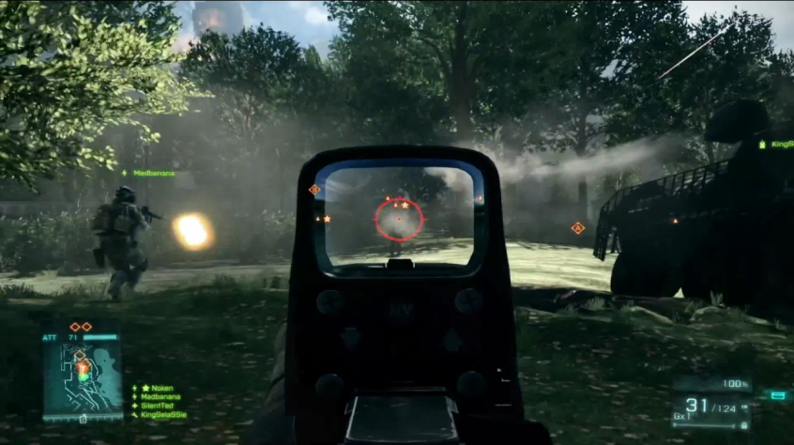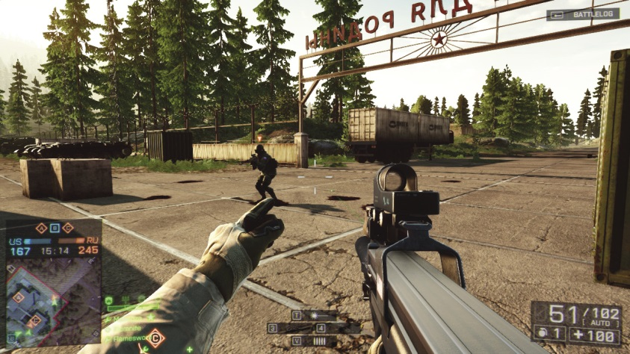

Figure 1.1: Images of the “spotting” mechanic featured in the Battlefield series. The left image (Prima) shows a player in the process of spotting an enemy and the right image (Battlefield Wikia) shows a player shooting at a spotted enemy.

**No-scoping/quick-scoping/hard-scoping**

It is difficult to say exactly when these styles came about, but the most popular occurrence and widespread adoption was in Call of Duty 4: Modern Warfare (Infinity Ward, 2007). These styles can also be referred to as “trick shooting”, due in large part of the player’s desire to look ‘stylish’ when killing enemy players. The frequent postings of clips and videos on YouTube (Hurley. *et al*, 2006) and Machinima (Hancock and DeBevoise, 2000); greatly helped to increase popularity of these styles. Trick shooting relates to the how players use a sniper rifle and how close they are to the ‘front lines’. It also includes several other factors such as: objective play, mouse/controller sensitivity, amount of movement and how long the player aims-down-sight in one go i.e. “hard-scoping”.

**Hard-scoping**

Hard-scoping in fact has been around for centuries and refers to aiming down a gun sight for a prolonged period of time, waiting for the ideal moment to shoot.

**No-scoping**

No-scoping is the complete opposite of traditional sniping, where the player never aims down their sight and ‘shoots from the hip’. Due to the wide bullet spread simulated for sniper rifles in games, it’s very tricky to hit the target from great distance with accuracy.

**Quick-scoping**

Quick-scoping is the middle ground between the two previous styles, where a player quickly raises their scope when an enemy is targeted. Just as the scope levels on the target the players shoots and then lowers the scope. This trick allows quick movement and wide awareness when moving around the map, combined with quick acquisition and accuracy when engaging an enemy.

**Heat maps**

Heat maps are used to display data from multiple players, and show the localisation and frequency of a single piece of data. Heat maps, as described by Drachen and Canossa (2009), are “density/location-based aggregated visualization of – traditionally - the kill locations of players, combat units or similar.” The frequency is denoted by the use of colours usually ranging from one colour to another; moving through the shades of the first colour and through the shades of the next. For example one heat map could be displaying the deaths of players throughout a map, and the frequency colours used could be blue and red. Blue would show the positions where players only died a few times, whereas red would show where players died multiple times (figure 1.2 shows an example of this). Heat maps are useful visual tool to display environmental data. They can be used to see where ‘bottle necks’ and ‘choke points’ occur, allowing a designer to address these areas to make the level play better.

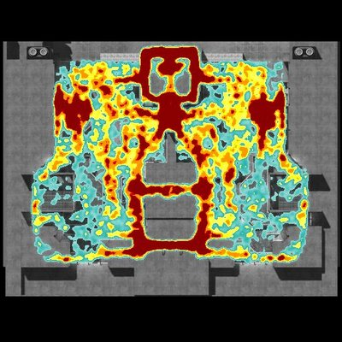

Figure 1.2: Image of a heatmap from the map ‘The Pit’ from Halo 3 (Bungie, 2007), featuring the death locations of players (Cool Infographics, 2009b).

**Chapter 2**

**Background**

**Chapter Introduction**

This chapter will look at two main areas of movement on multiplayer levels. The first section looks at “Multiplayer map movement flows” which categorises levels using a high level perspective. It is used as a generalisation of a multiplayer level and assumes that all players navigating the level will follow the same or similar pattern. The second section covers “Player Movement Patterns” which takes a low level perspective on the individual movements of each player. It looks at the actions performed by a single player irrespective of the level type; however it does present links to actions of other players.

**2.1 Multiplayer map movement flows**

**Introduction**

This section covers multiplayer map types, and provides descriptions of each, along with examples and diagrams to aid the explanation. Map types are a way of classify a multiplayer level by looking at the main movement structure and its general structure.

Below is a list of seven common multiplayer map types:

* Linear
* Theme-centred
* Arena
* Circular
* Location-based
* Asymmetrical (Team based)
* Symmetrical (Team based)

**Arena:**

This was a popular multiplayer map design in the days of Doom (id, 1993), Quake (id, 1996) and Unreal Tournament (Epic, 1999). It came about from the frantic, fast paced Deathmatch style gameplay of these games. Arena based maps encourage players to be constantly on the move and usually have a central area were most of the combat takes place (Saltzman, 1999). A good example of this is the map “Waste Management” featured in Warhammer 40,000: Space Marine (Relic Entertainment, 2011). These types of levels are usually quick and easy to learn, where players will always know where they are. They commonly have high kill limits due to the gameplay being very fast paced.

**Circular or ‘O’ shaped:**

Similar to ‘Arena’ these maps play very ‘fluidly’ and feature very little (if any) dead ends; encouraging the player to continue moving, and mostly centred around one object or location. For example in the level ‘Rust’ (Call of Duty: Modern Warfare 2, Infinity Ward), the level is centred round the refinery (as shown in figure 2.1 below). Players move around the refinery in a mostly circular pattern, and engage enemies as they are encountered.

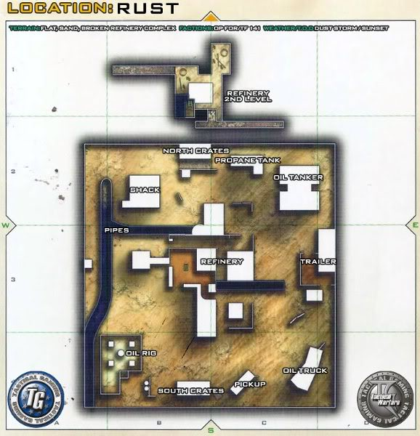

Figure 2.1: Overview of the map “Rust” featured in Call of Duty: Modern Warfare 2 (2009).

**Symmetrical:**

This flow pattern, along with the asymmetrical pattern (covered later), were introduced when games began to feature team based modes such as Team Deathmatch (TDM), Capture the flag (CTF) and Assault. They were designed to allow teams of players to engage each other head on and provided a more structured movement flow as illustrated in figure 2.2. They are also mostly mirror images of themselves, where the designers aim for no team to have an advantage of the other.

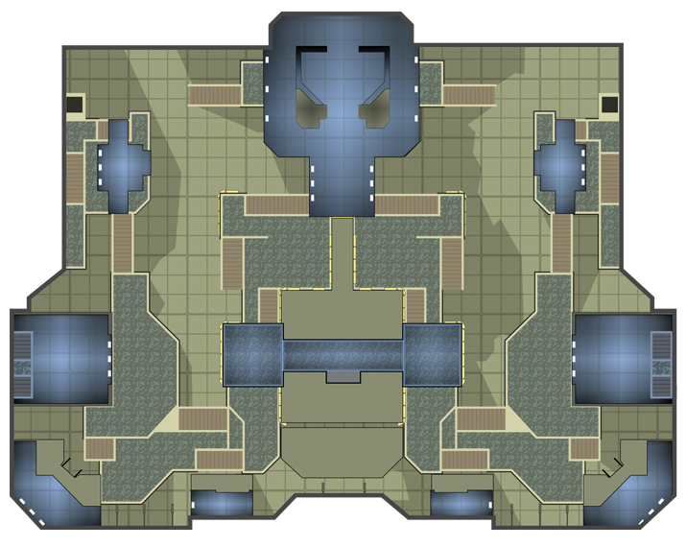

Figure 2.2: Overview of the map “The Pit” featured in Halo 3 (2007).

**Asymmetrical:**

In effective level design, asymmetry only means an asymmetrical level and not asymmetrical gameplay. In the article “Secrets of the Sages: Level Design” (Saltzman, 1999) Willits states “if the level is not symmetrical there should be a balanced strategy that needs to be employed by each individual team”. The example that he gives relates to the style or theme of each side of the map, for example if one side is covered in swimmable water then there should be many ‘re-breather’ pickups in the area. Like-wise if the other side of the map is covered in radioactive sludge, then there should be many ‘hazmat suits’ available to the team who spawn there (*ibid*).

The game type or skill level of the players on either team can also enhance asymmetrical behaviour; for example if one team was on defence (or not as good as the other), then this would lead to asymmetrical movement during the match. The defending team would most likely not move far away from their spawn point or their objective and would attempt to ‘dig in’, in order to create an advantage for themselves over the attackers. As for the attacking team, they would be constantly pressing the defenders in an attempt achieve ‘map control’, to better enable them to control the movement of the defending team and allow them to more easily assault the objective.

An excellent example of this can be found in almost every ‘rush’ match on the “Operation Metro” (overview shown figure 2.3) featured in Battlefield 3 (EA Digital Illusions, 2011). A good example of this is the gameplay video by FallenSinner (2011). In the video the player is rarely away from the objectives that he needs to protect and employs very static movement behaviour by ‘digging in’. Due to the weapon he was using (an M249 SAW LMG) he could have easily applied an even greater defensive stance, by equipping a ‘bipod’ and mounting his gun on the walls in the first 5 minutes of the game. This would have removed any movement while it was mounted, but it would have greatly increased accuracy (i.e. low movement for a defending player).

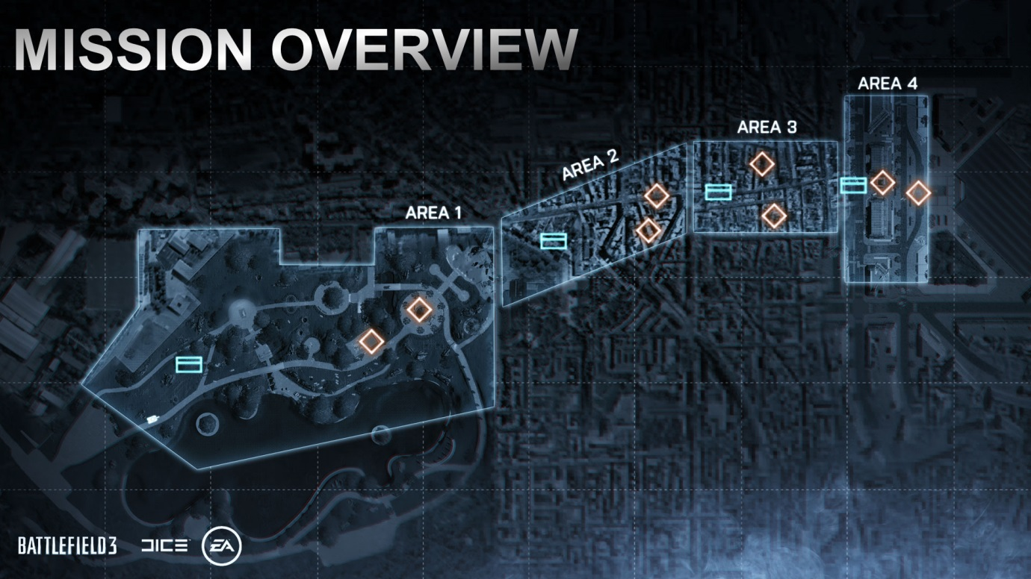

Figure 2.3: Overview of the ‘Rush’ gametype on the map “Operation Metro” featured in Battlefield 3 (EA Digital Illusions, 2011).

Attacking team’s spawn point.

Defending team’s spawn point.

Objectives that the attacking team must destroy.

**Linear or ‘I’ shaped:**

Linear can emerge as a variation of either symmetrical or asymmetrical design; this is the case because the basic layout of the design revolves around parallel lanes. These lanes are used to direct traffic flow towards the opposite side of the map, to increase the frequency of player interaction. The structure of this map design is wholly symmetrical as illustrated in figure 2.4 below; but the emergent behaviour of the players can become asymmetrical, which is illustrated in figure 2.5. This is explained in the previous section, where the difference in player skill or game type can cause different player movement. Linear maps, as described by Willits (*op cit*), “are built with only a few alternate paths. The architecture becomes a roadmap, where people instantly know which side of the map they're on.” And “…where players can enjoy jousting-type combat.”

Defender’s spawn

Attacker’s spawn

Lane swapping channels

Team engagement point

**Symmetrical**

Figure 2.4: Diagram of symmetrical linear design when both teams are equal and the main point of engagement is in the middle.

Defender’s spawn

Attacker’s spawn

Lane swapping channels

Team engagement point

**Asymmetrical**

Figure 2.5: Diagram of asymmetrical linear design when one team is better than the other (red) or the game type has an attacking team (red) and a defending team (blue).

**Location based**

This design has heavy emphasis on aesthetics because its main goal is to ensure that players always know exactly where they are in the level, as explained by Willits (*op cit*). This is achieved by including unique architecture or detailing objects; it could also involve various lighting colours and styles (e.g. solid, flickering, pulsing etc.). Applying this design helps to keep a high pace to the action, as players will know where they are and where they are going.

The map “Studio” from Call of Duty: Black Ops 2’s Uprising DLC (Treyarch, 2012), is a brilliant example of theme centred design as each area of the map is themed differently to the next. The map as a whole is based around a movie studio, where there are various decals, objects and architecture. Some of these locations include: a wooden backdrop of a medieval castle, a western style tavern, a ‘Pirates’ style dock and an alien invasion set. These examples can be seen in figure 2.6 below.

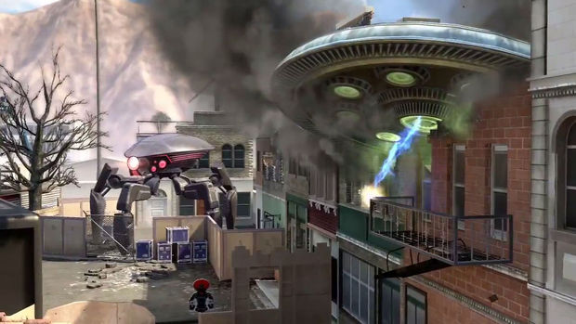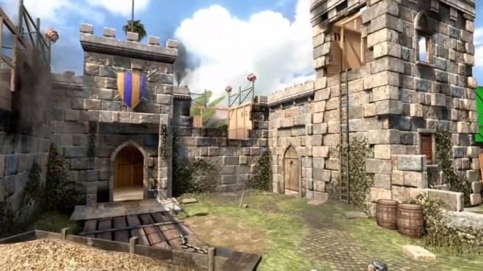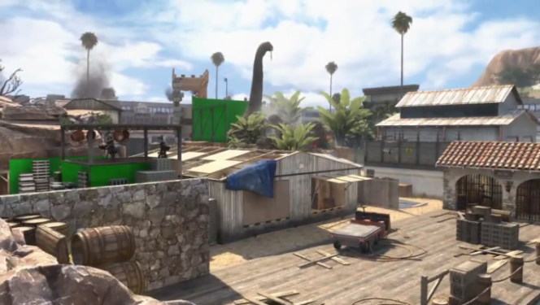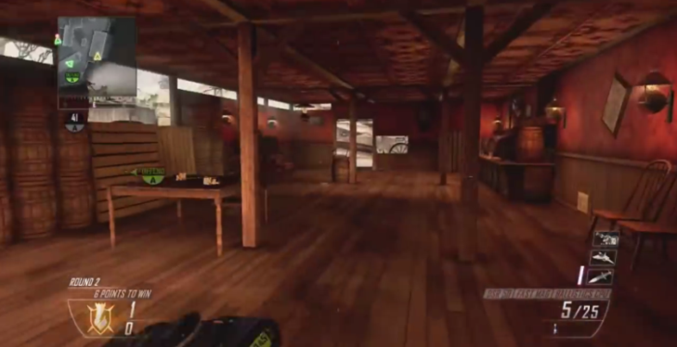

Figure 2.6: Images of various locations in the Call of Duty: Black Ops 2 map “Studio”. They show an alien invasion set (top left, Destructoid, 2013), a medieval castle back drop (top right, Expansive dlc, 2013), a ‘Pirates’ style dock (bottom left, FPS General, 2013) and a Western style tavern (bottom right, Treyarch, 2013).

**Theme centred**

Refers to a ‘stand out’ feature of a multiplayer level, that can take the form of a level with a high amount of water and swimmable areas, hazardous waste and radiation areas or high/low gravity areas. The example given in the “Secrets of the Sages article” (*op cit*) is the sewage system map called e1m4. The theme for this map is water where “Everywhere the player looks, he sees water or something related to water. In almost every area, the player can enter or exit the water.” Willits explains this map type as using “…something unique to combat and over exaggerates it all over the map.”

**Summary**

The majority of multiplayer levels present in commercial games could be categorised using these 7 map types. Understanding the overall style of a level can help designers to further manage the level or to replicate a particularly effective or popular map from another game.

**2.2 Player Movement Patterns**

**Introduction**

This section covers player movement patterns, and provides descriptions of each, along with examples and diagrams to aid the explanation. The layout is based on the style used in the paper by Milam and Seif El Nasr paper (*op cit*). Different to ‘map types’ that give a wide perspective on multiplayer gameplay; player movement patterns provide a much smaller perspective, on an individual player bases.

Below is a list of the initial set of player movement patterns. The patterns on the left are the five featured in the Milam/El Nasr paper, and the two on the right were added during the research stage.

Milam, El Nasr patterns:

* Collection pattern
* Path target
* Path movement and resistance
* Player is vulnerable
* Pursue AI

Added patterns:

* Pursue Player
* Camping

**Collection**

**Definition:** Refers to the act of players exploring the map in search of collectables, such as health, armour, weapons, ammunition and objective items.

**Design goal example:** Collect game objective items to allow the player/team to win by increasing game score. Items such as:

* The enemy’s flag in capture the flag (CTF).
* Territory points in:
  + “Domination” in Call of Duty 4 (Infinity Ward, 2007).
  + “Annex” Gears of War (Epic Games, 2006)
  + King of the hill (Bungie, Halo 2) and (Gears of War series)
  + “Headquarters” (Call of Duty series)
* A bomb in:
  + “Assault” (Halo series)
  + “Demolition” and “Sabotage” (Call of Duty series)
* A game specific item that allows the player/team to gain score points by holding it, such as:
  + “Oddball” (Halo series)
  + “Capture the Leader” Gears of War 3 (Epic Games, 2011)
  + “Team Defender Call of Duty: Modern Warfare 3 (Infinity Ward, 2009).

**Non-goal example:** Collect items that are not directly related to winning the match, but can aid the player/team to do so. Items such as:

* Power weapons, for example:
  + Sniper rifle and rocket launcher (Halo series)
  + “Boomshot” and mortar (Gears of War series)
* Pickups that increase player abilities:
  + “Overshield” and “Invisibility” (Halo series)
  + The “Boomshield” (Gears of War series)

These collectables can allow players to have an advantage over the enemy and provide them with the means to advance towards their base or an objective.

**Path Target**

**Definition:** Areas or objects in the map that stand out for players and that can be used to guide their movement around it, such as sniper towers, bunkers or hills (e.g. Valhalla map from Halo 3).

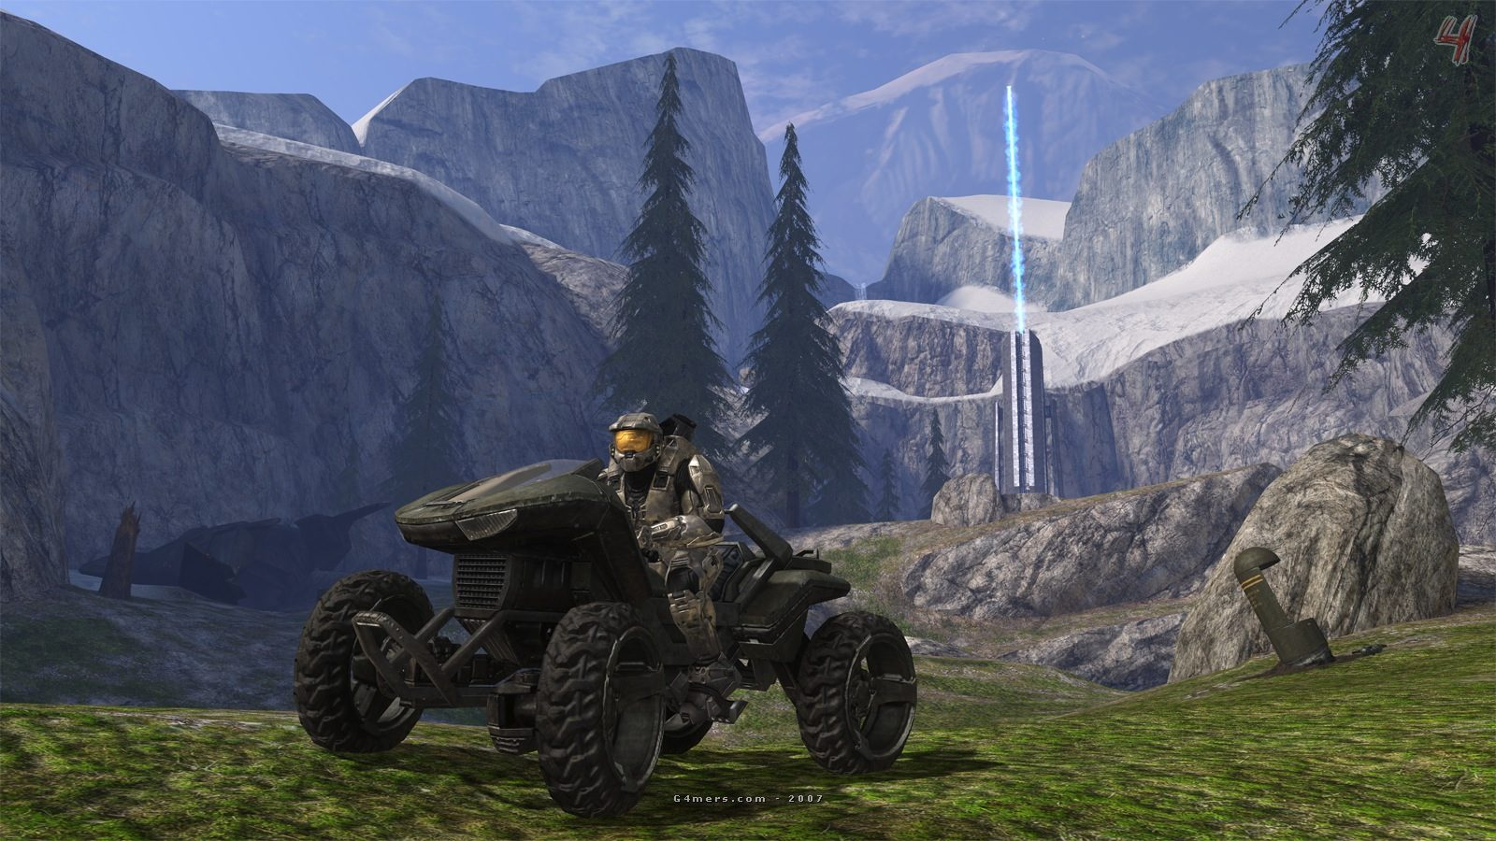

Hill/rock in middle of map, acts as a focal point for the gameplay.

Figure 2.7: Screenshots of the map “Valhalla” from Halo 3.

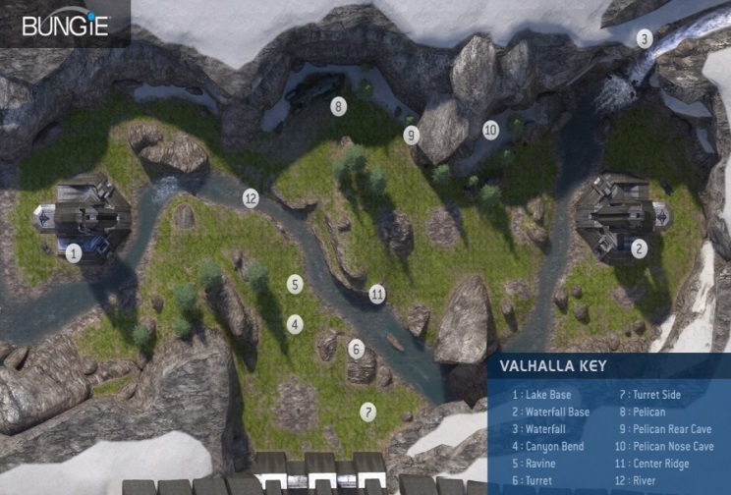

**Design goal example:** Areas or objects in the map that are designed to allow players/teams to increase their match score and to ultimately win the match. Areas such as the “hill” in the “King of the Hill” type game modes that encourage players to head towards these areas to earn points. Even when the “Hill” isn’t in the player’s direct line of sight, an icon on the player’s HUD (Heads up Display) and/or on their mini-map/compass, is usually displayed to help direct players towards it.

In some games there are maps that have team bases that stand out from the rest of the scenery, to easily show where players should be heading in game types like CTF or Assault. Team bases can be emphasised through different ways; one of which is making the map partially or completely symmetrical so that players can see where they spawned and compare it’s layout to the rest of the map to see an identical layout that they can then determine is the other team’s base (see figure 2.8). Examples of this can be found in the maps:

* “The Pit” from Halo 3 (Bungie, 2007).
* “River” from Gears of War 3 (Epic, 2011).
* “Wet Work” from Call of Duty 4: Modern Warfare (Infinity Ward, 2007).

Blue team base.

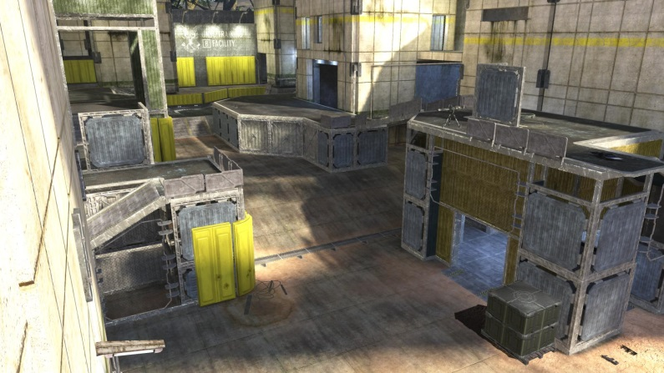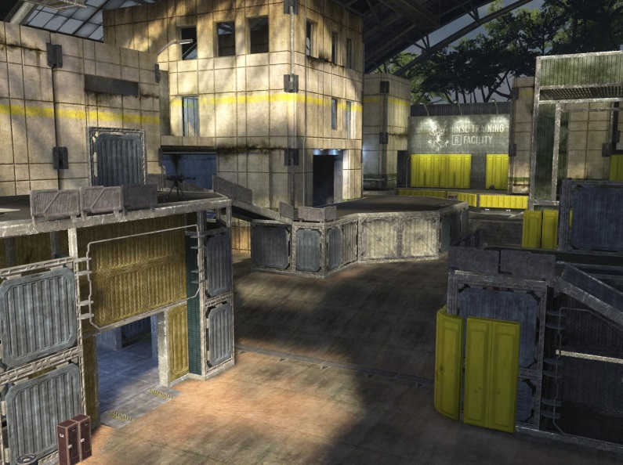

Red team base.

Figure 2.8: Images of the red base (Halo Wikia, 2007b) and blue base (Halo Wikia, 2007a), from the map “The Pit” featured in Halo 3 (Bungie, 2007). Each base is the symmetrical version of the other.

Another way of emphasising team bases is by using unique coloured lighting or detailing such as flags and banners, to help players distinguish their base from their enemy’s (see figure 2.9 below). The colours red and blue are used very often in this model and in many games tend to be the default team colours, for example “Coagulation” from Halo 2 (Bungie, 2004).

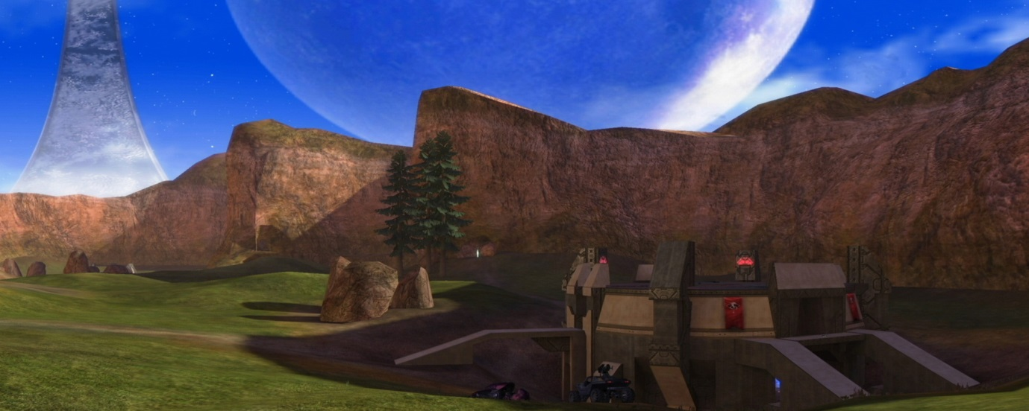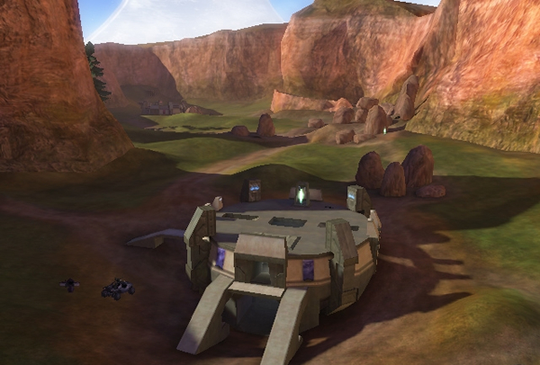

Blue team base.

Red team base.

Figure 2.9: Screenshots of the red and blue bases from the map “Coagulation” featured in Halo 2 (Bungie, 2004). Each base has lighting and banners in either red or blue, to signify which team it belongs to.

**Non-goal example:** Therecan also be areas and objects that don’t directly influence the match’s objectives but can aid in achieving them. For example in “The Pit” (Halo 3), on both sides of the map there is a tower that can be used by either team as a sniper perch to slow or stop the movement of the enemy team in games modes such as assault of CTF. Something like a tower is great for this because it provides elevation and usually a good view of the map, so it’s beneficial for players to go there, but it’s also an obvious part of the map that can be aimed at when moving about the map.

**Pursue AI**

**Definition:** Refers to artificial intelligence that is present in the level that interacts with the player, via friendly or aggressive AI. For example friendly AI such as shop owners or members of the player’s squad that guide you around the level for example the mission “All Ghillied Up” in Call of Duty 4: Modern Warfare. It can also be aggressive AI such as enemy soldiers that will attack you to prevent you from advancing through the level. Including AI into PvP (player vs player) multiplayer is quite rare, but there are a few instances of it.

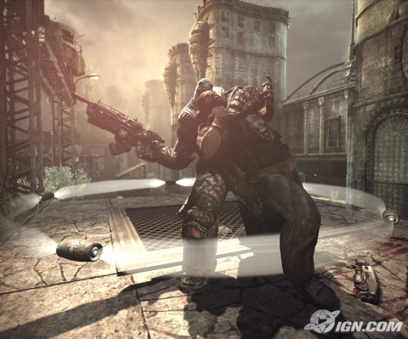

Figure 2.10: Screenshot of the game type “Submission” from Gears of War 2.

**Design goal example:** The game type “Submission”, which appeared in Gears of War 2 (Epic, 2008), is a unique take on the typical CTF game type where an AI controlled character, referred to as the “meat flag”, acts as the flag. This character creates engagements by attacking players on either team, forcing players to attack and “down” the meat flag in order to take him as a hostage.

**Non-goal example:** There are instances where there is an AI controlled aspect of the map that isn’t directly linked with winning the match. For example in the multiplayer map “Flood” featured in Gears of War 2 (*ibid*), which is set in a lake of imulsion, the environment can “attack” the players by slowing raising the imulsion higher up onto the map killing anyone who gets caught in it. This means that many parts of the map will become inaccessible to the player. Another instance is on the map “Berlin Wall” in Call of Duty: Black Ops (Treyarch, 2010) where there are three safe paths leading from one side of the wall to the other and in the between those is a “no man’s land” area (shown in figure 2.11). This area allows quick movement from one side of the map to the other, but players run the risk of being killed by automatic turrets while attempting to cross.

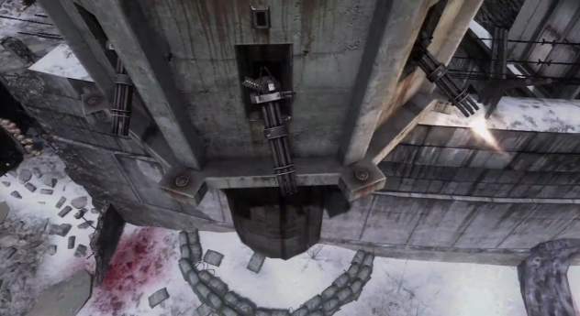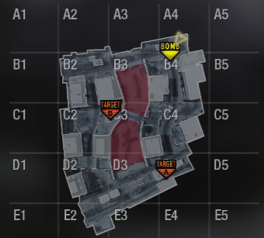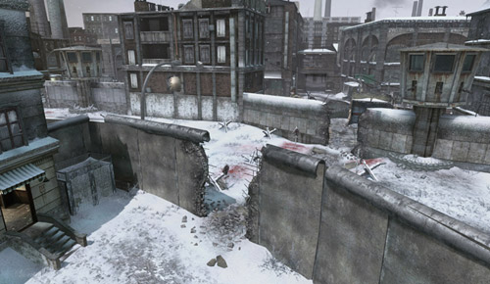

Figure 2.11: Screenshots from the map “Berlin Wall” featured in Call of Duty: Black Ops, DLC map pack “First Strike”.

No man’s land.

**Pursue Player**

**Definition:** Since the “Pursue AI” pattern can’t completely be applied to PvP multiplayer games, a replacement pattern could be added. This refers to other human players in the match, both allied players and enemy players that interact with each other in different ways. Enemy players can create engagements by attacking the player causing him to attack back, take cover, retreat etc. Allied players can be followed around the map to achieve the “strength in numbers” tactic, increasing their chances of winning engagements.

**Design goal example:** In game types such as “Deathmatch” and “Team Deathmatch”, it is a common goal to seek out and engage enemy players so that points can be gained for their individual or team’s score. Sometimes player engagements can be more indirectly forced, for example in the “Capture the Leader” game type (Gears of War 3), the objective of the match is to engage and capture the enemy team’s leader to earn points. Killing other enemy players isn’t necessary but it is usually beneficial. It allows easier access to the leader both in capturing him and holding him. The same could be applied to CTF, by engaging enemies surrounding the target flag, it can allow for easier access to it and after the flag has been picked up it is again beneficial for the rest of the team to engage the enemy players or to escort the flag carrier. This allows for safe passage and enabling him to score. This is illustrated in figure 2.12 below.

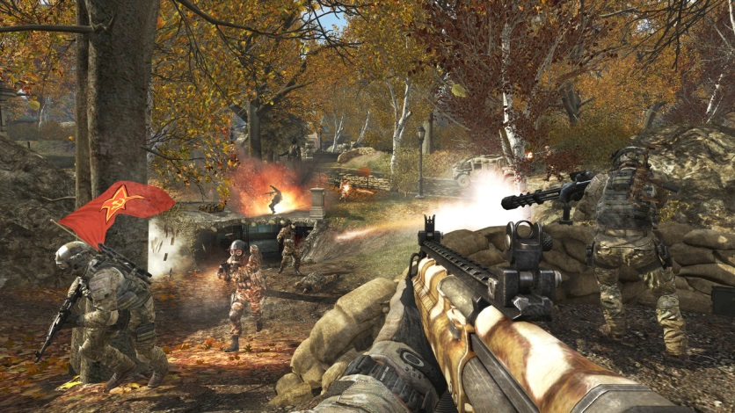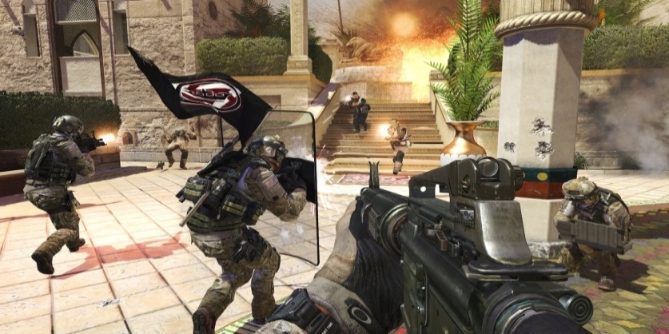

Figure 2.12: Screenshots of Capture the Flag game type in Call of Duty: Modern Warfare 3.

Flag carrier.

Ally players.

Enemy players.

Enemy players.

Ally players.

Flag carrier.

This is also the case in the “Territories” or “King of the Hill” style game types, where enemies don’t have to be engaged to earn points, but by doing so can aid in capturing and holding areas to earn points. In some cases it can be forced, for example when players from both teams are attempting to capture the same objective; this is referred to as an objective being “contested”.

**Non-goal example:** In most cases it is encouraged for players to engage other players to make it easier to achieve objective goals, but there a many cases when players engage others in an attempt to get a high K/D (kills - to - deaths ratio). This can cause players to stay in one area that is usually very defensible and will allow for easy kills, but does not necessarily aid in achieving the objective; referred to as “camping” (covered later).

**Path Movement and Resistance**

**Definition:** A path movement goal is something that either the game designer or the player has designed to encourage them to move in a certain way. Examples of this are: to move towards an objective, to a more advantageous position or to flee from an engagement. Any obstruction to that movement goal is resistance that the player must overcome. It could be physical obstacles such as buildings, walls or rivers, or it could be enemy players engaging the player and preventing them from advancing to their goals. In Battlefield 4 (EA Digital Illusions CE, 2013) there are many objects in the environment that players can interact with. Some include cargo doors in warehouses, road bollards on bridges and lifts in office buildings. Each of these can be used to resist advancing players by creating obstacles that they need to overcome. For example with the cargo doors (figure 2.13), players can press a button that closes the doors reducing the ways in or out of the building. This forces players wishing to enter or exit the building to press the button and wait for the doors to open, move to another open door or to blow a hole in the wall. Whatever action the player chooses to take will act as resistance to their movement goal.

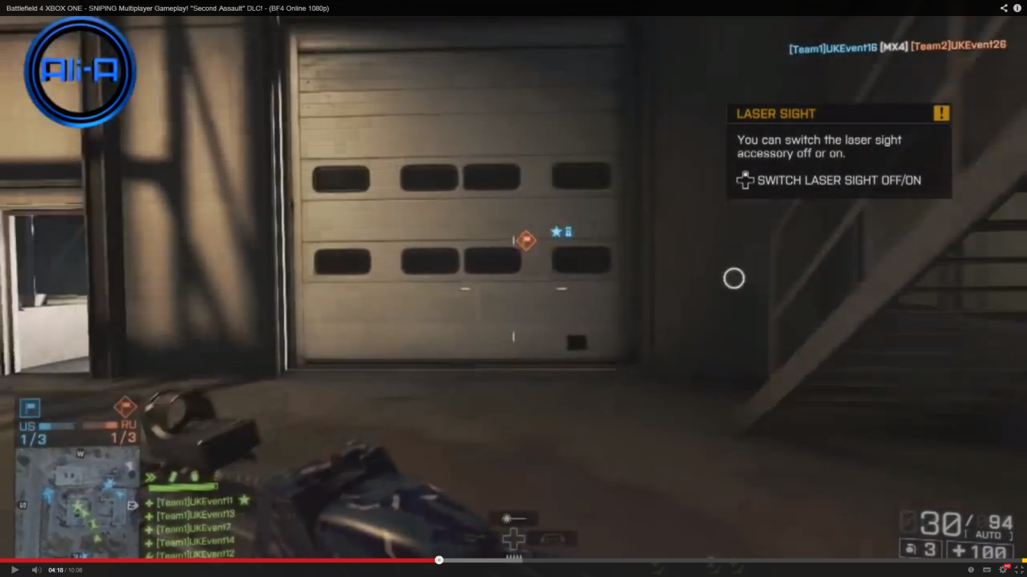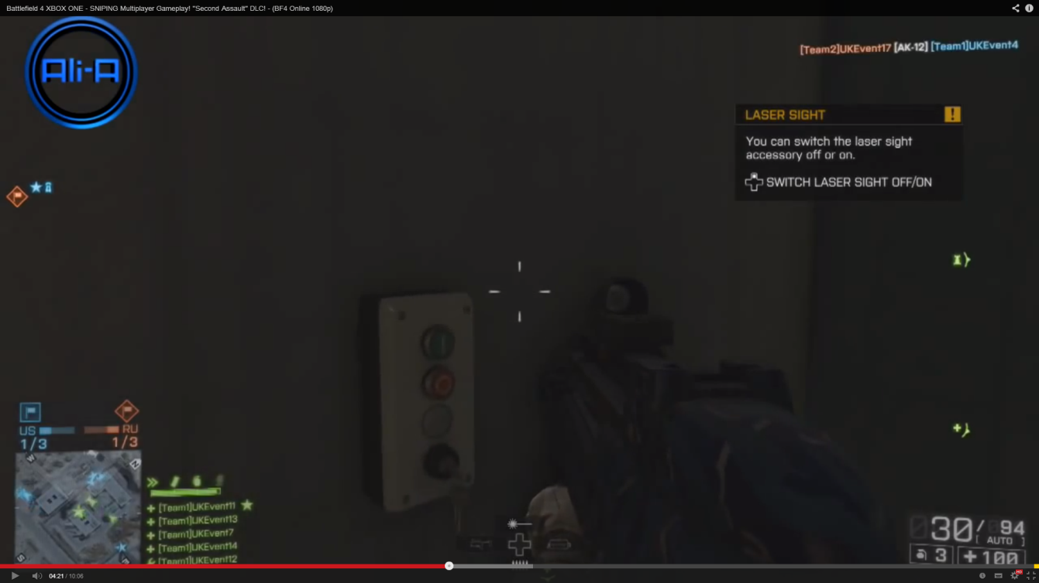

Figure 2.13: Two screenshots (EA, 2013) that show a cargo door to a warehouse (left) and an interactive panel used to open and close the door (right).

**Design goal example:** In many game types there are specific objects or areas that players need to head towards in order to complete the match’s objectives. In order to reach these objectives there are things that create resistance for the player that they must overcome, such as the level’s design or enemy players. The player’s own team can also cause resistance if they aren’t attempting to reach the objectives as well, causing unbalance.

**Non-goal example:** As mentioned previously, players may wish to move towards certain areas in order to gain an advantage against enemy players. These areas themselves can be advantageous by providing good lines of sight for the player e.g. atop towers and walls or on balconies etc. They can also be the opposite and provide lots of cover e.g. along walls, in tunnels or bunkers etc. Areas can also hold special weapons or items to aid players. Again enemy players can cause resistance since they may wish to reach these areas as well and will attempt to prevent their enemies from reaching them as well. Resistance is also caused by static scenery, but in some instances it can be caused by dynamic and interactive scenery. For example on the maps “Stockpile” (Call of Duty: Black Ops – DLC Map Pack: Escalation) and “High Ground” (Halo 3), there are doors that can be interacted with by closing or opening them, creating or reducing resistance.

**Player is Vulnerable**

**Definition:** This pattern refers to anytime that the player is susceptible to being killed, by enemy players or from environmental hazards.

**Design goal example:** The vulnerabilityof the player can alter depending on what game type they are playing and what action they have taken. For example the player’s vulnerability can be **i**ncreased when carrying the flag in CTF because they may move slower, have a less powerful or no weapon or they may be highlighted on the map. In other game types vulnerability can be decreased, for example in the “Juggernaut” game type (Halo), by becoming the “Juggernaut” players can receive over shields which make them harder to kill.

**Non-goal example:** Players can increases or decrease their own vulnerability depending on the paths they take across the map and at what areas they linger in. For example on “The Pit” map, there are many paths that players can take, with varying vulnerabilities. For example they can take the “Rocket Launcher” path with a high chance of engagement, increasing vulnerability. Or the player could take the underground path on the other side of the map which is less used, decreasing vulnerability.

**Camping**

**Definition:** This pattern represents a player staying in specific areas of the map for a prolonged period of time. The areas that players decide to ‘camp’ in are usually strategically advantageous; and is easier for players to get good kill-to-death ratios (KD). As described by Smith (2004) “Campingrefers to the less-than-brave tactic of placing one’s first person shooter character in a highly secure spot, waiting patiently for the enemy to come close enough to be surgically dispatched”. This play style is usually frowned upon by other players because it interferes with the ‘spirit’ of the game. This is the case because a player who is camping is usually hiding away from other players and not helping their team complete the object (see figure 2.14). There are exceptions to this though, as discussed next.

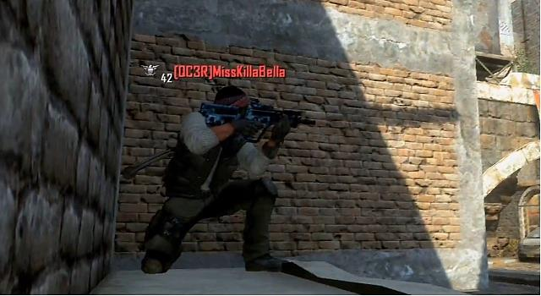

Figure 2.14: Image of a player camping in Black Ops 2 (egm now, 2013).

**Design goal example:** Players who want to camp but also help their team win may decide to do so near an objective point; such as the flag in CTF or an area of the map that has strategic value to the team. A good example of this is in the map ‘Vacant’ (figure 2.15), which appears in Call of Duty 4: Modern Warfare (Infinity Ward, 2007). There are two rooms at the back of the map that when held by a team, present a strategic advantage since there are only three ways in. This allows the controlling team to take cover in the rooms and force the enemy team to ‘bottle neck’ when attempting to enter. In objective game modes, one of the teams will have their objectives in the larger room, meaning that controlling these rooms is a benefit to the player and the team.

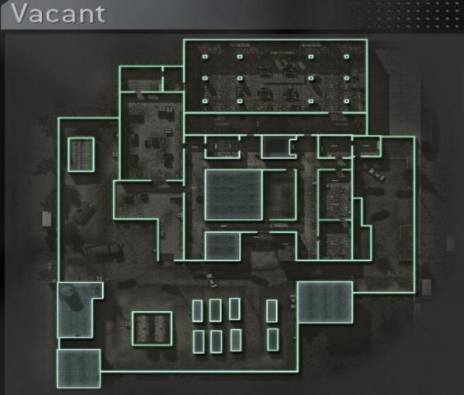

Figure 2.15: Image of the map ‘Vacant’ from COD4 (COD n Chips).

Entrances.

**Non-goal example:** More commonly players camp for their own benefit and don’t mind whether their team wins or not, just that they get a high KD. Sometimes the position that these players have chosen to camp at is beneficial to the team, but it is only because they chose a point where they are guaranteed that enemy players will come to i.e. an objective point. It is possible to distinguish between the two, because when a capture point, for example, is held by their team, players who want to help their team win the match will move up and camp at a position closer to the enemy’s spawn to prevent the enemy for re-capturing. Players who don’t want to help will simply stay where they were and will let the point be re-captured, as shown in figure 2.16.

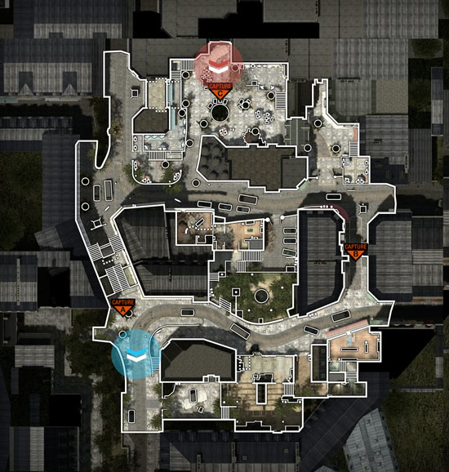

Initial camping position.

Camping position after capture.

Capture point.

Figure 2.16: Overview of the map resistance in Modern Warfare 3 (Call of Duty Wikia).

**Chapter 3**

**Methodology**

**Chapter Introduction**

This chapter covers the management of the project, and outlines the aims and objectives. It also provides descriptions of the processes and software used throughout, along with explanations as to why they were used over possible alternatives and how they were intended to meet the requirements and aims of the project.

**3.1 Project Management**

Since this project will mainly be looking at the behaviour of real people, the processes used should reflect this. Gamers can be in varying states of play in which both concentration and awareness varies (a lot of the time subconsciously); when both are high it is referred to as being ‘in the zone’. In the paper by Poels *et al* (2007) it is mentioned that “…some frequent gamers mentioned 'being in the zone' as a state of full concentration in which performance and competence are at their best”. These varying states means that the processes used should cover both conscious and automatic play. This in mind the following processes will be used in the project: questionnaires, group play testing (LANs) and visual identification of gameplay. To aid in the management of the project a Gantt chart was used, and can be seen in section 6.D; it was used to ensure that each task was completed by its deadline.

**3.2 Aims and Objectives**

**Aim 1:** Analyse existing player movement patterns.

1.1. Collate patterns from multiple sources.

* 1. Analyse gameplay through visual identification, to determine how often these patterns occur and the scale of the affect that they have on the player’s actions.
  2. Evaluate the results of the testing to inform what patterns are worth exploring further and if there are any gaps where additional patterns need to be developed.

**Aim 2:** Develop and modify patterns to create a more appropriate and in-depth set.

* 1. Propose a new set of patterns.
  2. Analyse player’s gameplay and thoughts, along with questioning average players to determine whether this new set is more appropriate and successful.
  3. Evaluate the results of the analysis to inform the success of the set and whether it requires additional development.

**Aim 3:** Design and create a multiplayer level where these new patterns can be tested in a real world situation.

* 1. Design the level layout where the majority of movement actions can be achieved.
  2. Create this level using an appropriate level editor/game engine.
  3. Analyse and question player’s experiences on the level with relation to the pattern set.
  4. Evaluate the results of the testing and decide whether these patterns were successful or whether they require further development.

**3.3 Software Development Life Cycle**

Since this dissertation is based around the development of game design patterns, it stands to reason that it would fit into the research and development stage of a commercial video game’s development cycle. The development of a video game usually follows the ‘Waterfall’ method; “Game development has been traditionally based on the waterfall method or some of its variants.” (Koutonen and Leppänen, 2013). The waterfall method relates to a sequential completion of stages and tasks to further the development of a software product. A conventional waterfall process would involve the following stages: requirements and specification, detailed designs, construction and debug, integration and system test, module re-work, and finished with re-integration and system test (Cusumano and Smith, 1995).

With this in mind, this dissertation would fit into the ‘requirements and specification’ stage, as developing a set of design patterns to be used in the development of the game’s levels, would be a requirement of the development cycle. Following the development of the design patterns, the completed pattern set would then be used in the main design and development stages (or ‘detailed designs’ and ‘construction and debug’ stages) of the video game. The pattern set potentially could appear in the Q.A. stages as well, outlined as: integration and system test, module re-work, and re-integration and system test (*ibid*). As mentioned in section 1.1, design patterns can be used in both the development of a game and in the review of it, so it would appropriately fit into these Q.A. stages also.

**3.4 Software used**

**UDK**

**Definition:** UDK (Epic Games, 2009) stands for Unreal Development Kit and is a reduced version of the Unreal Engine 3. It comes standard with two main components, ‘UDK Editor’ and ‘UDK Game’. The editor allows the user to create a 3D environment; texture it, add details and gameplay features such as pickups, vehicles and pathnodes. It also comes with Unreal’s visual debugger ‘Kismet’, and cinematic suite ‘Matinee’. ‘UDK Game’ allows the levels created in the editor to be played either with bots or with other people via custom servers.

**Reason:** UDK was chosen because it had all of the features that were required for this project. The editor allowed a fully functional multiplayer level to be created in a short amount of time. ‘Unreal Frontend’ allowed the level to be packaged in a redistributable, and UDK Game allowed other people to link to the same game using a ‘Local Area Network’. Another feature that was used later in the project was its easy implementation of AI controlled bots via its ‘pathnode’ system. All that was required to set up bots was to place pathnodes throughout the map and UDK would automatically set up linking paths between them. It also determined whether a path was valid or not, for example whether there was a ramp leading up to a higher node, if there wasn’t then no path link was made.

Alternatives include: Cry Engine 3 and Source SDK.

Cry Engine 3 (Crytek, 2011) was rejected due to it being complicated to work with and would have made the process of building the testing level more time consuming. Although the engine does comes with very similar functionality to UDK in terms of setting up multiplayer lobbies, UDK overall seemed the better choice.

Source SDK (Valve, 2004) (free developer version of Source Engine) was rejected due to the researcher having no prior experience with it. However this would have been disregarded if it were a more appropriate option but since it had similar features to UDK, it didn’t seem justified spending the extra time learning the software. Another reason was that the engine’s built in games; Team Fortress and Counter Strike (which would have been the only appropriate ones for this project) were more in depth than UDK Game. All of the extra classes and weapon types in both would have made the process more complicated and would have detracted from the purpose of the level.

**ezvid**

**Definition:** ezvid (2011) is free piece of video editing software that has similar features to Windows Movie Maker (except for any transitional effects such as fade to black or fade in from white). ezvid also has a screen capture feature that can be used to put footage directly into an ezvid project or to simply place it in memory.

**Reason:** ezvid was chosen because it is free and allowed infinite recording time, meaning the entirety of a LAN session could be recorded in one go.

Alternatives include: Fraps, CamStudio (nickthegeek *et al*, 2001)

Fraps was rejected due to its high cost for the full version and its free version only allowing 30 seconds of recording time. Since the recording software would be required to record for up to 30 minutes (the entirety of each LAN session), Fraps was not suitable.

CamStudio is free to use and allowed unlimited recording time, but was rejected due to its poor quality, codexing and compression; resulting in extremely large files. Relatively good video quality was required to see what players were doing, this along with large files meant that it was unsuitable for the testing processes.

**Summary**

In summary the software chosen seemed appropriate for the intentions and constraints of the project. Although there were alternatives, they were either rejected due to unfamiliarity or due to restrictions in the software, such as recording time.

**3.5 Visual Identification**

**Description**

Visual identification is a technique where patterns or actions of players are discovered by watching recorded gameplay videos. The researcher would watch a gameplay video and at every point where the player did a certain action or made a particular decision, a note would be made. This note would comprise of the time in the video that the action occurred along with the action itself, which would usually take the form of an abbreviation, for example CJ for a ‘crouch jump’.

The results of the analysis can be presented in two main ways, in a summation of every time each action occurred presenting it in a table or in a timeline showing when each action occurred. In this instance a table format was used to allow for better comparison between the results of the games analysed, since they are side-by-side. The complete raw data can be found in section 6.B, and displays the results from both stages (outlined later in this section) of the Visual identification.

A visual analysis technique was used in this work because it was also used in the two papers that this project is related to, the papers by Milam and Seif El-Nasr (2010a) and (2010b). It was important to use the same process since it had already been designed and developed specifically for processing and evaluating movement patterns; it also allowed both pieces of research to be comparable with each other. The technique allows the researcher to see what the player is doing at any given time in the gameplay and draw conclusions from what was seen. Using a manual process helped to determine the player’s behaviour because a human can better understand the behaviour of other humans, more so than a computer. For each paper the researchers analysed multiple video games (4 and 21 respectively), where both a table summation format (featuring percentage occurrence) along with a timeline format were used to present the results.

**Meeting the Requirements**

This process aided in the development of the proposed pattern set (outlined later), as it presented raw player data as to the frequency that a particular pattern occurred in any given game. This presented an insight as to the degree of influence that a particular pattern exerts on a player’s behaviour. It also displayed the duration of each occurrence of each pattern; and with the ‘time stamp’ of when it occurred in the video. It easily allowed for that point to be looked up and used to see where the player was in the level and what they were doing. This process greatly helped to achieve ‘Aim 1’ (outlined in section 3.2), in analysing existing player movement patterns. Specifically covering aims 1.2 and 1.3, and especially helped in determining gaps where additional patterns needed to be developed (discussed later in section 4.1).

**Behaviour Patterns:**

The 14 patterns below create the set that was developed and used in the visual identification; they include the initial set outlined in section 2.2, along with additions and alterations (specifics detailed later in section 4.1).

* Path Movement and Resistance (PM-R).
* Path Target – movement (PTm).
* Path Target – visual (PTv).
* Collection (Co).
* Reloading (R).
* Objective action (O).
* Player is Vulnerable (PV).
* Camping (Ca)
* Pursue Player – both (PP)
* Pursue Player – movement (PPm).
* Pursue Player – visual (PPv).
* Pursue Player – team (PPt).
* Controlling air support (CAS).
* Killstreak (K)

**Published games**

The games that were analysed are listed below in figure 3.1, along with the duration of the video, who the video belongs to, as well as the game type. The first 5 results from each game can be seen in figure (for the full results see figure 6.2, in the appendices).

|  |  |  |  |
| --- | --- | --- | --- |
| Game | Video owner | Video length | Game type |
| Halo 4 | xMurderotica89 | 13:20 | Big Team Slayer |
| Call of Duty: Ghosts | TmarTn | 10:45 | Domination |
| Battlefield 4 | Ali-A | 10:06 | Conquest, CTF, TDM |
| Team Fortress 2 | SquiiddishGaming | 06:53 | Payload |
| Gears of War: Judgement | GoldGloveTV | 10:27 | Domination |
| Unreal Tournament 3 | trippalhealicks | 08:33 | Warfare |

Figure 3.1: The results from the visual identification of gameplay from the 6 commercial games.

|  |  |  |  |  |  |
| --- | --- | --- | --- | --- | --- |
| **Halo 4** | **Call of Duty: Ghosts** | **Battlefield 4** | **Team Fortress 2** | **Gears of War Judgement** | **Unreal Tournament 3** |
| **Video length:** 13:20 | **Video length:** 10:45 | **Video length:** 10:06 | **Video length:** 06:53 | **Video length:** 10:27 | **Video length:** 08:33 |
| 0:01: PM-R | 00:45: PTm | 00:16: PPv, PV | 00:12: PPv | 00:00: PTm, PM-R, O, Co | 00:00: PTm, Co |
| 0:07: PTm | 00:49: O | 00:25: PPv, Ca, PTv | 00:15: PPv, PV | 00:13: PM-R | 00:12: O, Ca |
| 0:08: PM-R | 00:52: PM-R | 00:40: PPv, Ca, PTv | 00:22: O, PTm | 00:23: Co, PPv | 00:35: Co, PTm, PM-R |
| 0:23: Co | 00:57: PV, PTm | 01:16: PPv, Ca, R, PTv | 00:26: PV | 00:36: PM-R, PTm | 00:48: O, PP, PV |
| 0:24: PV | 01:04: O, PV, PPv | 01:52: PPv, Ca | 00:30: PPv, PV | 00:40: PP, PV, R | 01:05: O, Ca |

Figure 3.2: Shows the first 5 results from each game.

**Testing level**

The visual identification process was also used to process some of the footage recorded from the LAN sessions, (the full results can be found in figure 6.2 in the appendices). The results show two out of the four stages in the development of the testing level. Six pieces of 8-9 minute footage each from a different participant were taken from the LANs, three from the second LAN session and three from the fourth. These videos were chosen because they displayed varied behaviour, where the participant scored averagely in kills and death. The columns denoted with a ‘B’ relate to the second LAN session which was run on the second iteration of the level; whereas the columns with a ‘D’ relate to the fourth LAN session on the final version of the level. It is important to note that due to the nature of UDK and Unreal Tournament 3, the following patterns were not present in the results: reloading, killstreak and controlling air support.

**3.6 Alternative Processes**

This section outlines two alternatives to the ‘Visual Identification’ process (explained in the previous section). Both draw backs and justifications are presented as reasons for why these processes were rejected from the project.

**Interactive Visualisation System**

This process is used to visual the behaviour of players, by displaying representations of the data on an image of a level. It was proposed in the paper by Moura *et al* (2011). It is an alternative to heatmaps (outlined in the ‘Terminology’ section), and represents the data by displaying a ring in the area that a particular behaviour was performed; where the size of the ring is dependent on the value of the data. An example given in the paper was of how long players spent in various areas of the level.

**Reasons for rejection**

This process was designed to visualize player behaviour and was also contributed to by Seif El Nasr; who was one of two researchers who published the papers by Milam and Seif El Nasr (2010a and 2010b). The ‘Interactive Visualisation System’ looks at various player behaviours; from time spent playing a game and the duration spent in certain areas, to when players opened their map, and to how long they spent talking to NPCs. This kind of data is definitely useful when designing a level “Knowing how much time players spent playing the game is crucial” (*ibid*); but is mostly unrelated to developing a set of movement patterns specifically for multiplayer games. For example since there are generally no NPCs in multiplayer levels that the player can have conversations with, recording and displaying this data wouldn’t be useful in the context of this dissertation. This was the main reason why this process was rejected, along with the fact that the visualisation of player data isn’t an aim for this dissertation. The development of the patterns is more important than making it easier to visualise the data used in the development.

**VU-Flow**

This tool is aimed at automating the process of collecting and displaying player movement in a virtual environment, and was proposed by Chittaro and Leronutti (2004). It was intended to make it easier for virtual environment designers to discover player behaviour that was unexpected or problematic; “…make it easy for the VE designer to visually detect peculiar users' behaviours and thus better understand the effects of her design choices.” (*ibid*).

**Reasons for rejection**

This tool was designed specifically to record and display player movement in general terms and not elaborate on the specific actions performed. “…paths followed by single users, …areas of maximum (or minimum) users' flow, …the parts of the environment more seen (or less seen)….” (*ibid*). The type and amount of data recorded by this tool would be insufficient to meet the aims of this dissertation, and as a such was rejected.

**3.7 Questionnaire**

The questionnaire took the form of a 10-point Likert scale opposed to something such as a Thurstone scale, due to its simplicity for the user and for its ability to accurately categorise and display the results (Oppenheim, 1992). The Likert scale also removes the ambiguity of possibly unpredicted answers such as: “sort of” and “kind of”, since the user must choose from a pre-defined set.

**Developing the questionnaire**

The Likert scale could have taken the form of a 4, 5, 6, 7, 10 or 11 point scale; where the scale is determined mainly as to what the questionnaire is intended for. Various studies have been conducted on determining the optimal number of choices, along with the presence of a mid-point value in the scale. In questionnaires participants tend to favour more positive or neutral answers due to their desires to ‘please’ the interviewer and appear more helpful and socially acceptable (Garland, 1991). The removal of a mid-point value seems to partially alleviate this by presenting more negative results, balancing out the tendency to be more positive (*ibid*). In support of this, scales with more options tend to give slightly more negative results, “…a scale with more response options produces slightly lower scores relative to the upper limit of the scale.” (Dawes, 2008). This suggests that a 10-point Likert scale would produce the most accurate results; as it has the highest number of choices whilst remaining void of a midpoint value. The full 10-point questionnaire can be seen in the appendices and annexes section (section 6.B).

**Meeting the Requirements**

The responses for this questionnaire were used to aid in the development of the proposed pattern set (outlined in section 3.5). It allowed for a better understanding of the actions that players perform in multiplayer games; along with presenting an idea as to the thoughts and processes that players go through when determining the ‘correct’ course of action. Since design patterns are developed to help elicit certain actions from the player, the results from a questionnaire would outline whether the pattern was successful or not. For example if a design pattern was intended to cause a player to retreat in a particular circumstance, but the majority of players answered that they would advance instead; this would illustrate a flaw in the pattern. Implementing this process greatly aided in achieving ‘Aim 2’ (outlined in section 3.2) where the intent was to help in the development and modification of the proposed pattern set, and specifically aim 2.2.

**3.8 Play Testing**

In order to aid the development of the testing level, several LANs (Local Area Network) were conducted. In each session participants from the university competed on the level, playing multiple matches of the ‘Capture the Flag’ game mode. Each session lasted around 30 minutes, and throughout this time the gameplay of each participant was recorded using the screen capture feature of the “ezvid” software (outlined in section 3.4). Each session was run in a computer lab in the University of Lincoln, with a maximum number of participants reaching 10. Some of the recorded gameplay was used in another run of ‘Visual Analysis’ and the results were used in conjunction with the initial run of gameplay from 6 commercial games, to aid in the development of the movement pattern set (covered later in section 4.1).

**Meeting the Requirements**

As mentioned in section 1.1, play testing is a very important process in the development of a game level; again the following quote is relevant: “You never really know for sure how something will turn out until you actually play it. It’s that in-game testing that allows for true iteration.” (Scimeca, 2012). Running LANs allows gamers to experience a level and present feedback whilst it is still in development. It increases the chance that any prominent issues with the design of the level will be discovered before it is released as part of a commercial game. This play testing is essentially what Q.A. testers and the public would experience when playing a Beta version of a game, featured in the final development stages of a video game’s life cycle. This play testing process greatly helped in achieving ‘Aim 3’ (outlined in section 3.2), where the design and creation of a multiplayer level will allow for ‘real world’ testing of the proposed pattern set; and with specific emphasise on achieving aims 3.3 and 3.4.

**3.9 Level Design**

**Introduction**

This section covers the development of the ‘Testing Level’ that will be used in the play testing process (outlined in the previous section). It will look at architecture from pre-existing multiplayer levels along with how each choice was intended to influence a particular movement pattern. The finished level will also be made available for anyone to conduct further research and development on level design patterns (see Disc 1).

As outlined in ‘Path Target’ section of section 2.2, the hill that appears in the centre of the map ‘Valhalla’ featured in Halo 3 (Bungie, 2007), is a brilliant example of how a landmark can influence the movement of players. This is due to both its strategic advantage and how visible it is from the majority of the map. The architecture of the level suggests that the designers wanted the flow of gameplay to revolve around the hill. This assumption stems from its central location, and as evidenced by the two ‘man cannons’ that propel players in the direction of the hill, as shown in figure 3.3 below.

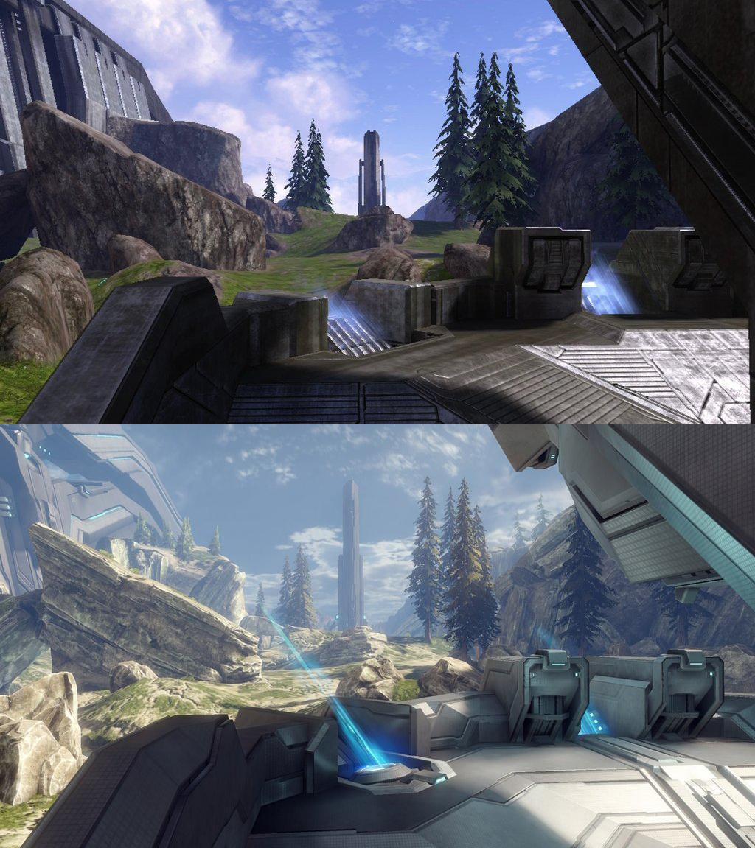

Figure 3.3: Image of a ‘Man Cannon’ from ‘Valhalla’ (reddit, 2012) featured in Halo 3.

Hill

Main ‘Man Cannon’

Heatmaps are also useful in illustrating the focal points on a map. The heatmap in figure 3.4 displays where the majority of kills and deaths occur in the map. As is apparent from the heatmap, the location where the vast majority of kills and deaths occur, is the hill in the centre of the map.

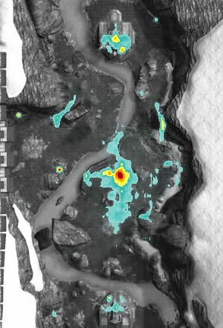

Figure 3.4: A heatmap image from the map ‘Valhalla’ featuring player kills and deaths (Halo Forever, 2007a).

Considering the effects that this hill has on the Path Target pattern, a similar piece of architecture has been included in the testing level and will hopefully serve in a similar manner (see figure 3.5 below).

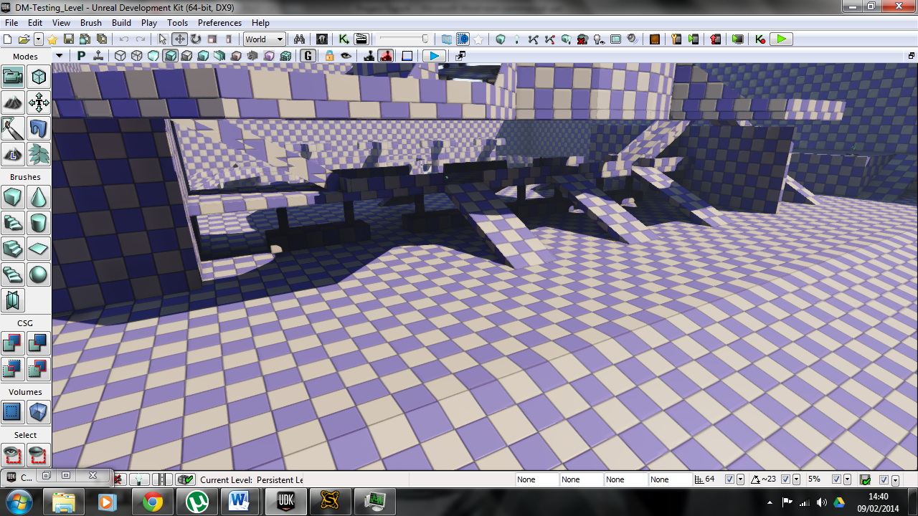

Figure 3.5: A screenshot of the piece of architecture in the testing level that was influenced by the hill in ‘Valhalla’.

With regards to the bases using corresponding lighting and coloured objects can help players distinguish between the enemy’s base and their own. This in mind, a similar approach has been taken with the Testing Level, as shown is figure 3.6.

With regards to the ‘Pursue Player - visual’ pattern, and as mentioned in the previous section, the hill in ‘Valhalla’ can be viewed from most positions in the map. This along with the elevation that it gives players makes it a brilliant vantage point to engage enemy players. This can be seen on the heatmaps in figure 3.7, as they show the position of players when they were killed by the ‘Spartan Laser’ (a powerful ‘one shot kill’ weapon) along with origination point of the blast. It shows that nearly every kill with the Spartan Laser originated from the hill.

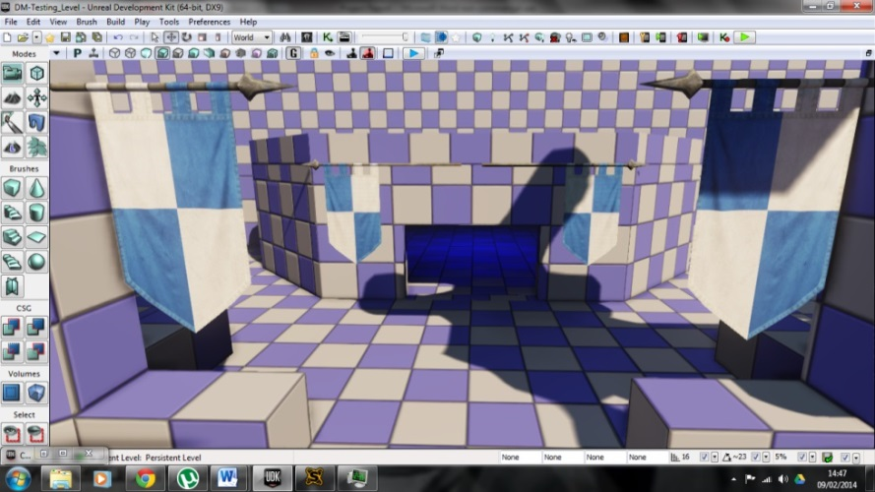

Figure 3.6: Screenshots (left) of the testing level’s red and blue bases, alongside images (right) of the red and blue bases in the map ‘Coagulation’ from Halo 2 (Bungie, 2004).

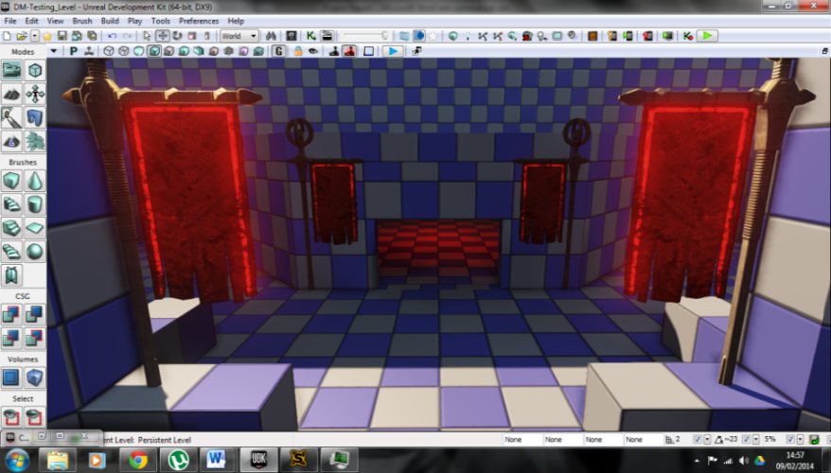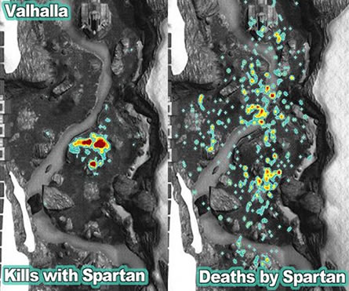

Figure 3.7: An image (Halo Forever, 2007b) featuring two heatmaps from the map ‘Valhalla’ showing player deaths from the ‘Spartan Laser’ (right) and the origin of the shot (left).

Another good example of map architecture that serves as a vantage point, are the two sniper towers in the map ‘The Pit’ again from Halo 3. The heatmap in figure 3.8, shows the positions on the map where most kills with the sniper occurred. It can be clearly seen that the two red clusters (which are the sniper towers) are the main location of kills whilst using the sniper.

Figure 3.8: Image of a heatmap of the map ‘The Pit’ from Halo 3, featuring the kill locations of players using the sniper rifle (Cool Infographics (2009a).

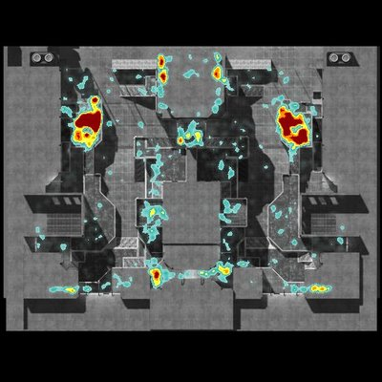

Valhalla’s hill type architecture had already been included for its effects on the Path Target pattern, but it along with the sniper towers from The Pit, will also be used to influence the design with the intention of eliciting the ‘Pursue Player – visual’ pattern.

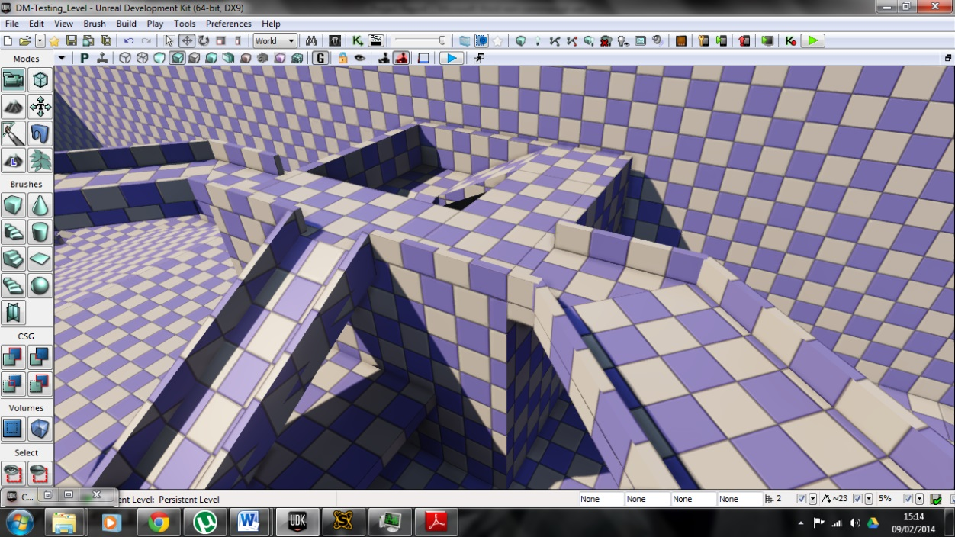

Figure 3.9: Image (right) of the red team’s sniper tower (Halo Wikia, 2007b) from the map “The Pit” featured in Halo 3 and a screenshot (left) of the tower in the testing level.

**Texturing**

For the level’s geometry the main texture that was used is UDK’s default material. This was chosen due to purpose of the level being to evaluate movement patterns, and the aesthetics of the level weren’t a priority. This choice also gives the feeling of a virtual environment used for testing and training, opposed to a representation of a real life environment.

**Meeting the Requirements**

As mentioned in the previous section (3.8), a testing level was required to run the LANs and conduct play testing to aid in the development of the proposed pattern set. Designing and creating a level with the pattern set in mind aided in achieving ‘Aim 3’, and specifically aims 3.1 and 3.2. The ‘Testing Level’ features various architecture intended to elicit varied movement behaviour from the player.

**Summary**

This chapter provided both a summary of the management of the project along with the methods that were used in the development of the proposed pattern set. The processes discussed were developed and implemented because they were the most appropriate to achieving the aims outlined at the beginning of the chapter.

**3.10 Participant Recruitment and Ethical Procedures**

Participants were recruited by advertising to Games Computing/Production students on social media sites and verbal invitation. This user group was approached due the prior experience they would have with video games, and most likely the multiplayer aspects of them.

To uphold ethical standards, the LAN sessions were run on University of Lincoln equipment in scheduled sessions. The responses from the questionnaires were kept anonymous by giving each one a random sequence of letters, so the results couldn’t be linked back to the participant. A consent form was also created (as seen in figure 6.6) and the participants were asked to read and sign it, to give consent to their data (questionnaire answers and gameplay footage) to be used in the project.

**Chapter 4**

**Evaluation**

**Chapter Introduction**

This section presents the results along with evaluations of the ‘Visual Identification’, the questionnaires and the play testing (LANs).

**4.1 Visual Identification**

**Introduction**

The following section shows how the visual identification stages (outlined in section 3.5) affected the proposed pattern set (also outlined in section 3.5). It covers additions, modification and removals from the set.

**Initial patterns modified**

**Path Target pattern**

As mentioned in the ‘Path Target’ section in section 2.2, this pattern can refer to both moving towards a land mark in the multiplayer level or simply aiming at it using an aiming device such as a weapon scope or binoculars. In the papers by Milam and Seif El-Nasr (2010a) and (2010b), the Path Target was referred to as a T or PT in their analyses, with no distinction as to whether the player is moving to, or simply looking at the land mark. As discovered in the visual analysis, there are many instances where the player is only looking at the land mark and not moving towards it. This occurred a total of 16 times in the 6 gameplay videos reviewed, out of a total of 55 times that either Path Target pattern appeared. This seemed to present enough reason to split the Path Target pattern into two separate patterns, PT – movement and PT – visual, making it easier to distinguish what the player is doing.

**Pursue Player pattern**

Similar to the ‘Path Target’ pattern, ‘Pursue Player’ was separated into three separate patterns; Pursue Player – both (PP), Pursue Player – visual (PPv) and Pursue Player – team (PPt). It was separated like this since each one displays different behaviour and intentions from the player. PP refers to when a player is both looking at and moving towards an enemy player. PPv refers to when they are remaining still and just aiming at an enemy, and PPt refers to when a player is following and friendly team mate for support, an example of this is when a flag carrier is escorted back to base.

**Additional patterns derived**

**Reloading pattern**

**Definition:** Reloading simply refers to players reloading their weapons following an engagement with an enemy player. It allows them to be ready for the next engagement by having the maximum amount of bullets in their weapon and the greatest chance of winning the gunfight. The practice of reloading varies greatly between players. Some reload every chance they get, even if only a few bullets have been fired, whereas others only reload when their weapon is empty, usually in the middle of a gunfight.

**Reason for adding:** Through the analysis it was apparent that reloading can have an effect on a player’s movement. Many players when they are reloading will momentarily stop their movement and take cover in order to safely reload. This makes sense since reloading leaves a player at a disadvantage to others who would be able to immediately start firing. The time in which a player remains in this position also depends on what type of weapon they are using. For example a pistol will take much less time to reload, opposed to light/heavy machine gun, as shown in figure 4.1. Reloading a weapon with a long reload time can even cause a player to retreat so they are safe if the enemy advances, potentially losing the position that they were previously holding.

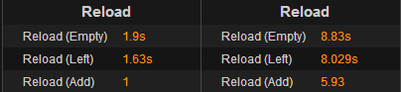

Figure 4.1: Screenshot of reload times of the ‘M9A1’ pistol (left) and the ‘Chain SAW’ light machinegun (right) from Call of Duty: Ghosts.

**Objective action**

**Definition:** Objective points in the map are usually a constant factor in the movement of players, because it gives them something to aim for (discussed in the ‘Path Target’ in section 2.2). Once a player is in the vicinity of an objective point, it can further influence their actions. For example in ‘Domination’ game modes, a player may lay prone on a capture point and stay there until it is captured. Seeing one team member doing this can further encourage other players to do the same in assistance, as was the case in the “Call of Duty: Ghosts” gameplay analysed.

**Reason for adding:** The analysis shows that objectives have a large influence on where players go in the map. For example in the analysis of the Team Fortress 2 (Valve Corporation, 2007) video, the player tended to stay near the ‘payload’ objective throughout the match, as shown in figure 4.2. This suggested that the player either wanted to get lots of kills because he knew that enemy players will most likely be in the area of the payload and/or he wanted to help his team win the match.

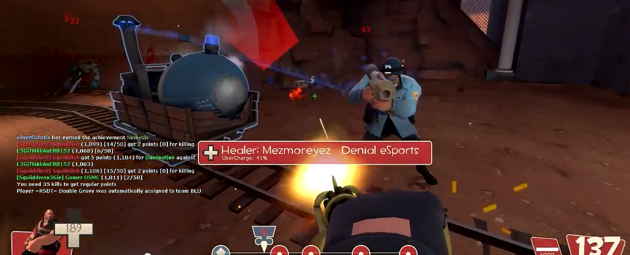

Figure 4.2: Screenshot from the Team Fortress 2 gameplay video (SquiiddishGaming, 2013) showing the player in the vicinity of the payload and engaging an enemy player.

Payload

**Killstreaks and Controlling Air Support**

**Definition:** Similar to the effect of reloading, these actions can affect a player’s movement. The ‘killstreak/pointstreak’ action is where a player reaches a certain amount of kills or points, and is rewarded with something that is beneficial to them. For example a UAV that reveals the locations of enemy players on the mini map, an air strike or other air support. In nearly all cases the higher the killstreak the more effective/destructive the reward. The killstreak pattern is very similar to the reloading action, as they are both performed very quickly. To activate a killstreak the player’s character flicks a switch or presses a button on a device that he is carrying. To reload the character simple ejects the spent magazine and inserts a new one. The ‘controlling air support’ action (CAS) however is where the player takes control of something other than their character, for example a drone, a chopper or an AC-130. Whilst this is happening the player’s character is stationary and vulnerable, easily killable by an enemy player.

**Reason for adding:** From the analysis it was apparent that when a player achieves a killstreak, it is common that they will seek cover and activate the killstreak, at the same time they will also reload their weapon, as shown in figure 4.3. As also displayed in the analysis, when a player achieves a killstreak with a controllable air support reward, he is likely to retreat to a safe position and hide there, whilst he controls the air support, as shown in figure 4.4. Both of these actions have an impact of a player’s movement, so seemed appropriate to be added to the pattern set.

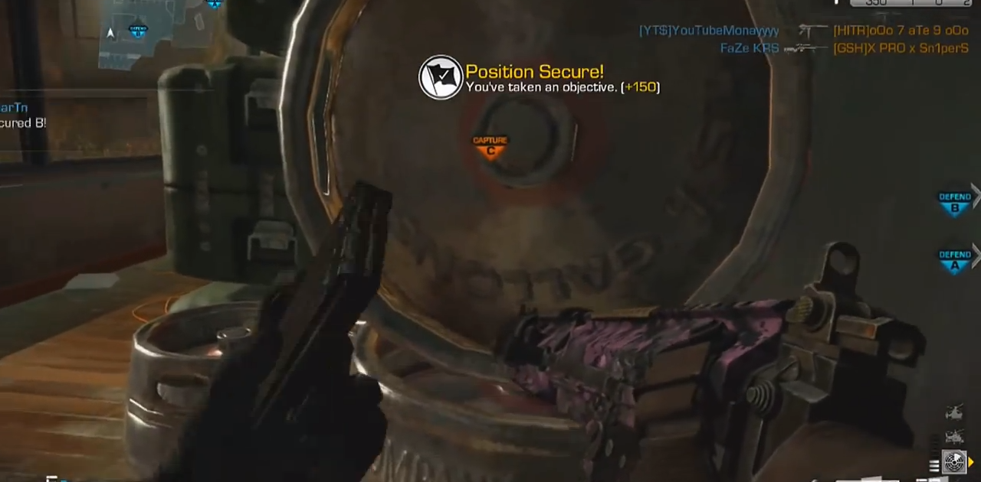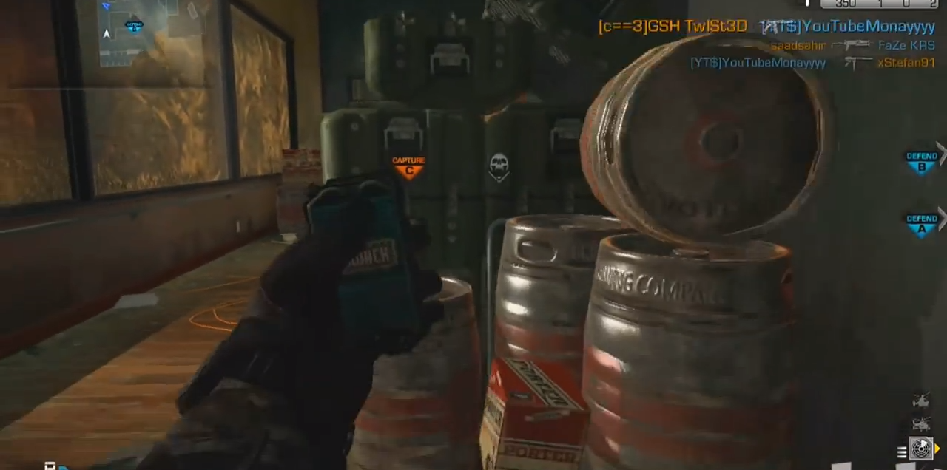

Figure 4.3: Screenshots from the Call of Duty: Ghosts gameplay video (TmarTn, 2013), showing the player activating his killstreak (left) and reloading his weapon (right) right after each other at the same position.

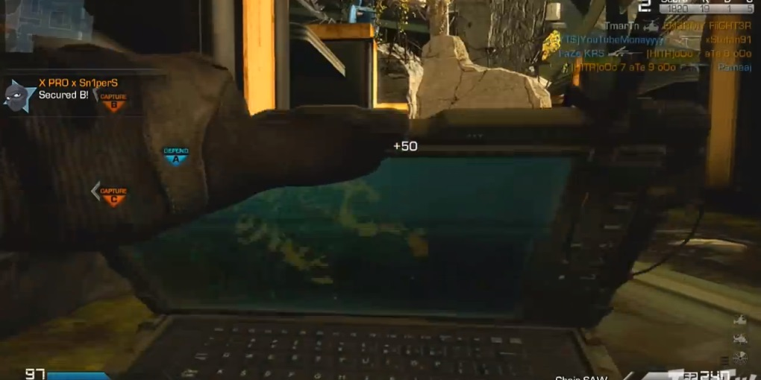

Figure 4.4: Screenshot from the Call of Duty: Ghosts gameplay video (TmarTn, 2013), showing the player activating his controllable air support, whilst prone in a hiding spot.

**Patterns removed**

**Pursue Player – movement (PPm)**

This was intended to represent the action where a player would move towards an enemy but not be tracking them with their weapon. It was initially created due to the ‘Path Target - movement’ pattern which represents the action of moving to a land mark on the map. In this situation it is not necessary for a player to track a land mark because it is very unlikely that it would be moving. However as discovered in the analysis, players are rarely stationary, so they will always need to be visually tracked to know where they are.

**4.2 Questionnaire**

**Introduction**

The following section shows the results from part 2 of the questionnaire, and discusses what can be drawn from each question. The results from the 20 questions have been broken down into 4 categories depending on what type of behaviour the question was looking for. The categories are listed below, along with the patterns associated with them.

**Objective action**

*This represents a single pattern, but was broad enough to warrant a separate category.*

**Additional actions**

Collection

Reloading

Killstreak

Controlling air support

**Player movement**

Path Movement and Resistance

Path Target – movement

Path Target – visual

Camping

**Player engagement**

Player is Vulnerable

Pursue Player

Pursue Player – visual

Pursue Player – team

**Results**

The following sections look at the results from 10 participants and evaluate each question. A copy of the questionnaire used, along with the complete raw data can be found in section 6.C. This section also features bar charts showing the results for all 10 participants for each question; providing a 1-3 word summation of what the question is asking.

**General**

The first question is used to roughly determine how often the participants play multiplayer games. As shown in figure 4.5, there was a split between the responses from the participants, five people answered 7 and five people answered either 3 or 4. This could suggest a difference in the participants interests, where some enjoy (or at least play) multiplayer games more than others. 7 or “a fair amount” was the most popular answer with the average coming to 5.2. This will hopefully give a good indication of average gamer’s behaviour.

Figure 4.5: Bar chart displaying the results from question 1.

**Player movement**

***Questions: 2,3,17,18,20***

The next 5 questions cover general player movement around a map, and include the following patterns: Path Movement and Resistance, Path Target (movement), Path Target (visual) and Camping.

Questions 2 and 3 cover player camping. At first look at figure 4.6, it seems that although the participants answered that they don’t often camp, they do still see it as a legitimate strategy. However looking at the average answer to “how often do you camp”, the result comes to 4.4 and fits into the “sometimes” category. Then looking at the average answer to “do you see it as a legitimate strategy” and seeing 7. 7 or “if the situation warrants it”, the answers make sense. The “sometimes” that the participants camp, seems to relate to the occasions where camping is warranted behaviour.

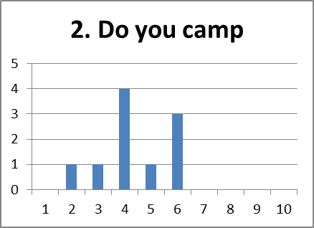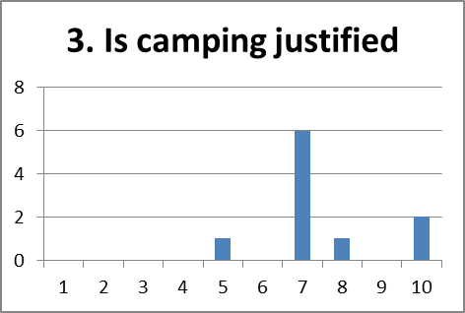

Figure 4.6: Shows bar charts of the results from question 2 and 3.

Interestingly two people answered 10 and saying it definitely is a legitimate strategy, but they answered 4 and 6 for question 2. This may show that they want to camp but feel that they shouldn’t. This could be linked to the ‘stigma’ surrounding camping (covered in section 1.2), where they feel that if they did camp other people in the game would be against it.

Questions 17 and 18 look at tactical movement and flanking. 17 looks at direct movement to map positions and 18 at the likely hood of flanking an enemy instead of facing them head on. As shown in figure 4.7 below, the results for 17 are very spread out with no definitive stand out answer and range from “quite likely” to “quite unlikely”. However when enemies are added to the situation as is the case with 18, the average answer is more distinctive as shown in figure 4.7. The averages are 5.7 and 6.7, for questions 17 and 18 respectively. The difference between the two averages is slight, but it does suggest that participants are more likely to move tactically if they are directly faced with an enemy, opposed to preparing for a possible encounter in the future.

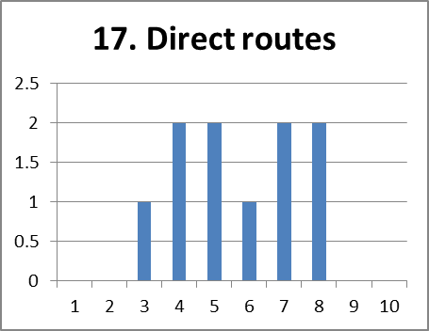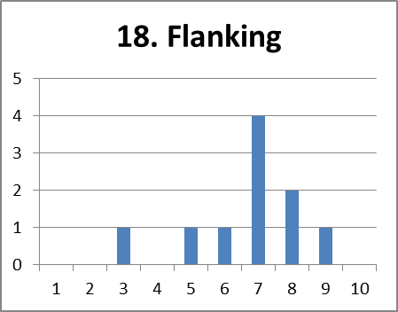

Figure 4.7: Shows bar charts of the results from question 17 and 18.

The final question in the player movement section question 20, covers movement when engaged with an enemy which differs slightly to questions 17 and 18 which look at tactical movement before the engagement. The results for this scenario show an overwhelming preference to be constantly on the move when engaging an enemy. They also present an average of 8.9, with the most popular answer being 10 or “extremely likely”.

Figure 4.8: Bar chart displaying the results from question 20.

The results for the past three questions show that the likelihood of tactical movement greatly increases as the likelihood of combat increases.

**Player engagement**

***Questions: 6,11,13,14,15***

The next 5 questions cover player combat, and include the following patterns: Player is Vulnerable, Pursue Player, Pursue Player (visual) and Pursue Player (team).

The first question in this category is question 6, which asks about the likelihood of escorting a friendly flag carrier back to base. The results in figure 4.9, show that out of the 10 participants, no one was ‘unlikely’ to escort their flag carrier. In fact with an average answer of 8.6, they are “quite likely” to. Three people even answered that they are “extremely likely” to. This shows good teamwork and that winning seems to be more important than personally doing well, either through flag captures or kills.

Figure 4.9: Bar chart displaying the results from question 6.

The next 2 questions, 11 and 13, look at an engagement scenario where one player has the upper hand over the other by targeting the other first. Question 11 looks at a situation where the participant is at a disadvantage and whether they choose to seek cover; whereas 13 looks at when the enemy player retreats because of the disadvantage and whether the participant chooses to pursue. With an average answer of exactly 5.5 for question 11, participants fit right in the middle of “minimally unlikely” and “minimally likely”. Suggesting that there is a 50/50 chance of whether they choose to continue the engagement.

The results for question 13 as shown in figure 4.10, have a more stand out result. With an average answer of 7.9, and the trend leaning to the higher end, participants are more likely to press the advantage over an enemy player. Again with two people answering that they are “extremely likely” to.

Figure 4.10: Bar charts displaying the results from questions 11 and 13.

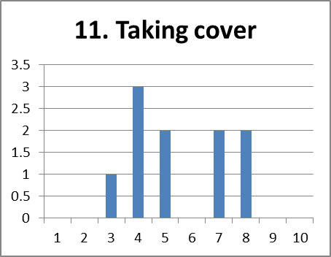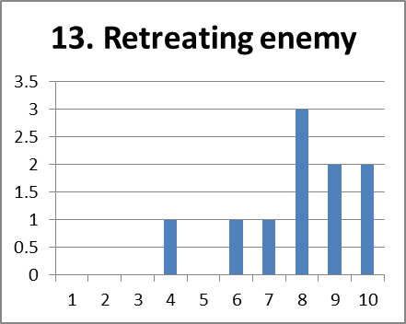

Question 14, gives an alternate course of action to the participant in the same situation in question 13. Instead of pursuing the fleeing enemy, how likely is the participant to “tag” them instead. This is known as spotting and is explained in section 1.2. The results of this question, displayed in figure 4.11 below, show a very spread out trend to the likelihood of spotting an enemy before engaging them. With an average answer of 4.8, the participants only “sometimes” tag before shooting, with the majority of people saying they do “not often” do so.

Figure 4.11: Bar chart displaying the results from question 14.

Combining the results for the past three questions overall shows a slight tendency for more aggressive behaviour when it comes to direct combat with an enemy. This seems to be the case due to participants being 50/50 when it comes to retreating, only “sometimes” spotting before shooting and being “quite likely” to carry on fighting.

The final question in the player movement category is question 15, and asks how often the participants play the “aggressive” sniper role. “Aggressive” sniping, also referred to as “quick-scoping” or “no-scoping”, is covered in section 1.2. The results for 15 (figure 4.12), show a slightly lower trend with an average answer of 4.5 or “sometimes”. Since aggressive sniping is considered a more challenging play style; as suggested in the article “Modern Warfare 3 producer defends quick-scoping, explains "more challenging" aiming” (Evans-Thirlwell, E, 2011). The three participants that answered 8 and 9 could be considered as “better” players because they have the “skill” to play this way; opposed to the people who answered lower. Alternatively it could mean that people don’t want to play in this style.

Figure 4.12: Bar chart displaying the results from question 15.

**Objective actions**

***Questions: 4,5,12,19***

The next 4 questions relate to how players act in relation to the match’s current objective e.g. the flag, capture point or assault/bomb target.

The first question, question 4 is used to give a general indication as to the participant’s behaviour with regards to the objective. As can be seen from the results, shown below in figure 4.13, the trend is completely on the mid-high end, with an average answer of 8.1 or “very likely to”. Although this will probably provide insightful answers to the following questions with regards to objective players, it may be lacking in the opinions of non-objective players or “lone wolves”. This should be taken into account when viewing the results for the following 4 questions.

Figure 4.13: Bar chart displaying the results from question 4.

Question 5 asks the participant how likely they are to mainly defend their own team’s flag in the game mode “capture the flag”. As can be seen in the results below in figure 4.14, and considering the average answer coming to 5.1; the results are very 50/50. The most common answer is 3 or “not often”, but interestingly one person answered 10 or “definitely”. Only defending the team’s flag could be considered “camping” behaviour, and unusually out of the two people who answer “definitely” to question 3 (Do you view camping as a legitimate strategy?), neither answered 10 for this question. The participant who did answer 10 for question 5, in fact answered “If the situation warrants it” for question 3. This suggests that the participant believes that always defending the team’s flag is absolutely warranted behaviour.

Figure 4.14: Bar chart displaying the results from question 5.

The next two questions, 12 and 19, look at how likely the participant is to aid a team mate capturing a domination point (question 12), and how likely they are to stay and defend one after they have captured it (question 19). More so than any other question, the results for question 12 as displayed in figure 4.15, show an extremely high trend with the average answer coming to 8.5. Comparing this to the average results of question 4 “how often do you play the objective?”; the participants are “quite likely” to do so if a team mate already is. The results for question 19 are generally lower but still overall on the higher end and at an average answer of 7.4. This again links in with camping behaviour where participants are “slightly likely” to stay and defend a capture point.

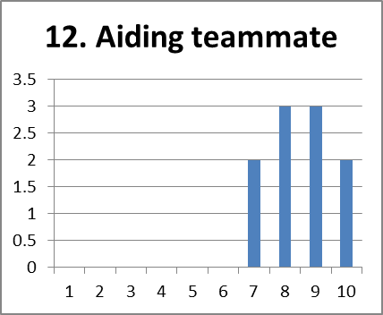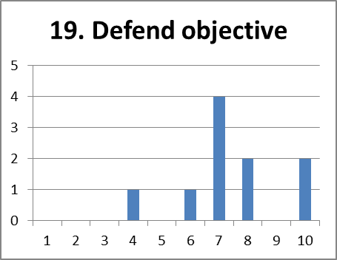

Figure 4.15: Shows bar charts of the results from question 12 and 19.

**Additional actions**

***Questions: 7,8,9,10,16***

The final 5 questions cover additional actions that are commonly performed in conjunction with other patterns and include the following: Collection, Reloading, Killstreak and Controlling Air Support.

The first 2 questions in this section relate to the killstreak/pointstreak feature that appears in games such as the Call of Duty series, Halo 4 and Battlefield 4. Question 7 asks the participant if they feel that killstreaks are beneficial to the rest of the team; and 8 asks about the likelihood that they will ‘camp’ if on a high killstreak. As shown in figure 4.16, the results for 7 are quite spread out, and with an average answer of 5.1 there seems to be mixed feelings towards the benefit of killstreaks. In general killstreaks are seen as controversial (see section 4.1) and considering the 50/50 results, it is very apparent.

The results for question 8 are even more spread out and give an average answer of 5.2, only 0.1 off of question 7. Considering the more aggressive play style of the participants (discovered in the ‘player engagement’ section) coupled with the positive attitude towards camping as a legitimate strategy (question 2). This average answer appears to make sense. Taking a further average of the two average answers from questions 2 and 3 (coming to 6.05), it is quite close to the 5.2 average of this question.

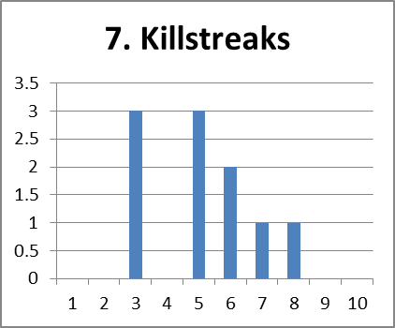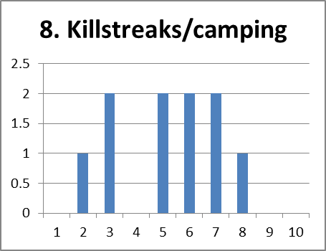

Figure 4.16: Bars charts displaying the results from questions 7 and 8.

Question 9 asks the participant how likely they are to take cover when reloading their weapon. The results (shown in figure 4.17 below) show a higher trend and give an average answer of 7.7. This is slightly contradictory to the more aggressive play style established for the participants; although it is what is expected (as outlined in section 4.1).

Figure 4.17: Bar chart displaying the results from question 9.

Question 10 covers the “collection” behaviour and how likely the participant is to rush for weapon pickups on the map, in games such as Halo and Gears of War. Figure 4.18 also shows very spread out results, giving an average answer of 5.9. The most popular answer is 7 or “if the situation warrants it”, this could be the due to the numerous factors that would play into whether a participant would rush for a pickup. Factors such as the map, the weapon, game type and where the weapon is positioned e.g. in a dangerous place (see “Player is Vulnerable” in section 2.2).

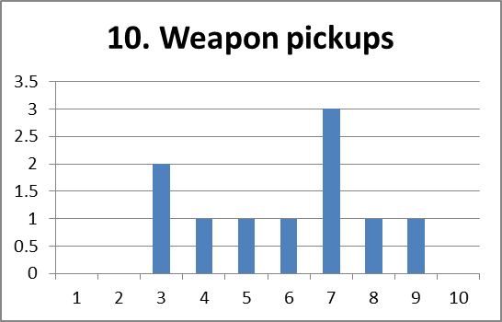

Figure 4.18: Bar chart displaying the results from question 10.

The final question to be covered is question 16, and relates to the likelihood that the participant will retreat to their base before calling in controllable air support. The results show a medium trend and with an average answer of 5.7, some people seem to be more tactical and want to be safe before they call it in, whereas others seem to want to use it straight away. The most common answer is 8 or “very likely to” and someone put 10 or “all the time”, so these could be the participant who exhibit more tactical behaviour.

Figure 4.19: Bar chart displaying the results from question 16.

**Summary**

**Summary**

The results from the questionnaire gave a brilliant insight to the behaviour of the average gamers. The results suggest how likely players are to perform actions relating to the pattern set, along with the variance of each. For example the results for questions 8 and 10 showed very varied behaviour, whereas question 12 in particular generally showed a consensus as to the ‘correct’ behaviour. The answers provided were useful in determining the effect that each pattern has on the player, via the behaviour that is exhibited.

**4.3 Play Testing**

**Introduction**

This section presents an iterative process of the development of the ‘Testing Level’ (outlined in sections 3.8 and 3.9) and gives a description of the changes that it went through due to the results from the six LAN sessions. It will explain the area of improvement that was addressed, what changes were made and followed with the results and the participant’s initial and resulting comments. The comments were gathered at the end of each play session and were collected using ‘Part 1’ of the questionnaire; where participants could express their opinions on the good and bad points of the level, along with any suggested improvements. A total of 6 sessions were run but only four sets of changes were made; this was due to one LAN running the day after another, which prevented any improvements due to limited time. The other instance was due to an insufficiency of participants to warrant changes to the level.

**Iteration 1 improvements**

**Outer wall**

Comment: “*On the corners without towers, move in the walls so there’s not a load of empty space*.”

Changes: The outer walls on both corners were pulled in to become flush with the base and the walkway. This removes the empty space and makes these sections more streamlined.

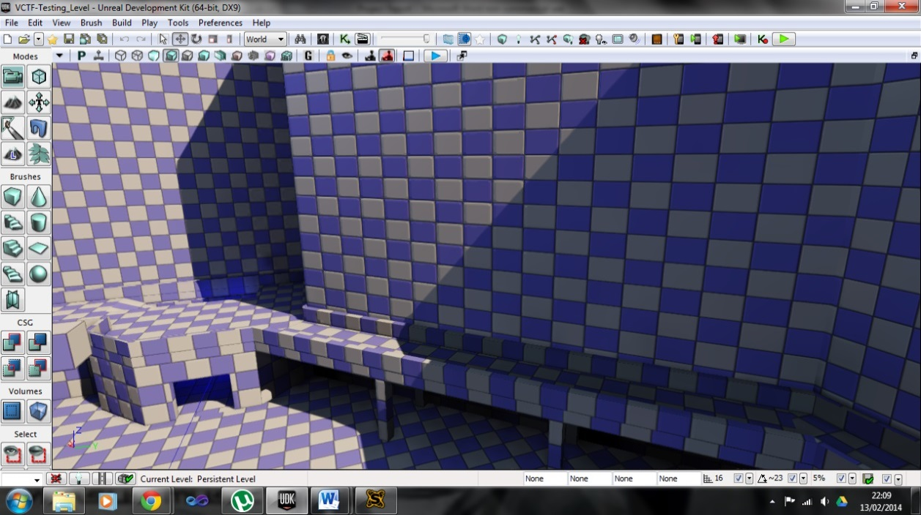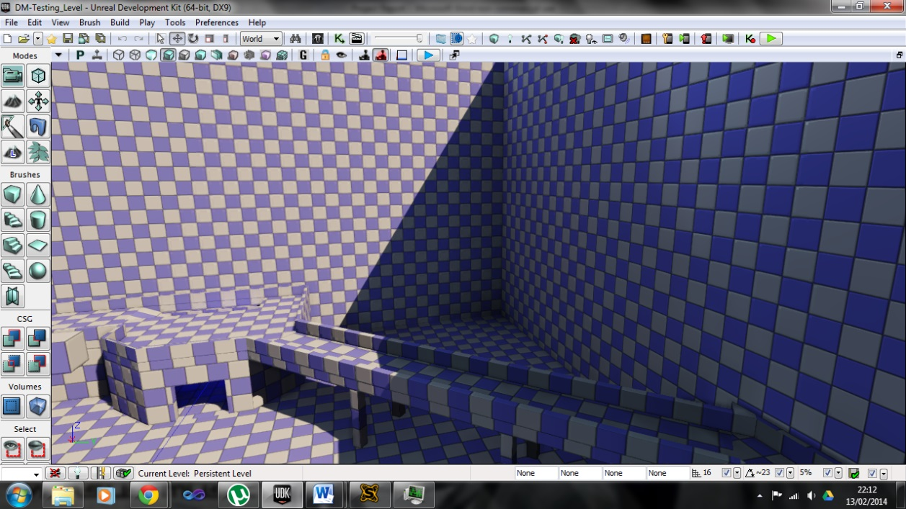

Before

After

Figure 4.20: Screenshots showing the before and after of the changes made to the outer wall.

**Spider (middle structure)**

Comment: “*Block off the top of the structure in the middle so you can’t get up there*.”

Changes: An invisible blocking volume was placed on top of the middle structure which is referred to as “The Spider”.

Result: This prevented players from reaching the top of the Spider and having an advantage over other players.

**Spider (middle structure)**

Comment: “*The two side walls in the middle structure can be walked through*.”

Changes: The walls were replaced and now prevent players from clipping through.

Result: This prevents players from either accidentally or on purpose, walking through the walls.

**Game type**

Comment: “*Sometimes spawn on the wrong side of the map, for example I’m one red team but I spawn on blue team’s side*.”

Changes: Because the Team Deathmatch game type in Unreal Tournament doesn’t support team spawning (i.e. players spawn irrespective of their affiliation). To solve this problem the game type used was changed to ‘Capture the Flag’.

Result: This meant that players would spawn at their appropriate bases. It also made the gameplay more interesting since the participants had an objective to aim for, other than to simply kill other players

**Tower walls**

Comment: “*When I go up the tower ramps I sometimes fall off the top, maybe extend the low wall so that doesn’t happen.”*

Changes: A low wall was placed around the top of the tower.

Result: This prevented players from falling off of the top and also made it look neater.

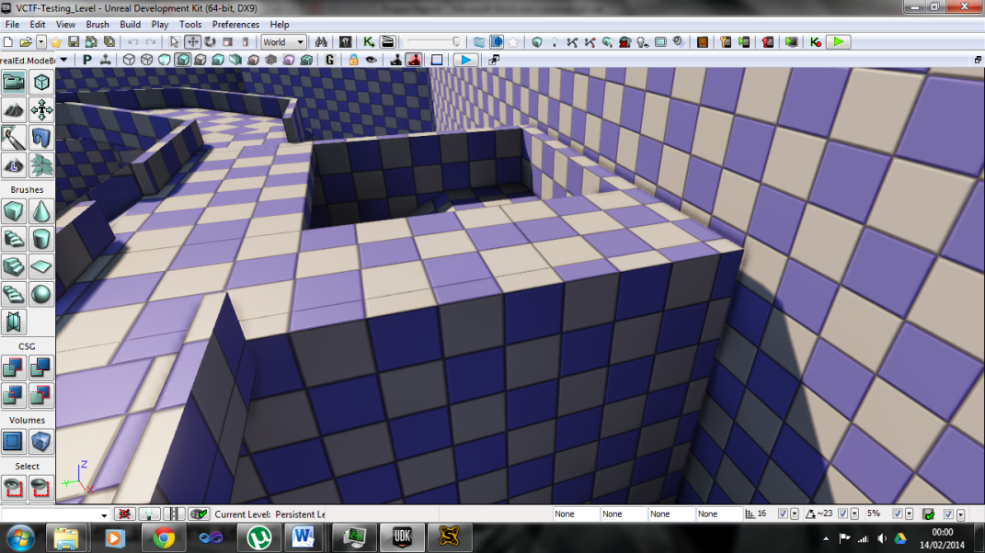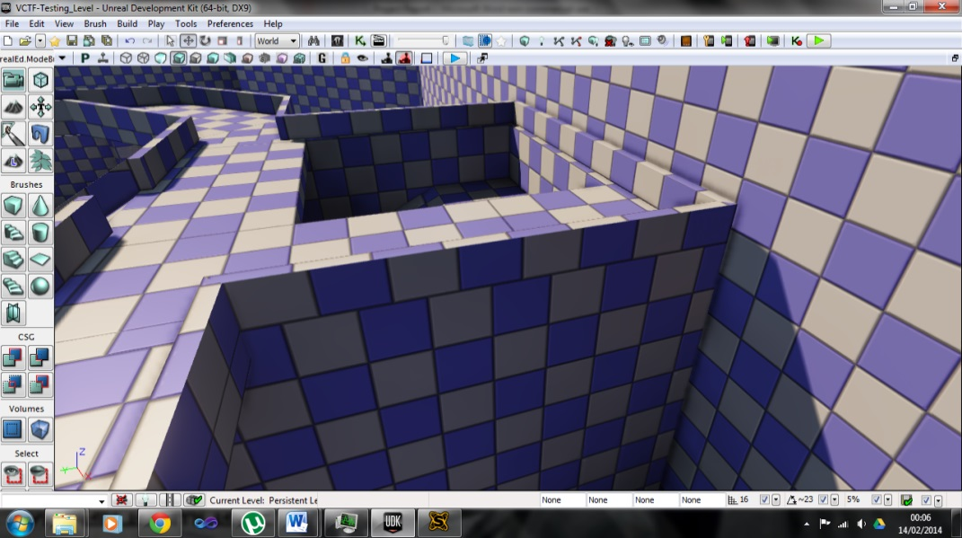

Before

After

Figure 4.21: Screenshots showing the before and after of the changes made to the tower’s upper walls.

**Iteration 2 improvements**

**Team base identification**

Comment: *“Sometimes you get lost knowing which base is which.”*

Changes: Several team identifying features were added to each base, these included:

* An extra chequered material in white and in each team’s colour, was added to each base.
* A red/blue stripe was added along the top of each base and along each walkway.
* Extra flags were added to each side of the base’s barriers, along with two large ones on the walls above each base.

Result: These changes allowed the participants to more easily identify what team they are on when they spawn, as well as which team each base belongs to.

Comments on changes:

* *“It is a lot easier to tell which part of the level you are in now.”*
* *“Colours now give us the associated team.”*

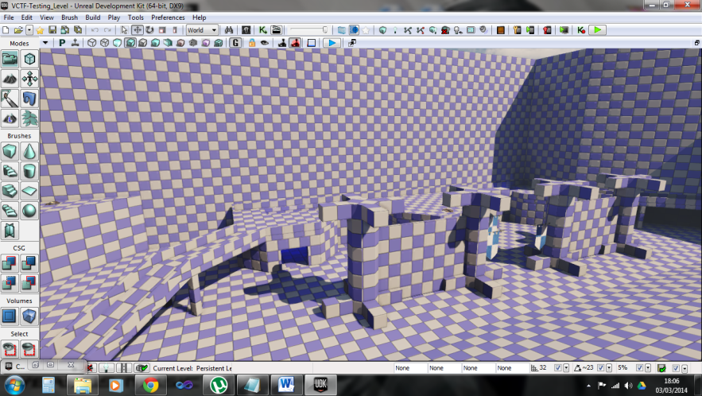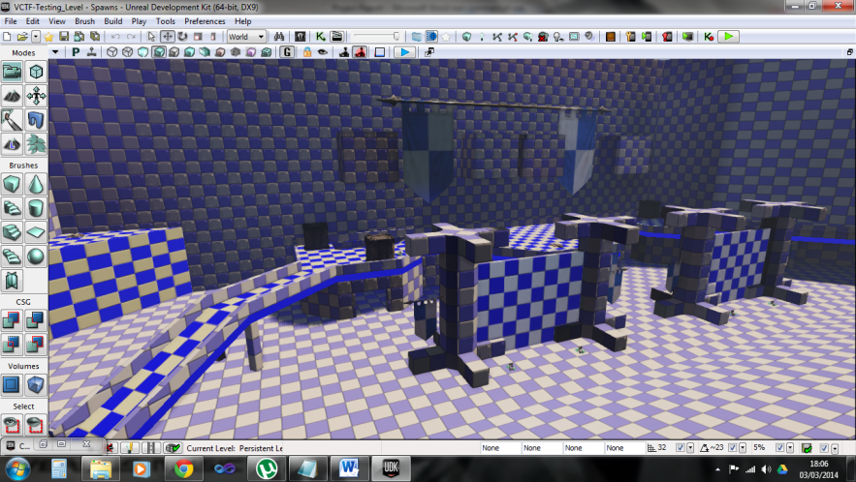

Blue Base - After

Blue Base - Before

Figure 4.22: Screenshots showing the before and after of the identification changes made to blue team’s base.

**Spawns**

Comments:

* *“Close off spawn to prevent potential camping.”*
* *“The spawn points could be altered slightly to make it harder for the other team to spawn kill.”*
* *“Change spawn camping by adding area only accessible by one team.”*
* *“The spawns are very open to spawn camping at times – though this is difficult to avoid.”*
* *“Spawn points very close to flag capture.”*

Changes: An extra room set in the wall above each base was added to the level, which allowed players to spawn safely. Closed off shoots were added to this new spawning room, which allowed players to drop down onto their base and prevent enemy players from getting into the spawn area. To give spawning players a further advantage over potential spawn campers, a 50% armour pickup was placed on lip of each shoot.

Result: Although one person disliked the changes made to the spawning, overall they were well received. The new design allowed players to spawn in the safety of an elevated and enclosed room, preventing spawn killing. If enemy players are camping on top of the base waiting for the other team to drop down, then the 50% armour pickups are available to the spawning team.

Comments on changes:

* *“The spawns are pretty cool now. I actually like the way you drop onto the flag area, it helps with defence.”*
* *“Drop down is an improvement.”*
* *“New spawns get rid of spawn kills.”*

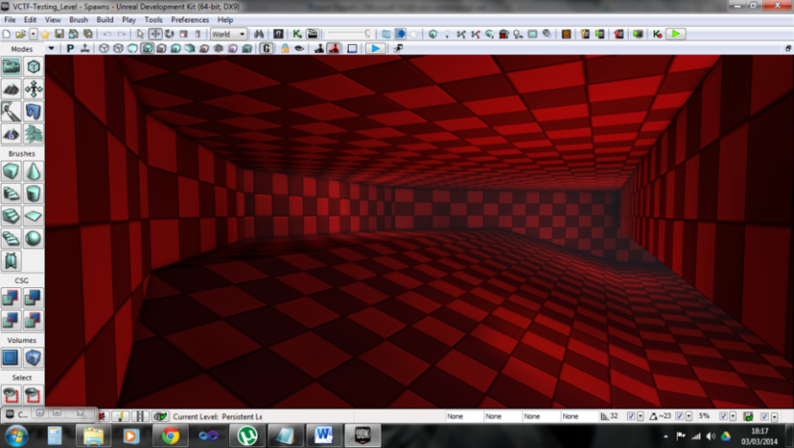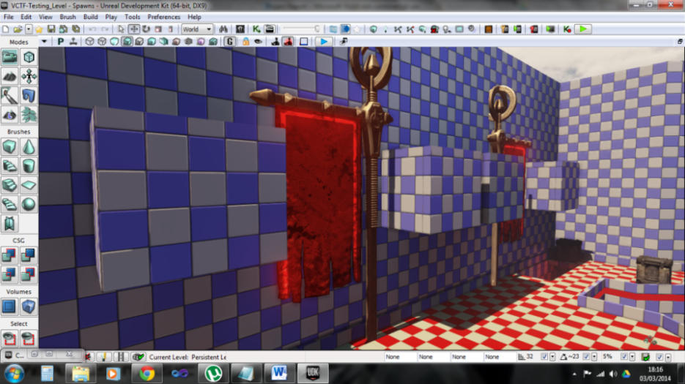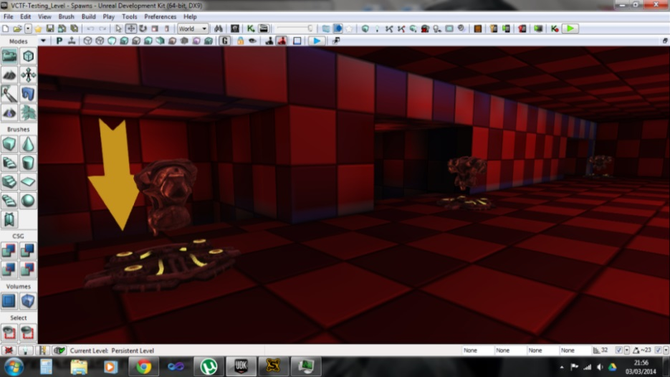

Figure 4.23: Screenshots of Red team’s new spawning area.

**Cover and detail**

Comments:

* *“Additional cover for crouching players.”*
* *“More decoration in the form of textures, but also with small objects that the player could use as cover when under attack.”*

Changes: several large crates were added to the top of the bases and along the edges of the hill.

Results: These crates gave the participants extra cover when in combat.

Comments on changes:

* + *“Cover points in open areas helped.”*
  + *“Enjoyed more cover.”*

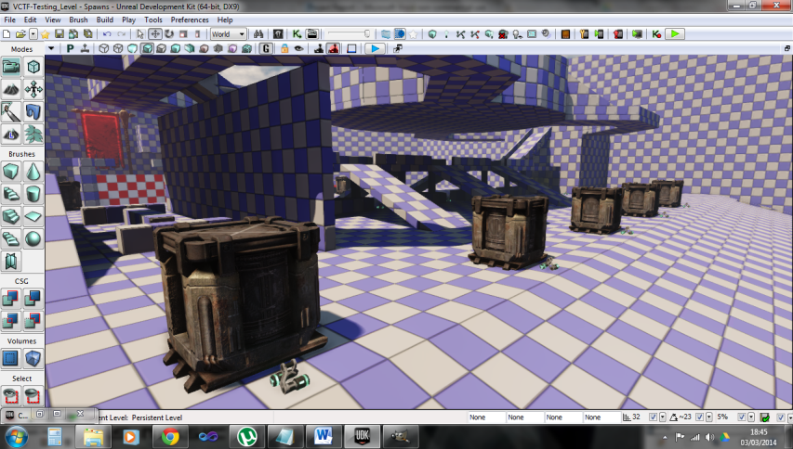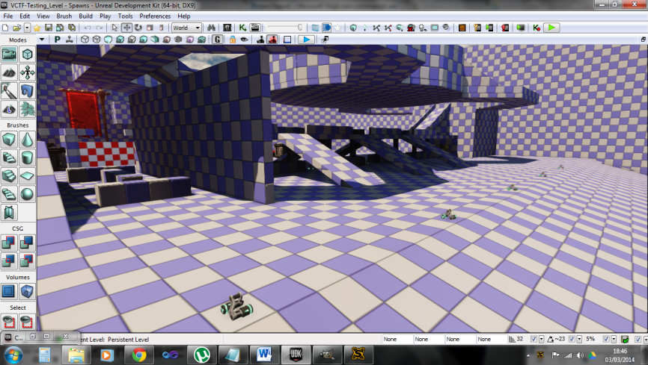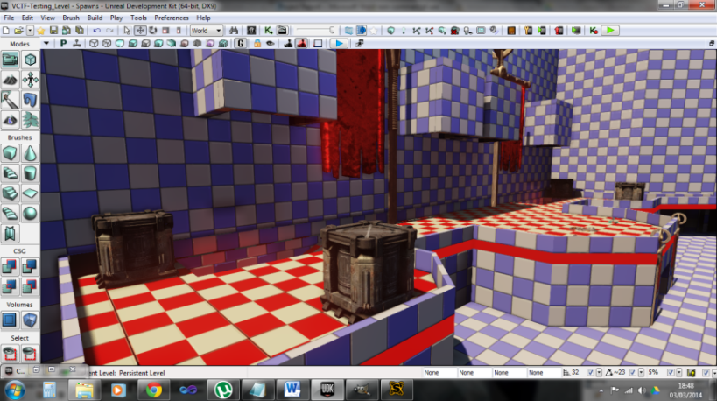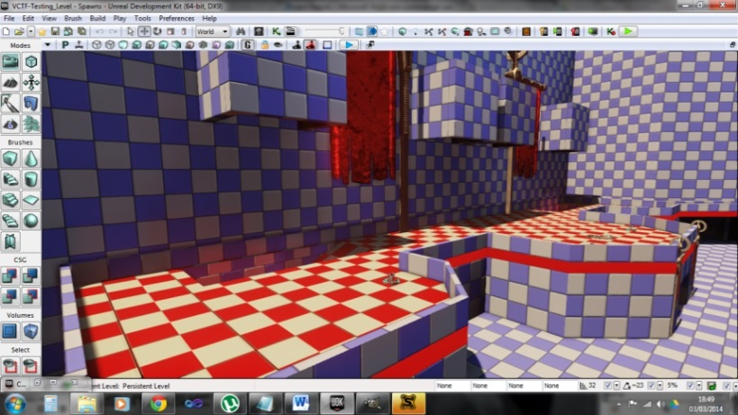

After

Before

After

Before

Figure 4.24: Screenshots showing the before and after of the cover and detail changes made to the level.

**Health and Ammo**

Comments:

* *“There was a lack of ammo around the level.”*
* *“More weapons and more ammo distributed at the entrance of the bases”*
* *“There is very little ammunition on the base of the level.”*

Changes: Many extra ammo and health pickups were added throughout the level.

Results: This prevented players from being in an engagement with no ammunition. The health pickups also allowed players to regain their health after each engagement so they are not at a disadvantage for the next one.

Comments on changes:

* *“Useful to have health when taking the flag.”*
* *“The extra ammo was good, meant I didn’t run out.”*

**Lighting**

Comments:

* “*One of the bases was darker than the other.”*
* *“Lightning currently favours one side [one side is bright, other is dark]”*
* *“Add more lighting with team colours”*
* *“The lighting is very dark in the red spawn area. Perhaps add some extra lighting to the red spawn area.”*

Changes: Extra team coloured lights were added to the bases and were made brighter. The main directional light (the sun) was rotated so it now directs onto the level at a 90 degree angle along its length.

Results: The extra lights and increased brightness in the bases makes it easier to see as well as know which team the bases belong to. The repositioned sun means that half of each base is in shadow and the other halves are lit, making it even.

Comments on changes:

* *“Brightness allowed easier player identification.”*

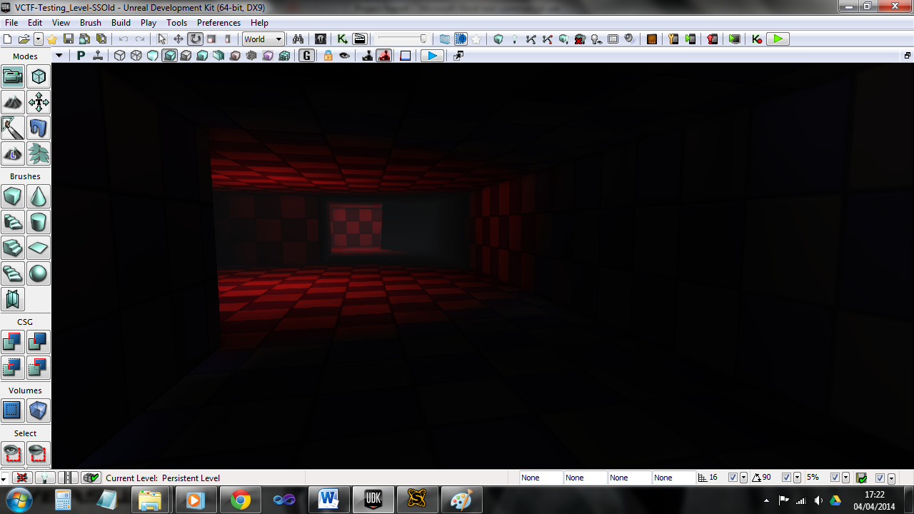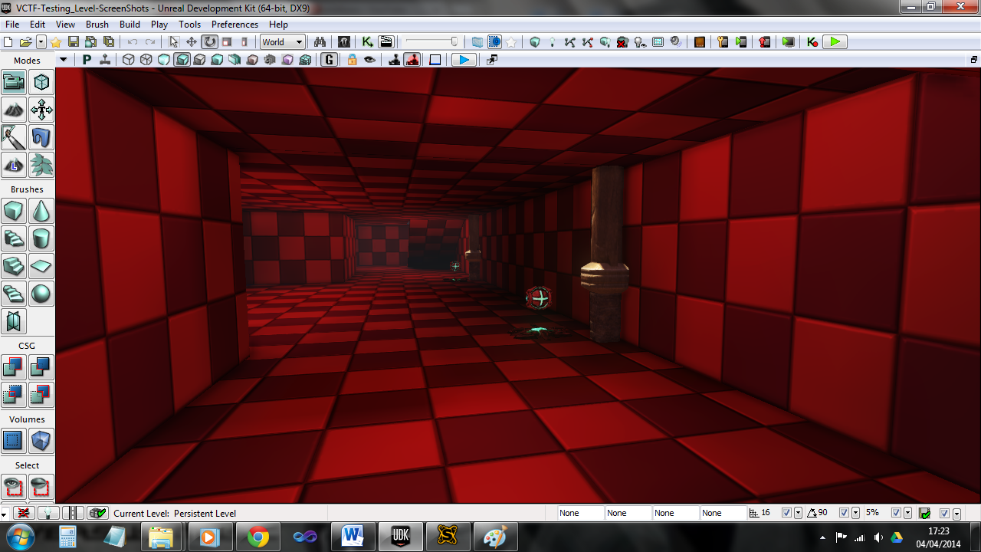

Before

After

Figure 4.25: Screenshots showing the before and after of the lighting changes made to red base.

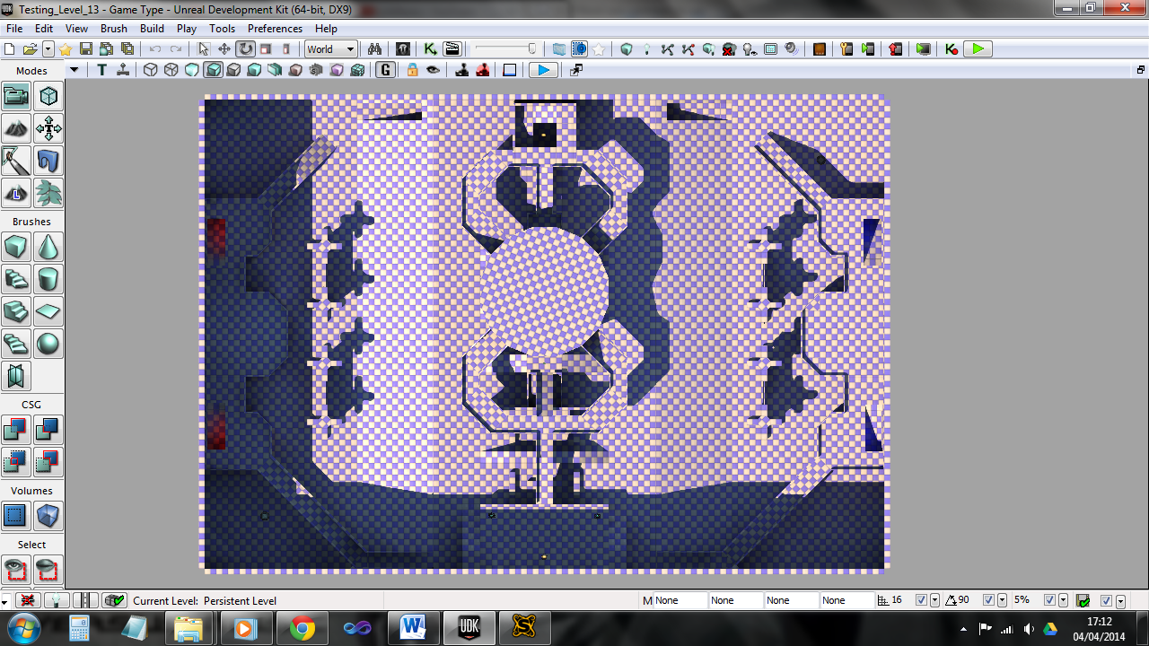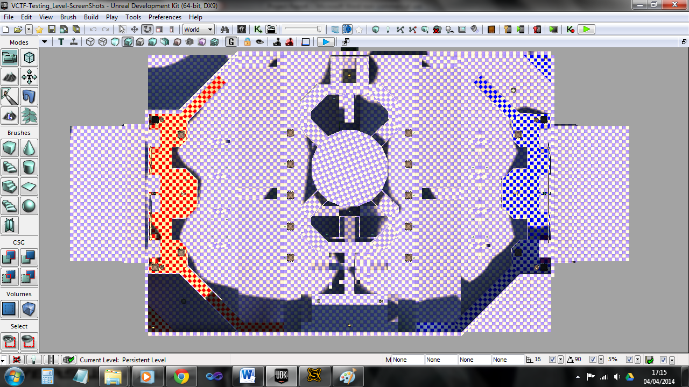

Before

After

Blocked off areas

Sun direction

Sun direction

Figure 4.26: Screenshots showing the before and after of the changes made to the main directional light (sun).

**Iteration 3 improvements**

**Weapons – Rocket launcher (middle)**

Comments:

* *“Spread out weapons more, very clustered to the upper platforms.”*
* *“Add more rockets, they are fun to play with.”*

Changes: An extra rocket launcher was added to the map and positioned on the bridge in the middle.

Results: This allowed for easier access to a rocket launcher and also gave something for each team to race for when the match began. However because of this easier to reach rocket launcher, players were less likely to go up to the ‘Spider’.

Comments on changes:

* “*Rocket spawn points are better*.”
* *“Extra rocket launcher on mid bridge is good.”*

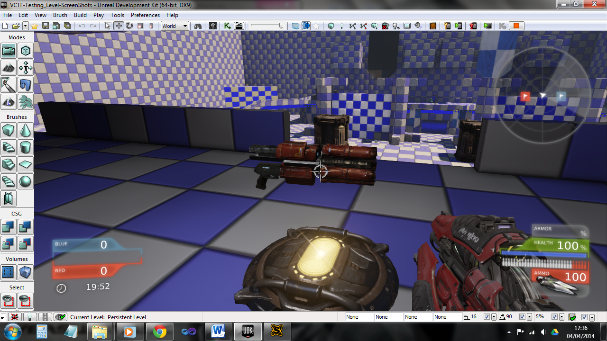

Figure 4.27: Screenshot showing the spawn location for the new rocket launcher.

**Iteration 4 improvements**

**Underground Section**

Comments:

* “*Perhaps an underground bit in the middle giving another route for flag bearers to hide.*”
* “*Would be nice if the centre point had more focus*.”

Changes: An underground section was added to the middle of the map, under the bridge. It has four ways in, two on the sides of each base and two in the tunnels. Extra ammo and a ‘Berserker’ power up were placed here as well.

Result: This provided extra routes for players to take, along with varied combat because it encouraged close quarters combat.

Comments on changes:

* *“An interesting alternative route.”*
* *“This section allowed me to plot methods to hide from my opponents.”*
* *“More options with regards to where to move.*
* *“Good for cover and forces close-quarters combat.”*
* *“The underground section adds a third layer to the level, and a lot of additional paths.”*

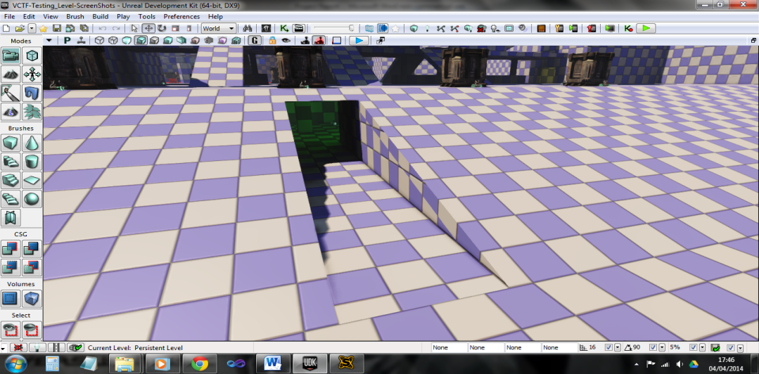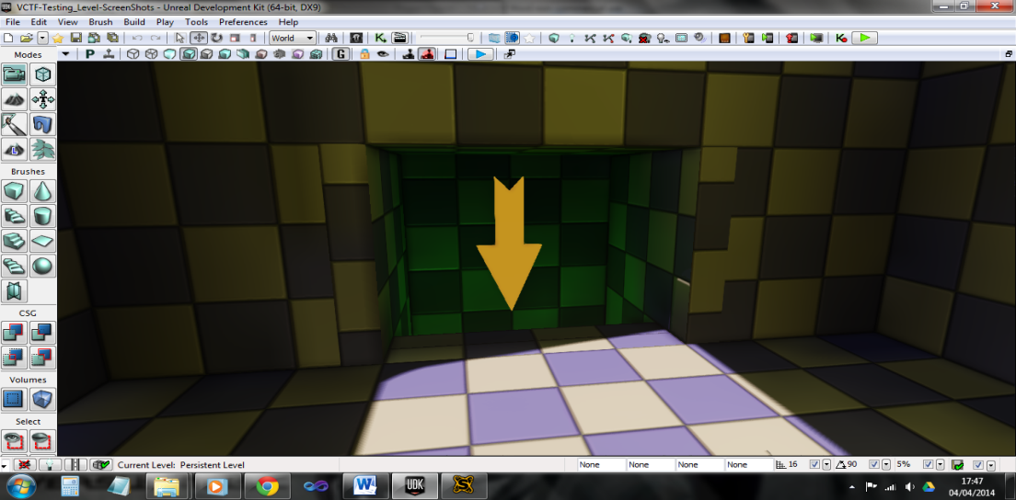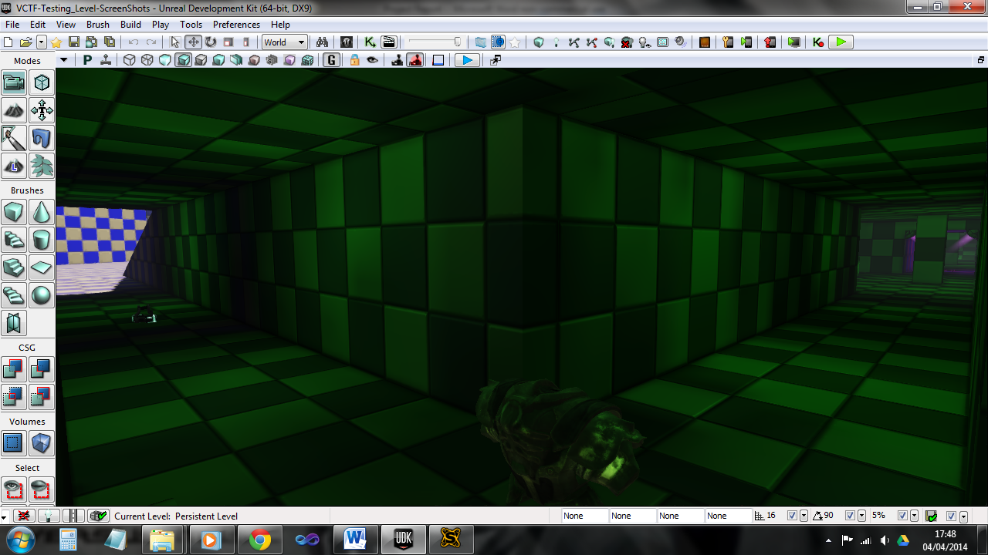

Figure 4.28: Screenshots showing some of the entrances to the underground section. The entrances in front of the team bases (top left), the drop down shoot in the tower (top right), and the T junction in the tunnel under the tower (bottom).

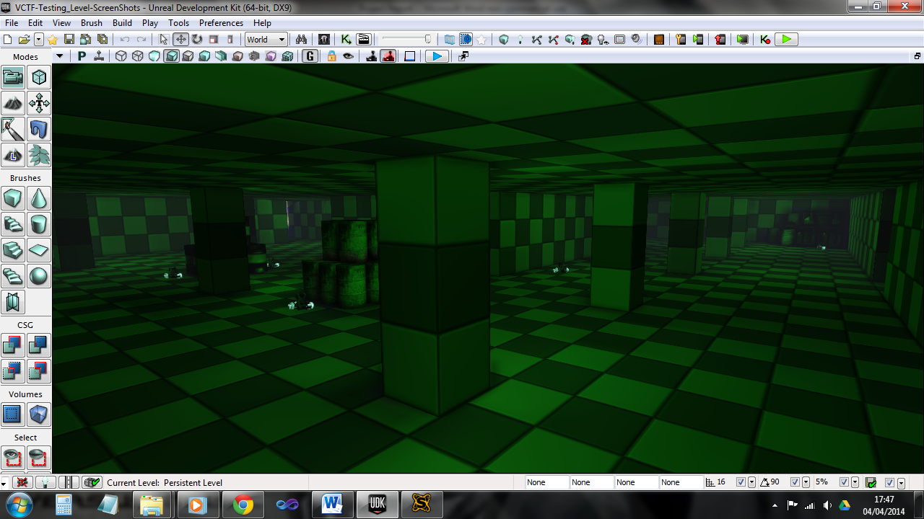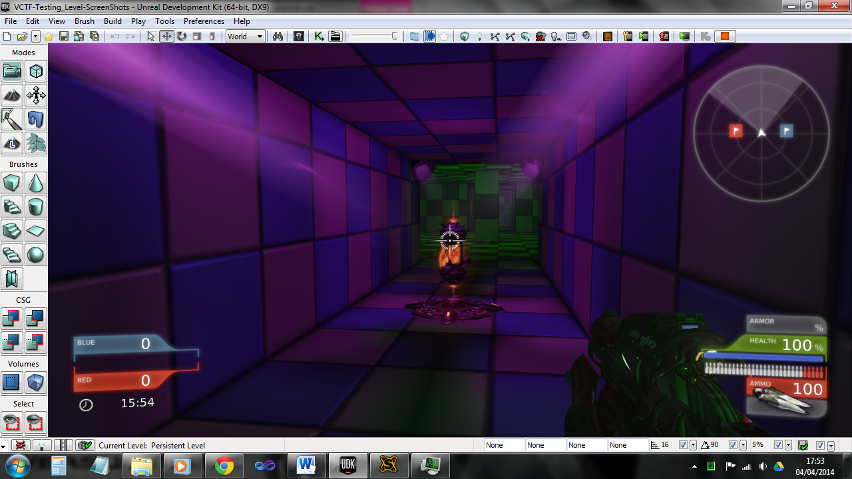

Figure 4.29: Screenshots showing the underground section (top) and the ‘Berserker’ pickup in the centre of the underground (left).

**Summary**

The two screenshots in figure 4.30 show the initial and final design of the ‘Testing Level’. Apart from the underground section, the structure of the level has remained mostly the same. The changes made during the play testing period, mostly took the form of aesthetics or small gameplay enhancements (such as additional ammo and weapons). Apart from the underground section the largest change was the spawning rooms above each team’s bases. These rooms allowed players to spawn safely (preventing spawn camping) and allowed them to choose which side of their base that they wanted to enter the level. The largest aesthetic changes were the alterations made to each base, in the form of team colours and props. The team coloured chequered materials and solid stripes turned out to be very effective additions to the level. They allowed players to easily know which base was theirs and where they should be heading. This was especially important after spending time in either the ‘Spider’ or the underground section, because it was easy to get turned around in these areas.

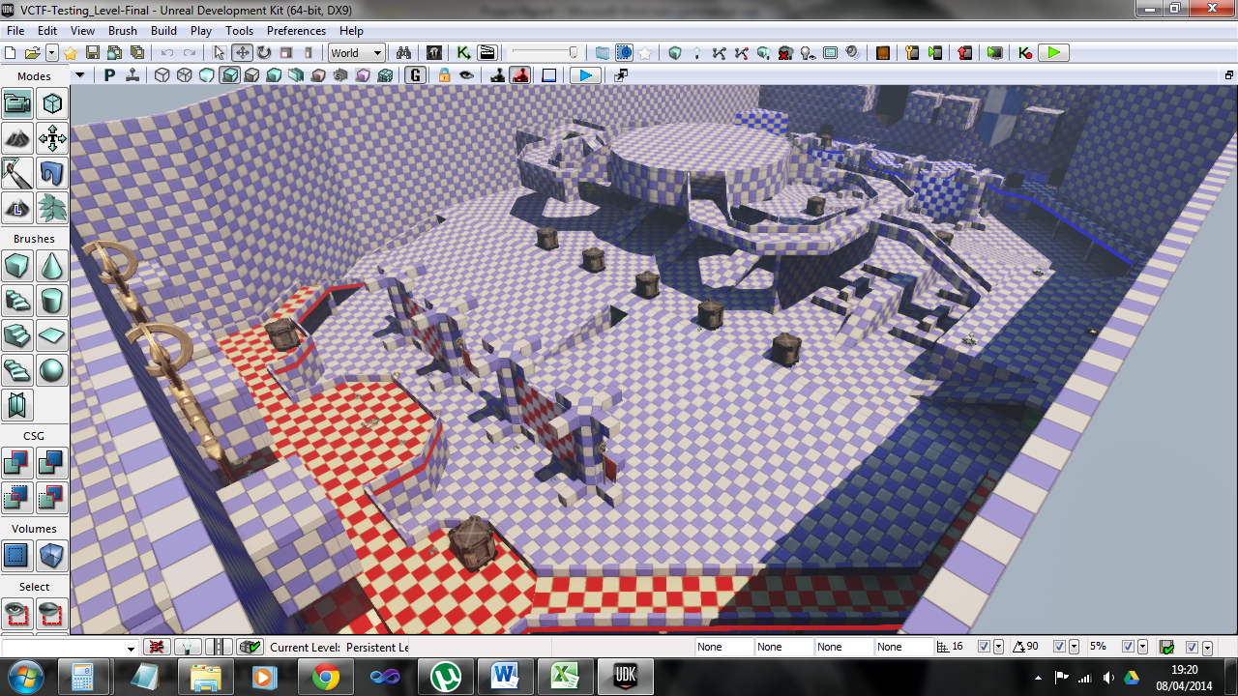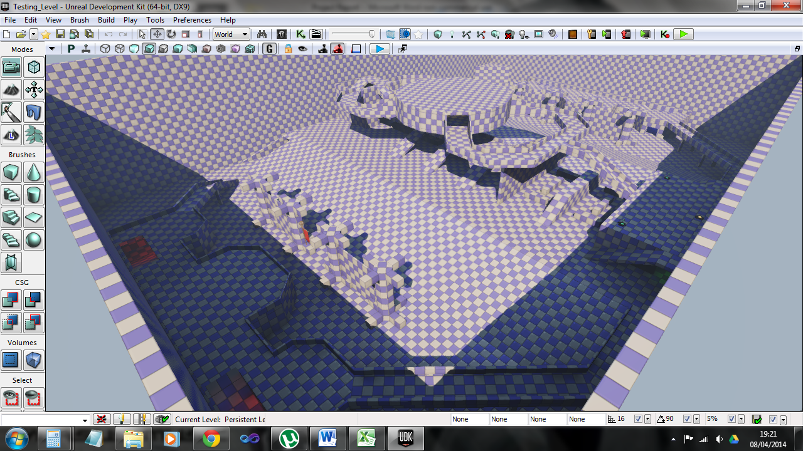

**Initial**

**Final**

Figure 4.30: Screenshots of the ‘Testing Level’ showing the initial design (top) and the final design (bottom).

**Chapter summary**

This section outlined the evaluation of the results from the visual identification, questionnaires and the play testing. The visual identification process was very effective at developing the initial pattern set; outlining the changes, additions and removals. The analysis of the questionnaire results displayed the behaviour gamers elicit with regards to each pattern in the set; showing both similar thinking as well as very varied behaviour. The play testing provided a large amount of gameplay footage, of which six 8 to 9 minute clips were used in the visual analysis. It also greatly aided in the development of the ‘Testing Level’, highlighting both areas of improvement and effective level design. All of this allowed for a final complete pattern set to be developed and presented in the following chapter.

**Chapter 5**

**Conclusion**

**Chapter introduction**

This chapter comprises of two sections; the first is the final set of player movement patterns based around multiplayer games, presented in a ‘score card’ style. The second is a conclusion of the entire dissertation; illustrating a brief overview, an account of the processes and research used in the development of the pattern set, and possible further work in this area.

**5.1 Final Pattern Set**

**Introduction**

The following is a list of the finalised pattern set, along with details on each pattern. They are displayed in a ‘score card’ style based on the style that was proposed in the book by Björk and Holopainen (*op cit*). Each pattern is written irrespective to the others, which means some bits might be repeated. It was also done this way in the book, and it means that someone can read and understand each pattern without having to ready any others.

**Path Movement and Resistance**

*A path movement goal that encourages players to move in a certain way, any obstruction to this movement goal is resistance that the player must overcome.*

This relates to moving towards an objective, a more advantageous position or fleeing an engagement. Obstacles that interfere with this cause resistance and could take the form of buildings, walls, rivers or enemy players.

**Using the pattern:** When applying this pattern a designer must ensure that it is interesting for a player to navigate; but not overly cluttered so that it causes frustration. The next point is the obstacles chosen should fit in with the theme of the level.

**Consequences:** Player frustration is the main consequence of this pattern, for example if a player dies because they got stuck on a box, the player would see it as unfair.

**Relations:**

* Path Target – Movement: A player will very likely be moving between path targets as they encounter resistance.

**Path Target - movement**

*Areas or objects in the map that stand out for players and that can be used to guide their movement.*

This pattern relates to pieces of architecture (both natural and manmade) in the level that are unique and easily recognisable. These areas are used to orient the player in the 3D environment, and enable them to create paths between them, creating a sort of network. These objects can take the form of, towers, power plants, hills, bunkers hills, large rocks, rivers, waterfalls etc. Anything that stands out from the rest of the architecture in the level.

**Using the pattern:** When applying the pattern, the designer first needs to decide on the objects that they want to use in the level (ensuring that they are not the same as any other objects already in the level), then he/she needs to determine the optimal places for them to be positioned. The objects need to be placed where they can be seen by a large portion of the map (especially from other path targets). The same object can be used multiple times, but it has to be intended as a ‘path target’ (e.g. duplicated base, one for each team). A good example is the map “Creek” featured in Call of Duty 4: Modern Warfare, which uses 4 main objects: a waterfall, large house, barn and a central hill.

**Consequences:** The main consequence of implementing this pattern is that players may tend to stick to the routes between the path targets. This would mean that portions of the map won’t be used as much since they aren’t on the main routes.

**Relations:**

* Path Target – visual: Both derivatives of the ‘Path Target’ pattern.
* Path Movement and Resistance: Players are likely to encounter resistance when moving between path targets.

**Path Target - visual**

*Areas or objects in the map that stand out for players and that can be used to draw their attention through the use of a view finder e.g. a gun sight.*

This pattern relates to pieces of architecture (both natural and manmade) in the level that are unique and easily recognisable. These areas are used by the player to aim at using their weapon. They are usually places that the player expects enemies to be positioned or to be coming from (e.g. enemy base, mouth of a tunnel, a bridge, lift doors etc.) A good example is the map “Siege of Shanghai” featured in Battlefield 4.

**Using the pattern:** When applying the pattern, the designer first needs to decide on the objects that they want to use in the level (ensuring that they are not the same as any other objects already in the level), then they need to determine the optimal place for it to be positioned. The object needs to be placed where it can be seen by a large portion of the map (especially from other path targets), which will allow players to use for visual targeting. The same object can be used multiple times, but is has to be intended as a ‘path target’ (e.g. duplicated base, one for each team).

**Consequences:** The main consequence of implementing this pattern is that players may tend to stay in specific areas and aim at the path targets. This may happen since players will have a good indication as to where the enemy will be positioned or approaching from.

**Relations:**

* Path Target – movement: Both derivatives of the ‘Path Target’ pattern.
* Camping: Players may tend to remain in certain areas.

**Collection**

*Refers to the act of players exploring the map in search of collectables, such as health, armour, weapons, ammunition and objective items.*

This pattern relates to any collectable that is present in the level and the desire of players to seek out and retrieve these items. The items can take the one of three forms, objective, useful and miscellaneous. Objective relates to items that are required to progress or to earn points. Useful relates to items that make the player stronger. Miscellaneous relates to items that can add to the players experience but aren’t necessary to the gameplay. A good example of all three is the game Doom 3 (id software, 2004). It has PDAs and codes to open doors, ‘buff’ items such as health packs and armour shards, and additional PDAs and data disks holding message logs and informational videos.

**Using the pattern:** The items used in this pattern would depend on: the theme of the level, its layout and the game types that would be played on it. For example a sniper rifle wouldn’t be very useful in small rooms, just as a shotgun wouldn’t be useful in a field.

**Consequences:** Placing too many items in the level could mean that players spend a lot of time collecting them and not playing the game or become very powerful. Although encouraging players to explore and learn the map is beneficial.

**Relations:**

* Objective Action: Collecting objective items.
* Reloading: Ammunition used for reloading.
* Player is Vulnerable: Health and armour to decrease vulnerability.

**Reloading**

*Refers to the players altering their current movement to allow them to safely reload their weapon.*

When a player reloads their weapon they may choose to move to cover, retreat or simply stop advancing. This disrupts the movement goal of the player due to the vulnerability created while in a reload animation.

**Using the pattern:** A level’s architecture could affect this pattern by providing ample cover in areas where players are likely to engage each other; allowing safe reloading following a fight.

**Consequences:** If too much or too little cover is provided for the player, then it can cause frustration. For example if it is too easy for a player to be safe whilst reloading then the enemy player won’t get the benefit from either a larger magazine or more efficient use of ammo; the same can be said for the reverse. Both instances make it unfair for the particular player.

**Relations:**

* Player is Vulnerable: A player is vulnerable when they are reloading.
* Collection: A player will seek out ammo to allow them to reload or a new weapon as a replacement.
* Pursue Player: Player will need to reload after an engagement
* Killstreak: Likely that a player would also activate a killstreak when reloading.

**Objective Action**

*Requirements of the player to perform certain actions in order to achieve an objective.*

The actions are mostly dictated by the game type that is being played, and can be used to guide player movement through the level. For example in the game type “Crazy King” (featured in Halo 3), players are required to control ‘the hill’ in order to earn points. After a certain amount of time the hill will move to another area of the map; encouraging players to move around the map.

**Using the pattern:** In terms of the level’s architecture the designer needs to decide where the objectives will be positioned, and consider how players can get there and how vulnerable they are when performing the objective action.

**Consequences:** If the area around an objective is too easy to defend by the enemy team, players may find it difficult to perform the objective action without being killed. Alternatively if the area is too difficult to defend then, it may become a focal point of the map due to players continually capturing and re-capturing the objective.

**Relations:**

* Path Target – movement: The objective point would become a path target.
* Collection: The objective might be a collectable.
* Player is Vulnerable: A player performing an objective action might be vulnerable.
* Pursue Player – team: A player may want to escort their friendly flag carrier back to base.

**Player is Vulnerable**

*Anytime that the player is susceptible to injury, caused by enemy players or from environmental hazards.*

Player vulnerability can be a large factor as to how a player moves around the level; it can encourage players to move slowly and cautiously, sticking to cover in order to decrease their vulnerability.

**Using the pattern:** The designer must account for the level’s architecture which can greatly affect player vulnerability, by how open or restricted the player’s movement is; for example a tunnel provides little cover and high vulnerability from snipers.

**Consequences:** The design of a level needs to be balanced so that all areas of the map have some degree of vulnerability. Obviously an open area would have higher vulnerability than a building, but the building should still have a weakness, otherwise the player(s) in the building would have an unfair advantage.

**Relations:**

* Player is Vulnerable relates to most patterns since it is nearly always possible for players to be vulnerable.

**Camping**

*Strategically advantageous areas of the level that a player chooses to remain for a prolonged period of time.*

Camping can be very useful in objective based game modes where the player can camp at the objective and defend it whilst the rest of the team go on the offensive.

**Using the pattern:** Designing a level with camping points can be great for gameplay, since it allows for various play styles and abilities. However these points need to be balanced properly so they are not too powerful. A good example of balanced camping is the map ‘Yemen’ featured in Call of Duty: Black Ops 2, where no camping spot is overly powerful.

**Consequences:** Designing a level that is too easy for players to camp, may cause the ‘flow’ of the level to slow down as many players will simply stay in the same area. This can cause frustration for the other players on the team, as the camper may not be helping to achieve the objective.

**Relations:**

* Pursue Player – visual: Little movement, mainly tracking the enemy.
* Killstreak and Control Air Support: Players are likely to camp in order to achieve these.

**Pursue Player**

*Player engagement through either direct combat or through chasing behaviour.*

This pattern is a key influencer to a player’s movement, with three main instances to player engagements: first being a standard fire fight between two players, they may be standing still or moving but they are both attempting to kill each other. The second is where a player is pursuing a retreating enemy, and the third is the reverse.

**Using the pattern:** When considering this pattern the designer must decide on the desired pace of the level, for example if a high paced level is desired then player engagements should be encouraged constantly. Alternatively if a slow paced level is desired then a lower number of engagements will be required.

**Consequences:** This pattern can be considered the main determining factor to the ‘feel’ of the level, due to how much influence it has on the level’s gameplay.

**Relations:**

* Reloading: Always performed after an engagement (if the player survives).
* Objective Action: Usually cause direct conflict.
* Path Movement and Resistance: Players can act as resistance.

**Pursue Player - visual**

*Player engagement through visual acquisition of enemy players.*

This relates to a player using their weapon to track and engage enemy players whilst remaining still.

**Using the pattern:** Every area of the map that allows players to have a wide field of view, will allow this pattern to be performed. It is up to the designer as to the size of the player’s view that is provided. Vulnerability also needs to be considered whilst performing this action, since if the player can see a large portion of the map, then potentially many enemies could also see the player.

**Consequences:** A fine balanced needs to be achieved for this pattern to prevent player frustration. As mentioned in the previous paragraph the vulnerability of both the player and the enemies needs to be considered in order to prevent frustration.

**Relations:**

* Most notably this pattern relates to the ‘Pursue Player’ and Path Target – visual’ patterns due to their similarities.
* Camping: Players may camp when performing this pattern.
* Player is Vulnerable: Both the player and the enemy may be vulnerable.

**Pursue Player - team**

*Friendly player engagement through flocking behaviour.*

Relates to when two or more players move together towards a shared goal, this is very apparent at the beginning of Domination matches in Call of Duty; when players rush for the closet domination point.

**Using the pattern:** It is difficult for a designer to elicit this type of action since it is ultimately down to the players whether they perform this pattern. However it can be encouraged by allowing other player to easily see what a teammate is doing. This pattern may also cause ‘bunching’ if too many players try to move through a tight area at the same time.

**Consequences:** As mentioned in the previous paragraph, this ‘flocking’ behaviour may cause bunching to occur, potentially allowing an enemy player to kill each player with a single grenade or explosive. Positively if the designers can allow players to see a friendly flag carrier then they will be more likely to escort the flag carrier back to base.

**Relations:**

* Pursue Player – visual: Both derivatives of the ‘Pursue Player’ pattern.

**Killstreak**

*The ‘killstreak/pointstreak’ action is where a player reaches a certain amount of kills or points, and is rewarded with something that is beneficial to them.*

The killstreak pattern can drastically alter a player’s movement, since when they reach a high killstreak (with only a couple more kills required to achieve a powerful killstreak bonus), the player will most likely slow down and play more defensively.

**Using the pattern:** Since the killstreak pattern has a tendency to cause camping, designers may want to discourage this to keep the pace of the level.

**Consequences:** Making it too easy or too difficult to reach high killstreaks can cause frustration for both the player who can’t reach them and the enemies who are killed too often by them.

**Relations:**

* Controlling Air Support: Is a form of killstreak.
* Reloading: Players tend to call in their killstreaks when reloading.

**Controlling Air Support**

*Instances where the player takes control of something other than their character, such as a drone, a chopper or an AC-130.*

Whilst the player is controlling air support he/she is stationary and vulnerable to enemies. This is the main reason why players will usually attempt to find a safe location to hide before controlling air support.

**Using the pattern:** When considering this pattern a designer may want to allow players to safely retreat through buildings and along walls, and provide safe areas for them to hide such as: bushes, ditches and long grass.

**Consequences:** Either making it too difficult or too easy for a player to retreat can cause frustration. If it is too easy to retreat and hide then the enemy players won’t have a chance to kill the player, but if it is too difficult then it would be unfair for the player.

**Relations:**

* Killstreak: Is a form of killstreak.

**5.2 Dissertation Review**

**Introduction**

This section will give a review of both the success of the artefact and of the dissertation as a whole. It will give an overview of the dissertation, present an account of the background research and the processes used in the development of the artefact, along with evaluating how successful the project and the artefact were in meeting the aims of the dissertation.

**Dissertation overview**

This dissertation presented research on both existing movement patterns and multiplayer level movement flows. It also proposed a pattern set specifically directed at multiplayer shooter games, and presented processes that were used in the development and validation of this set. The results and evaluations of each process were also discussed, relating each section and conclusion to the artefact. Finally a complete list of the finalised pattern set was also presented, in a ‘score card’ style based on the work by Björk and Holopainen (2005).

**Processes and research**

Every process that was conducted in this project was used because it was the most appropriate way of achieving the relevant requirements. The ‘Visual Identification’ process was used because it had been developed specifically for analysing player movement patterns (outlined in section 3.5). The 10-point Likert scale questionnaire was used to effectively question and record the views of the participants, which were used in the development of the artefact (section 3.7). The play testing was used to conduct an iterative approach to the development of the ‘Testing Level’ and the verification of the pattern set.

**Meeting the project requirements**

The following is a recap of the Aims of the dissertation along with an account as to the extent that the artefact and project has fulfilled them.

**Aim 1:** Analyse existing player movement patterns.

The research process looked at both existing movement patterns along with the movement flows of multiplayer levels (discussed in chapter 2). Although some very useful information was gathered, since the only movement patterns discovered were those from the Milam/Seif El Nasr paper (2010a), aim 1.1 wasn’t completely fulfilled. However this was more to do with a deficiency in the area of player movement patterns, than necessarily a failure in discovering them. The results of this research were then used in the first stage of visual identification; where 6 commercial shooter games were analysed to discover how often each pattern occurred and for how long. Aim 1.2 describes discovering the frequency of each pattern, along with the ‘scale’ of the affect that it had on the player’s actions. In this regard, the scale would be the length of time that each pattern instance occurred. The results of this analysis, along with the process itself, helped to determine if the patterns needed further development and if there were any gaps where additional patterns needed to be developed. This fulfilled aim 1.3, as the initial 5 patterns were expanded into 8 variations, and a total of 5 additional patterns were added to the pattern set (covered in section 4.1).

**Aim 2:** Develop and modify patterns to create a more appropriate and in-depth set.

The initial proposed pattern set was outlined in section 3.5, and covered Aim 2.1, which required a culmination of the patterns derived from the first visual identification stage to be proposed. Aim 2.2 was looking for the thoughts of gamers to be gathered and analysed through the use of a questionnaire; it was intended to determine whether the proposed set was appropriate. The analyses of the questionnaire results presented an idea as to the effect that each pattern had on average gamers; and suggested reasons and conclusions as to why this was the case. It showed that the patterns were worthwhile and useful in determining player behaviour, and that they were appropriate in the context of level design. This also achieved aim 2.3, which was looking to determine the success of the set.

**Aim 3:** Design and create a multiplayer level where these new patterns can be tested in a real world situation.

Aim 3.1 was looking for a design of a level layout where the majority of movement actions could be achieved. The design of the level included movement at various elevations as well as multiple ways of navigating the map. For example both ramps and jump pads were incorporated into the design to allow for height traversal, along with multiple tunnels, cat walks, bridges, towers and spiral ramps, to allow for varied movement. This successful fulfilled the requirement. Aim 3.2 was looking for the design to be created in an appropriate level editor. This was successfully achieved due to three level editors being reviewed (section 3.4), and the most appropriate one was used to create the level. The creation of the level was undertaken in UDK and the process was outlined in section 3.9.

The results from the play testing, along with the comments expressed via ‘Part 1’ of the questionnaire, were used to both develop the level and present an account of the participants experiences on it. This mostly covered aim 3.3, although the participant’s experiences were meant to be looked at in relation to the pattern set, which wasn’t explicitly achieved. However they were effectively used in the iterative development of the level and were extremely useful at highlighting and addressing aspects of the level that required improvement. As covered throughout chapter 4, the patterns were successful in highlighting the behaviour of gamers in multiplayer environments; and a complete list of each pattern is presented in section 5.1, which fulfils aim 3.4.

**Project Success**

The overall aim of the project and the literature reviewed was to collate and develop a set of design patterns related to player movement in multiplayer video games. As seen in section 5.1, a complete list of each pattern in the set has been illustrated and how each one can be used to either analyse or encourage specific player behaviour (as outlined in section 4.2). This means the project appears to be a success.

**Further work**

The first paper by Milam and Seif El Nasr (2010a) looked at four games when developing their proposed patterns. Later in the year they published another paper where they analysed 21 games in order to further validate their findings (2010b). This would mean that the next likely step to the work presented in this dissertation, would be to look at more games other than the six that were already analysed. It would hopefully help to further validate its findings, just as it did with Milam and Seif El Nasr’s work.

**5.3 References**

Alexander, C., Ishikawa, S., and Silverstein, M. (1977). *A Pattern Language: Towns, Buildings, Construction*. Vol 2. Oxford: Oxford University Press.

Ali-A (2013) *Battlefield 4 XBOX ONE - SNIPING Multiplayer Gameplay! "Second Assault" DLC! - (BF4 Online 1080p)*. [online] Available from: <http://www.youtube.com/watch?v=3H8wp1YOf7w>. Accessed: [Monday 25th November 2013].

Bjork, S., and Holopainen, J. (2005). *Patterns in game design*. Chicago: Cengage Learning.

Crytek (2011) *Cry Engine 3*. [software]. Frankfurt, Germany: Crytek. Available from: <http://www.crydev.net/dm_eds/download_detail.php?id=4>. Accessed: [Monday 10th February 2014].

Cusumano, M. A., and Smith, S. A. (1995). *Beyond the waterfall: Software development at Microsoft*. Massachusetts: Massachusetts Institute of Technology.

Dawes, J. (2008) Do Data Characteristics Change According to the Number of Scale Points Used ? An Experiment Using 5 Point, 7 Point and 10 Point Scales. *International Journal of Market Research* vol.50 (1)

Drachen, A., and Canossa, A. (2009). Analyzing spatial user behavior in computer games using geographic information systems. In: *Proceedings of the 13th International MindTrek.* Tampere: 30 September - 2 October, Tampere, Finland: ACM, 182-189.

Evans-Thirlwell, E. (2011) *Modern Warfare 3 producer defends quick-scoping, explains "more challenging" aiming*. [online] Available from: <http://www.totalxbox.com/35599/modern-warfare-3-producer-defends-quick-scoping-explains-more-challenging-aiming/>. Accessed: [Tuesday 1st April 2014].

Epic Games (2009) *Unreal Development Kit*. [software] version July 2013. North Carolina, USA. Epic Games. Available from: <https://www.unrealengine.com/products/udk/>. Accessed: [Wednesday 4th December 2013].

ezvid (2011) *ezvid*. [software]. Available from: <http://www.ezvid.com/>. Accessed: [Thursday 34rd January 2014].

Feil, J., and Scattergood, M. (2005). *Beginning game level design*. Course Technology PTR.

Garland, R. (1991) The Mid-Point on a Rating Scale: Is it Desirable?. *Marketing Bulletin* vol.2, p.66 -70.

GoldGloveTV (2013) *Gears of War Judgment - Domination Multiplayer Gameplay #1*. [online] Available from: <http://www.youtube.com/watch?v=_K6PumgPfig>. Accessed: [Thursday 19th December].

Hancock, H. and DeBevoise, A. (2000) *Machinima*. [online] Los Angeles. Available from: <https://www.machinima.com/>. Accessed: [Tuesday 8th April].

Hurley, C., Chen, S. and Karim, J. (2005) *YouTube*. [online] San Mateo: Google. Available from: <https://www.youtube.com/>. Accessed: [Tuesday 8th April].

Koutonen, J., and Leppänen, M. (2013). How Are Agile Methods and Practices Deployed in Video Game Development? A Survey into Finnish Game Studios. In: *Agile Processes in Software Engineering and Extreme Programming*, 135-149, Springer Berlin Heidelberg.

luckySkillFaker (2014) *BF4 Aggressive Recon Tutorial / Sniper Guide - Tips & Tricks for Battlefield 4.* [online] Available from: <https://www.youtube.com/watch?v=9L2qPKHa5Rw>. Accessed: [Tuesday 1st April 2014].

Milam, D and Seif El-Nasr, M. (2010a) Design Patterns to Guide Player Movement in 3D Games. In: *Proceedings of the 5th ACM SIGGRAPH Symposium on Video Games*, Los Angeles, 25-29 July, Los Angeles, USA: ACM, 37-42.

Milam, D and Seif El-Nasr, M. (2010b) Analysis of Level Design 'Push & Pull' within 21 games. In: *Proceedings of the Fifth International Conference on the Foundations of Digital Games*, California, 19-21 June, California, USA:ACM, 139-146.

Moura, D., Seif El Nasr, M. S., and Shaw, C. D. (2011). Visualizing and understanding players' behavior in video games: discovering patterns and supporting aggregation and comparison. In: *ACM SIGGRAPH 2011 Game Papers*, Vancouver, 9-11 August, Vancouver, USA: ACM.

Nickthegeek, windycity, wolfpackmars2, romulus9, jpetroules, gotschai, bleeblap (2001) *CamStudio*. [software]. V.2.6 Available from: <http://camstudio.org/>. Accessed: [Wednesday 9th January 2013].

Oppenheim, A (1992) *Questionnaire Design, Interviewing and Attitude Measurement*. London, Continuum.

Poels, K., De Kort, Y. and IJsselsteijn, W. (2007) "It is always a lot of fun!"

Exploring Dimensions of Digital Game Experience using Focus Group Methodology. In: *Proceedings of the 2007 conference on Future Play*, Toronto, 15-17 November, Toronto, Canada: ACM, 83-89.

Saltzman, Marc. (1999) *Secrets of the Sages: Level Design*. [online] Available from: <http://www.gamasutra.com/view/feature/131767/secrets_of_the_sages_level_design.php?print=1>. Accessed [Monday 27th January 2014].

Scimeca, Dennis. (2012) *The Legacy of Fail: Gears of War 3 Level Design with Epic’s Jim Brown* [online]. Available from: <http://www.g4tv.com/thefeed/blog/post/725057/the-legacy-of-fail-gears-of-war-3-level-design-with-epics-jim-brown/> Accessed: [Wednesday 2nd October 2013].

Smith, J. H. (2004) Playing dirty – understanding conflicts in multiplayer games. In: *The Association of Internet Researchers*, Sussex. 19-22 September, Sussex, England: AolR, 19-22.

SquiiddishGaming (2013) *Every Bullet Ever [Team Fortress 2 Gameplay, PC]*. [online Available from: <http://www.youtube.com/watch?v=rrc4e-HA6GA>. Accessed: [Monday 16th December 2013].

TmarTn (2013) *Ghosts MULTIPLAYER GAMEPLAY! 42-5 SC-2010 Domination (Call of Duty COD Ghost Online Today HD)*. [online] Available from: <http://www.youtube.com/watch?v=ByqzrbzEuxs>. Accessed: [Monday 25th November 2013].

trippalhealicks (2011) *Unreal Tournament 3 Multiplayer Gameplay Warfare on Torlan*. [online]. Available from: <http://www.youtube.com/watch?v=jiWbDoXqxKE>. Accessed: [Friday 20th December 2013].

Valve (2004) *Source SDK*. [software]. Version 2013. Washington, USA: Valve.

xMurderotica89 (2012) *Halo 4 - Big Team Infinity Slayer - Multiplayer / War Games Gameplay*. [online] Available from: <http://www.youtube.com/watch?v=8fndFX0g4rk>. Accessed: [Sunday 17th November 2013].

**5.4 Ludography**

343 Industries (2012) *Halo 4*. [Console game: Xbox 360] Washington, USA: Microsoft Game Studios.

Bungie (2001) *Halo: Combat Evolved.* [Console game: Xbox, PC game] Washington, USA: Microsoft Game Studios.

Bungie (2004) *Halo 2.* [Console game: Xbox] Washington, USA: Microsoft Game Studios.

Bungie (2007) *Halo 3.* [Console game: Xbox 360] Washington, USA: Microsoft Game Studios.

Epic Games (1999) *Unreal Tournament.* [PC Game] North Carolina, USA: GT Interactive.

Epic Games (2006) *Gears of War.* [Console game: Xbox 360] Washington, USA: Microsoft Game Studios.

Epic Games (2008) *Gears of War 2*. [Console game: Xbox 360] Washington, USA: Microsoft Game Studios.

Epic Games (2011) *Gears of War 3*. [Console game: Xbox 360] Washington, USA: Microsoft Game Studios.

EA Digital Illusions (2011) *Battlefield 3*. [PC, Console Game] Redwood Shores California, USA: Electronic Arts.

EA Digital Illusions CE (2013) *Battlefield 4*. [PC, Console Game] Redwood Shores California, USA: Electronic Arts.

id Software (1993) *Doom*. [PC Game] Texas, USA: id Software.

id Software (2004) *Doom 3*. [PC Game] Texas, USA: id Software.

id Software (1996) *Quake*. [PC Game] Texas, USA: GT Interactive.

Infinity Ward (2007) *Call of Duty 4: Modern Warfare*. [Console, PC Game] California, USA: Activision.

Infinity Ward (2009) *Call of Duty: Modern Warfare 2*. [Console, PC Game] California, USA: Activision.

Infinity Ward (2011) *Call of Duty: Modern Warfare 3*. [Console, PC Game] California, USA: Activision.

Infinity Ward (2013) *Call of Duty: Ghosts*. [Console, PC Game] California, USA: Activision.

Relic Entertainment (2011) *Warhammer 40,000: Space Marine*. [Console, PC Game] California, USA: THQ.

Treyarch (2010) *Call of Duty: Black Ops*. [Console, PC Game] California, USA: Activision.

Treyarch (2012) *Call of Duty: Black Ops 2*. [Console, PC Game] California, USA: Activision.

Valve Corporation (2007) *Team Fortress 2*. [game]. Washington, USA: Valve Corporation.

**5.5 Image References**

Battlefield Wikia. *Image of a player aiming down sight at a “spotted” enemy player in Battlefield 3*. [image] Available from: <http://img1.wikia.nocookie.net/__cb20110723103846/battlefield/images/b/b5/BF3_SPOT.png>. Accesses: [Tuesday 1st April 2014].

Call of Duty Wikia. *Overview image of the map ‘Resistance’*. [image] Available from: <http://img3.wikia.nocookie.net/__cb20111206233238/callofduty/images/archive/9/93/20120121070019!Map_2_Resistance_MW3.png>. Accessed: [Tuesday 1st April 2014].

COD n Chips. *Image of the map ‘Vacant’ from COD4*. [image] Available from: <http://www.codnchips.co.uk/images/cod4/vacant.jpg>. Accessed: [Monday 16th December 2013].

Cool Infographics (2009a) *Image of a heatmap of the map ‘The Pit’ from Halo 3, featuring the kill locations of players using the sniper rifle*. [image]. Available from: <http://s3.media.squarespace.com/production/482333/5498857/_V1hky3QMM4k/SWouhdAdqqI/AAAAAAAABFw/O82kw3TT-AA/s400/Halo+HeatMaps+Sniper+Kills.jpg>. Accessed: [Friday 20th December 2013].

Cool Infographics (2009b) *Image of a heatmap from the map ‘The Pit’ from Halo 3, featuring the death locations of players*. [image]. Available from: <http://www.coolinfographics.com/blog/2009/1/12/halo-3-heatmaps.html>. Accessed: [Friday 11th April 2014].

Destructoid (2013) *Image of the ‘alien invasion’ section of the map “Studio” from CoD: Black Ops 2’s Uprising dlc*. [image]. Available from: <http://www.destructoid.com/ul/250789-review-call-of-duty-black-ops-ii-uprising-dlc/studio-620x.jpg>. Accessed: [Wednesday 26th February 2014].

EA (2013) *Battlefield 4 interactive environment – cargo doors*. [image].

egm now (2013) *Image of a player ‘camping’ in Black Ops 2*. [image] Available from: <http://d1vr6n66ssr06c.cloudfront.net/wp-content/uploads/2013/01/black-ops-2-camper.jpg>. Accessed: [Thursday 3rd April 2014].

Expansive dlc (2013) *Image of the medieval castle backdrop on the map “Studio” from CoD: Black Ops 2’s Uprising dlc*. [image]. Available from: <http://expansivedlc.com/wp-content/uploads/2013/04/IxzlV7c-660x370.jpg>. Accessed: [Wednesday 26th February 2014].

FPS General (2013) *Image of the ‘Pirates’ style set on the map “Studio” from CoD: Black Ops 2’s Uprising dlc*. [image]. Available from: <http://media-titanium.cursecdn.com/attachments/48/131/image25.png>. Accessed: [Wednesday 26th February 2014].

Halo Forever (2007a) *A heatmap image from the map ‘Valhalla’ featuring player kills and deaths*. [image]. Available from: <http://haloforever.battlefieldforever.com/images/heatmaps/halo_3_valhalla_heatmap.jpg>. Accessed: [Friday 20th December 2013].

Halo Forever (2007b) *An image featuring two heatmaps from the map ‘Valhalla’ featuring player deaths from the ‘Spartan Laser’ and the origin of the shot*. [image]. Available from: <http://haloforever.battlefieldforever.com/images/Valhalla_spartankillsdeaths--screenshot_large.jpg>. Accessed: [Friday 20th December 2013].

Halo Wikia (2007a) *Image of blue team’s base from the map ‘The Pit’ featured in Halo 3*. [image]. Available from: <http://static3.wikia.nocookie.net/__cb20081206042957/halo/images/f/f8/Thepit_1.jpg>.

Accessed: [Friday 20th December 2013].

Halo Wikia (2007b) *Image of red team’s base from the map ‘The Pit’ featured in Halo 3*. [image]. Available from: <http://static4.wikia.nocookie.net/__cb20071115160023/halo/images/4/4e/ThePit-Base1_Overview.jpg>. Accessed: [Friday 20th December 2013].

ign (2008) *Gears of War 2 Submission game mode*. [image] Available from: <http://xbox360media.ign.com/xbox360/image/article/884/884154/gears-of-war-2-20080625074159752-000.jpg> Accessed: [17th November 2013].

Prima. *Image of a player spotting an enemy in Battlefield 4*. [image] Available from: <http://www.primagames.com/media/files/eguide_assets/battlefield-4-eguide/018_BF4_NEW-web-resources/image/01-014_opt.jpeg>. Accessed: [Tuesday 1st April 2014].

reddit (2012) *Image of the ‘Man Cannon’ from Valhalla in Halo 3*. [image]. Available from: <http://i.imgur.com/zGEb4.jpg>. Accessed: [Friday 20th December 2013].

Segment Next (2011) *Image of the map ‘Resistance’ from Modern Warfare 3*. [image] Available from: <http://cdn.segmentnext.com/wp-content/uploads/2011/11/resistance-sm.jpg>. Accessed: [Monday 16th December 2013].

Treyarch (2013) *Call of Duty: Black Ops 2 Studio’s Western style tavern*. [image].

Screenshots of the map “The Pit”: Accessed: [17th November 2013].

<http://images.wikia.com/halo/images/4/4e/ThePit-Base1_Overview.jpg>

<http://images3.wikia.nocookie.net/__cb20081206042957/halo/images/f/f8/Thepit_1.jpg>

Screenshot of the map “Valhalla”: Accessed: [17th November 2013].

<http://images2.wikia.nocookie.net/__cb20110217050914/halo/images/f/f2/Shot_3_353.jpg>

Screenshots of Coagulation: Accessed: [17th November 2013].

<http://static4.wikia.nocookie.net/__cb20110822012947/rvb/images/9/9e/Coagulation.png>

<http://images3.wikia.nocookie.net/__cb20120906051005/halo/images/6/69/Halo-2-coagulation.jpg>

Screenshots of Berlin Wall: Accessed: [17th November 2013].

<http://images.wikia.com/callofduty/images/4/41/Turrets_Berlin_Wall_BO.png>

<http://oyster.ignimgs.com/mediawiki/wiki-api.ign.com/call-of-duty-black-ops/c/c1/Map_berlin_wall_snd_demolition.png>

<http://blogs.coventrytelegraph.net/ladslounge/Black-Ops---Berlin-Wall1.jpg>

Screenshots of CTF in Call of Duty: [17th November 2013].

<http://images3.wikia.nocookie.net/__cb20120512100338/callofduty/images/7/72/Capture_the_Flag_Oasis_MW3.jpg>

<http://image.jeuxvideo.com/images/x3/c/a/call-of-duty-modern-warfare-3-xbox-360-1326217218-232.jpg>

**Chapter 6**

**Appendices and Annexes**

**6.A Critical Reflection**

The project generally went very well; this is partly due to good planning and by starting the project early and consistently adding to it throughout the year.

**Problems and Mistakes**

I didn’t experience many problems during the project but a large one was finding participants for the both the questionnaire and the LANs. Despite losing two weeks because of the delay, a good number of participants was finally reached and the project continued mostly problem free. Overall I don’t believe I made any real mistakes, there were times when aspects of my project didn’t link together or relate properly to its aims, but in each instance I was able to make changes to my processes or mind set so that the project would line up.

Another problem occurred whilst recording the gameplay from the LANs. I used the screen capture feature of the “ezvid” software to do this; however it frequently lost footage when attempting to process it. Roughly half the footage was lost because of this, and even though I attempted to record for only 10 minutes at time for one session, half the footage was still lost. Although these seemed bad at the time only a small amount of the footage was actually used in the end, since it would have taken an extremely long time to process all of the footage using the visual identification process.

**Changes**

As mentioned above the aims and processes of the project mostly remained the same since its inception, although the order of events did alter somewhat. During the four weeks over Christmas the plan was to design the layout for the testing level whilst waiting on answers for the questionnaire. However since only two responses were collected but the level layout was completed; I decided to begin creating the level instead.

The second big order change was the period when I ran the LANs on the testing level. Initially I intended to run them during the two weeks before the Easter holidays, but since the level was completed by February and considering the problems I had in getting questionnaire responses, I decided to run them in February. Starting them earlier like this allowed me to run more than I originally intended. The original number was only twice but I ended up running them a total of six times. Starting them earlier like this also allowed me to ask the LAN participants to fill out the questionnaire at the same time. This proved to be the correct thing to do as I collected a lot of data, both footage and questionnaire answers this way.

**What went well**

As mentioned in previously I ran more LANs than originally intended, this also allowed me to receive feedback on the testing level on a weekly basis. Each week I would ask the LAN participants to write down the good and bad points, along with suggested improvements for the level. I would then make any necessary changes to the level during the week and present a new version in the next LAN. This allowed me to develop a very good level by the end of the LAN period.

**Lessons learnt**

As outlined in the previous paragraphs, running LANs (at least at first) doesn’t go completely as planned. Either it’s not getting enough participants or it’s the network acting up and preventing a stable server from being created. I guess the biggest lesson that I learnt from this, and the entire project, is to start things well in advance of when they are required to be completed (or even started). Luckily I did this since I already had the concept for my project figured out before the end of the summer, and for each stage of the project (proposal, background research, processes, analysing results, as well as actually writing the dissertation) I started early, and consistently furthered throughout the year.

|  |  |  |  |  |  |
| --- | --- | --- | --- | --- | --- |
| **Halo 4**  Figure 6.1: The results from the Visual Identification of gameplay from the 6 commercial games, illustrated in section 3.5.  **6.B Visual Identification Raw Data** | **Call of Duty: Ghosts** | **Battlefield 4** | **Team Fortress 2** | **Gears of War Judgement** | **Unreal Tournament 3** |
| **Video length:** 13:20 | **Video length:** 10:45 | **Video length:** 10:06 | **Video length:** 06:53 | **Video length:** 10:27 | **Video length:** 08:33 |
| 0:01: PM-R | 00:45: PTm | 00:16: PPv, PV | 00:12: PPv | 00:00: PTm, PM-R, O, Co | 00:00: PTm, Co |
| 0:07: PTm | 00:49: O | 00:25: PPv, Ca, PTv | 00:15: PPv, PV | 00:13: PM-R | 00:12: O, Ca |
| 0:08: PM-R | 00:52: PM-R | 00:40: PPv, Ca, PTv | 00:22: O, PTm | 00:23: Co, PPv | 00:35: Co, PTm, PM-R |
| 0:23: Co | 00:57: PV, PTm | 01:16: PPv, Ca, R, PTv | 00:26: PV | 00:36: PM-R, PTm | 00:48: O, PP, PV |
| 0:24: PV | 01:04: O, PV, PPv | 01:52: PPv, Ca | 00:30: PPv, PV | 00:40: PP, PV, R | 01:05: O, Ca |
| 0:26: PTm | 01:12: PM-R | 02:00: R | 00:40: PTm | 00:58: PPv | 01:17: Co, PTm, PM-R |
| 0:28: PM-R | 01:17: R, K | 02:08: PTv | 00:44: Co | 01:03: PM-R, PTm, O | 01:31: O |
| 0:35: PTv, PPv | 01:25: PP | 02:23: PPv, PV, | 00:47: PTm, PP, PV, O | 01:07: PP, PV, O | 01:41: O, Ca |
| 0:40: Ca | 01:34: PV | 02:37: PPt | 00:14: PV, PPv, O | 01:23: PM-R | 01:46: Co, PP, PV |
| 0:43: PTv, PP | 01:38: PM-R, PTm | 02:43: PPv, Ca, PTv | 01:38: PM-R | 01:28: PP, PV | 02:00: Co, PTm, PM-R |
| 0:52: Ca | 01:50: PPv | 03:04: PPv, PV, Ca, R, PTv | 02:00: PM-R, PTm | 01:45: PM-R | 02:15: PP |
| 0:54: PTv | 01:50: O | 03:21: PPv, PV, Ca | 02:14: O, Ca | 01:58: PPv, PV | 02:23: PTm, O |
| 01:01: PTv, PPv | 02:00: PM-R | 03:43: PM-R, PTm | 02:36: PPv | 02:02: Co | 02:29: PP, PV, O |
| 01:05: PTm, PM-R | 02:08: PTm | 03:59: PPv, PV | 02:41: PV, PPv, Ca | 02:11: Co, PM-R, R | 02:39: Co, PTm |
| 01:08: PV | 02:12: O, PV | 04:06: R | 02:50: PM-R | 02:27: Co, PP, PV | 03:03: PM-R, PPt, PTm, O |
| 01:10: PM-R | 02:20: PPv | 04:09: PM-R, PTm | 02:58: PP | 02:46: Co, R | 03:20: O |
| 01:11: Co | 02:36: PTm | 04:19: PTm, PM-R | 03:10: Ca, PPv | 02:47: PM-R | 03:23: Co |
| 01:17: PP, PTv, PTm, PV | 02:40: O | 04:35: PP, R | 03:17: PM-R | 02:59: PP, PV, PTm, O | 03:33: PP, PV |
| 01:29: R | 02:47: R, K | 04:50: PPv, PV | 03:29: Co, | 03:14: Co, Ca, O, PPv, PV | 03:52: PTm, O |
| 01:31: PT, PP | 02:55: PM-R, PTm, PP | 04:55: R | 03:35: PTm, PM-R | 03:27: PTm, R, Co | 04:19: PTm |
| 01:41: PV | 03:10: O | 05:00: PTm | 03:40: PP, PV, O | 03:36: PP, PV | 04:26: O, PP, PV |
| 01:46: R | 03:22: PM-R | 05:08: PPv | 04:00: PTv, PPv, PV, O | 04:00: PTm, O | 04:48: PP, PV |
| 02:00: PTv, PPv | 03:37: PPv | 05:17: PM-R, PPv, PV, R | 04:15: Co | 04:03: PM-R | 05:00: Co, PTm |
| 02:12: R | 03:46: R, K | 05:28: PP | 04:18: PV, PPv, O, Ca | 04:16: PP, PV | 05:20: PM-R |
| 02:28: PTv, PPv | 03:50: PM-R | 05:35: R | 04:23: Co | 04:33: PM-R | 05:30: PP |
| 02:32: PTm | 03:58: Ca | 05:47: PM-R | 04:35: PTv, Ca | 04:36: PP, PV, PM-R | 05:43: PP, PV |
| 02:36: PV | 04:04: Co | 05:57: PPv, Ca, R, PTv | 04:39: PPv, PV, O | 04:54: Co, PV | 06:00: Co, PTm |
| 02:49: K,Co | 04:11: PTv, Ca | 06:12: PV | 04:54: PP, PV | 05:12: PTm, O, Co, PPv, PV | 06:33: PTm, O |
| 02:56: Ca, PTv | 04:35: CAS | 06:38: PP, PV, R | 05:14: PM-R, Co | 05:27: O, Ca | 06:43: PP, O |
| 03:01: PPv | 05:39: PP | 07:11: CAS, PTm | 05:20: PP, PV | 05:34: PM-R | 07:05: Co, O |
| 03:07: PP, PV | 05:47: PV | 07:31: PP, PM-R, PV, O, R | 05:34: PTm, Co | 05:38: PP, PV | 07:21: PV |
| 03:34: PP, PV | 05:57: PM-R, PTm | 07:53: PP, PM-R, PV | 05:45: PP, PV, O, Ca | 06:12: Co, PM-R, PTm | 07:28: PV |
| 03:46: R | 06:03: O, PV | 08:20: PV | 05:55: PTm | 06:22: PP | 07:30: Co, PTm, PM-R |
| 03:52: PP, PV | 06:13: PM-R | 08:27: PP, PM-R, PV, O | 06:04: PPv, PV, Ca | 06:28: PP, PV | 07:45: O, PP, PV |
| 04:04: PTm | 6:20: PPv, PV | 08:38: PPv | 06:20: PTm, Co | 06:50: PM-R, PTm, Co | 08:03: PTm, O |
| 04:08: PPv | 06:26: R | 08:46: PM-R | 06:26: PTm | 07:00: PPv, PV |  |
| 04:20: Ca, R | 06:35: K, PM-R | 08:51: PP, R, PV | 06:30: PPv, PV, O, Ca | 07:07: Co |  |
| 04:31: PPv | 06:46: PTm | 09:11: PPv, PV |  | 07:16: PM-R, PTm, O |  |
| 04:46: PP, R | 06:50: PPv, O | 09:22: R |  | 07:27: O, Ca |  |
| 04:52: PM-R | 06:57: Ca, R | 09:34: PM-R, PPv, PTv |  | 07:40: Co, PTm, PM-R |  |
| 05:10: PPv | 07:08: PPv | 10:00: PPv, PV |  | 07:47: PP |  |
| 05:20: PPv, PV | 07:15: K, PV |  |  | 07:56: Co |  |
| 05:32: PP, PV, R | 07:22: R |  |  | 08:05: O, PV, PPv, Ca |  |
| 05:36: PTm, PM-R, PV | 07:28: PTv |  |  | 08:34: PP, PV |  |
| 05:44: Co | 07:34: PTm |  |  | 08:49: PTm, O |  |
| 05:50: PV, PPv, R | 07:39: PPv, PV |  |  | 08:56: PV |  |
| 06:01: R | 07:46: PM-R, PTm |  |  | 09:03: PM-R |  |
| 06:12: K, Co | 07:55: O |  |  | 09:13: PTm, Co |  |
| 06:20: PTv, Ca | 08:09: PPv, PV |  |  | 09:25: PTm, O, PP, PV |  |
| 06:30: PPv, R | 08:17: PM-R |  |  | 09:36: O, Ca |  |
| 06:45: PPv, R | 08:19: PPv, PV |  |  | 09:50: Co, PTm, PP |  |
| 06:51: PTv | 08:30: R, K |  |  | 10:00: PPv |  |
| 07:07: PPv | 08:35: PM-R |  |  |  |  |
| 07:25: Ca | 08:43: PPv, PV |  |  |  |  |
| 07:40: PM-R | 08:52: PTm, PM-R |  |  |  |  |
| 07:54: PTv | 08:57: PPv |  |  |  |  |
| 08:05: PPv, R | 09:12: PP |  |  |  |  |
| 08:15: PV | 09:19: R, K |  |  |  |  |
| 08:30: PM-R, PP | 09:25: PM-R |  |  |  |  |
| 08:50: PP, PV | 09:28: PPv, PV |  |  |  |  |
| 08:54: Co, R | 09:35: PM-R |  |  |  |  |
| 09:06: Ca, PTv | 09:41: PTm |  |  |  |  |
| 09:07: PP, PV | 09:50: O, PPv, PV, R, K |  |  |  |  |
| 09:22: R | 10:05: PTm, PPv |  |  |  |  |
| 09:38: PM-R | 10:18: O, PPv |  |  |  |  |
| 09:47: PV, PP | 10:22: PM-R |  |  |  |  |
| 10:01: PP, PV | 10:27: PV, PP |  |  |  |  |
| 10:07: R | 10:33: PTm |  |  |  |  |
| 10:10: PTm |  |  |  |  |  |
| 10:18: PPv |  |  |  |  |  |
| 10:28: PM-R |  |  |  |  |  |
| 10:40: PP, R |  |  |  |  |  |
| 10:50: PV |  |  |  |  |  |
| 11:07: PPv, R |  |  |  |  |  |
| 11:14: PTm, Co |  |  |  |  |  |
| 11:21: PP, PV |  |  |  |  |  |
| 11:30: R |  |  |  |  |  |
| 11:34: PPv, R |  |  |  |  |  |
| 11:50: PTm, Co |  |  |  |  |  |
| 12:00: PPv |  |  |  |  |  |
| 12:10: PM-R |  |  |  |  |  |
| 12:20: PPv |  |  |  |  |  |
| 12:32: PV, PP, R |  |  |  |  |  |
| 12:55: PP, PV |  |  |  |  |  |
| 13:06: K, Co |  |  |  |  |  |
| 13:11: PTm |  |  |  |  |  |

Figure 6.2: The results from the Visual Identification of six pieces of gameplay footage from the second and fourth LANs.

|  |  |  |  |  |  |
| --- | --- | --- | --- | --- | --- |
| B1 - 08:49 | B2 - 08:41 | B3 - 08:36 | D1 - 08:22 | D2 - 08:29 | D3 - 08: 49 |
| 00:00: PM-R | 00:26: PTm, PM-R, Co | 00:03: PM-R | 00:01: PTm, Co, PM-R, PV, PP | 00:03: PM-R, PTm | 00:01: PM-R, PTm |
| 00:18: Co, PP, PV | 00:48: Ca, PTv, PPv | 00:26: Co, PP, PV, PM-R | 00:20: PTm, PV, PM-R, PP | 00:06: PPv | 00:08: PV, PP, PM-R |
| 00:37: PTm, PM-R | 00:58: PV, PP | 00:49: PPv, PTm, PP | 00:43: PTm, Co, PM-R, PP, PV, O | 00:08: PP, PM-R | 00:22: PTm, Co, PM-R |
| 00:49: Co | 01:02: PM-R | 00:59: O, Co, PM-R, PV | 01:03: PPv, PV | 00:13: PP, PV | 00:31: Co, PM-R, PTm |
| 00:56: PP, PV, Co | 01:29: PP, PV | 01:10: Co, PTm, PM-R, O | 01:17: PTm, Co, PM-R | 00:28: PTm, Co | 00:39: PP |
| 01:09: PP, PV | 01:41: PTm, Co, PV, PP | 01:27: PP, Co, PM-R | 01:29: Co, PV, PP, PM-R | 00:32: PM-R, PP, PV | 00:46: Co, PP |
| 01:32: PTm, PV, PP | 02:04: PM-R | 02:02: Co, PM-R, PP, PV | 01:48: PTm, Co, PM-R, PP, PV | 00:48: PTm, Co | 00:51: PV, PP |
| 01:45: PV, PP | 02:20: PV, PP | 02:20: PP, PV | 02:05: PPt, PV | 00:53: PP, PV | 01:12: PM-R |
| 01:56: PM-R, PP, PV | 02:30: PM-R, PP | 02:27: PM-R, PP, PV | 02:14: PTm, PM-R, PV, PP | 00:55: PM-R, PP | 01:19: Co, PM-R |
| 02:07: PTm | 02:46: Co, PV, PP. PTm | 02:39: PM-R, PP, O, PV, Co | 02:24: PTm, PM-R, PP, PV | 01:02: PP, O | 01:25: Co, O |
| 02:14: PP, PV | 02:56: PP, O, PV, Co | 03:00: PP, PV | 02:42: PTm, PV, PP, O | 01:10: PV, PTm, O, Co | 01:27: PP, PV |
| 02:28: O, PM-R | 03:13: PTm, PPv, PM-R | 03:11: PM-R, PP, PV | 02:56: PTm, PM-R, PP, PV, Co | 01:15: PTv, PM-R | 01:34: PTm, Co, PM-R |
| 02:39: Co, PTm, PM-R | 03:29: PTm, PM-R, O, Co, PV | 03:31: PM-R, PTm, Co | 03:26: PTm, Co, PM-R | 01:23: PP, PV | 01:58: PTm |
| 03:10: PP, PV | 03:48: PP, O, PV | 03:41: PP, PM-R, Co | 03:35: Co, PP, PV | 01:33: PM-R, PTm | 02:01: PP, PM-R |
| 03:23: PTm | 03:58: PM-R, PTm | 03:55: PPt, PP, PM-R, Co | 04:02: PP, PV, Co | 01:37: PPv | 02:14: O, PP |
| 03:29: PP, Co | 04:08: PP, PV | 04:22: PP, PV, PM-R | 04:16: Co, Ca | 01:40: PP | 02:27: Co, O, PV, PP |
| 03:44: PP, PV, Co | 04:42: PM-R, Co, | 04:50: PP, O, PV, Co | 04:30: PTv, PP, PV, C | 01:45: PP, PV | 02:38: O, PM-R |
| 04:01: PM-R, PP, PV | 04:58: PPv, PV | 04:57: PM-R, Ca | 04:54: Co, Ca | 01:52: PTm, Co | 02:46: PTm, PM-R |
| 04:16: PTm, PM-R | 05:00: PP, PTm, Co | 05:26: PM-R, PP, O, Co | 05:04: PTv, PM-R | 01:56: PP, PV | 02:57: PV, PP |
| 04:25: PP, PV | 05:14: PM-R, PP, O | 05:35: PTm, PM-R, | 05:18: PTm, PM-R, | 02:01: PTm, Co, PM-R | 03:04: PP, O, PTt |
| 04:33: PM-R, PTm | 05:31: PP, PV | 05:52: PTv, PM-R, Co, PV | 05:26: PP, O, PV, PM-R | 02:01: PM-R, Co | 03:23: Co, PTt, PM-R |
| 04:37: PP, PM-R | 05:40: PTm, Co, PP, PV | 06:04: PP, Co, PM-R | 05:42: Co, PV, PPv | 02:29: PTm, O, Co | 03:41: PV, PP, Co, O |
| 04:44: PV, PP, PM-R | 05:59: PTm, PM-R, Co | 06:15: PV, PP | 05:49: PM-R, PTm, Co | 02:43: PM-R, O, PTm | 03:51: PM-R, Co, PV, PP, O |
| 05:12: PP, O, Co, PV | 06:15: PPv, PP, PV | 06:19: PM-R, PP, PV | 06:01: PV, PP, O, PPt | 02:55: PP, PV, O, Co | 04:04: PTm, Co, PM-R |
| 05:27: PM-R, PP, PV | 06:45: PM-R, PP, PV, Co | 06:31: PV, PP | 06:16: PP, PV | 03:07: Co, PM-R | 04:19: Co |
| 05:46: PM-R, PTm | 07:04: PTv, Ca | 06:43: PP, O, PV | 06:21: PTm, PTm, PM-R | 03:13: PTv, PV, PP, PM-R | 04:31: PM-R |
| 05:55: Co, PP, PV | 07:18: PPv, Ca | 06:50: PM-R, PP, PV | 06:36: Co, PM-R | 03:25: PTm, PM-R | 04:36: PP, PV |
| 06:05: PM-R, PP | 07:44: PM-R, O, PPv | 07:14: O, PP, PV | 06:43: PTm, Co, PV, PP | 03:31: O, PV, Co, PM-R | 04:52: PM-R, PP |
| 06:28: PP, PV | 08:10: Co, O, PM-R, PV | 07:21: PTm, PM-R | 06:59: PTm, PP, PPt | 03:39: PTm, Co | 05:00: O |
| 06:33: PM-R, PTm | 08:15: Co, PP, PV | 07:33: PP, PV, Co | 07:11: PM-R, PTm, Co | 03:42: PM-R, PTm | 05:13: PT, Co, PM-R, Co |
| 06:46: Co, PM-R |  | 07:42: PM-R | 07:24: PTm, PP, PV | 03:49: Co, PP, PV | 05:32: PTm, |
| 06:55: PP, PM-R |  | 08:02: PP, O, Co | 07:34: PTm, Co, PM-R | 04:03: PTm | 05:41: PP, PV |
| 07:08: Co, O, PM-R, PV, PP |  | 08:14: PP, PV, PM-R | 07:50: PTv, PTm, PP, PV | 04:07: PP, PV | 05:54: Co, O, PV, PP, PM-R |
| 07:30: O, PP, PV |  | 08:30: O, PP, PV | 08:02: O, Co, PM-R | 04:12: Co, PV, PP | 06:21: O |
| 07:51: PP, PV |  |  | 08:08: PTm, Co, PM-R, | 04:33: PTm, Co | 06:25: Co, PM-R |
| 08:03: O, PP, PV |  |  | 08:17: Co | 04:35: PP, O, PM-R, PV | 06:34: Co, PP |
| 08:17: PTm |  |  |  | 04:45: O, Co | 06:44: Co, PM-R |
| 08:24: Co, PM-R, Co |  |  |  | 04:47: PTm, PP, PV | 06:51: PV, PP |
| 08:44: PP, PV |  |  |  | 05:11: O, PP, PV | 07:01: PTm, Co |
|  |  |  |  | 05:17: PTm, Co | 07:11: PP, PV, Co |
|  |  |  |  | 05:25: PTm, Co | 07:16: PM-R |
|  |  |  |  | 05:34: PP, PV | 07:34: Co, PM-R |
|  |  |  |  | 05:45: PTm | 07:41: PV |
|  |  |  |  | 05:51: PM-R, Co | 07:45: PTm, Co, PM-R |
|  |  |  |  | 05:58: PTm, Co | 08:14: PP, PV |
|  |  |  |  | 06:14: PTm, | 08:18: PTm, Co, PM-R |
|  |  |  |  | 06:18: PP, PV, O | 08:33: Co, PM-R |
|  |  |  |  | 06:33: PTm | 08:42: PP, O, Co |
|  |  |  |  | 06:40: PM-R, PP |  |
|  |  |  |  | 06:51: Co, PTm |  |
|  |  |  |  | 06:56: PP, PV |  |
|  |  |  |  | 07:02: PTm, Co |  |
|  |  |  |  | 07:08: PTm, PM-R |  |
|  |  |  |  | 07:14: Co, PM-R |  |
|  |  |  |  | 07:21: PV, PP |  |
|  |  |  |  | 07:30: PM-R |  |
|  |  |  |  | 07:35: PTm, PV |  |
|  |  |  |  | 07:38: O, Co, PV |  |
|  |  |  |  | 07:42: PTm, Co |  |
|  |  |  |  | 07:46: PM-R, PP, PV |  |
|  |  |  |  | 07:59: PTm, Co |  |
|  |  |  |  | 08:07: PM-R |  |
|  |  |  |  | 08:17: Co, PM-R |  |

**Questionnaire**

**6.C Questionnaire and Raw Answers**

Figure 6.3: Copy of the questionnaire used for the development of the movement patterns and the testing level.

**Part 1**

For this section please write down what you think is good and bad about the level, along with any suggestions for improvements that you may have.

Good

Bad

Improvements

**Part 2**

This section will aim to gather information on gamer’s actions when playing first/third person shooter multiplayer games. Each question has a scale from 1 – 10, please select the one that accurately represents your views (by highlighting, filling in etc.) 1 represents never, absolutely not or extremely unlikely, and 10 represents nothing but, definitely or extremely likely. Your participation would be greatly appreciated and all of your answers will remain anonymous. Thanks for your help.

1. On average how often would you say you play first/third person shooter multiplayer games?

|  |  |  |  |  |  |  |  |  |  |
| --- | --- | --- | --- | --- | --- | --- | --- | --- | --- |
| Never | On rare occasions | Not often | Sometimes | Less than others | More than others | A fair amount | A lot of the time | Most of the time | Nothing but |
| (1) | (2) | (3) | (4) | (5) | (6) | (7) | (8) | (9) | (10) |

1. On average how often do you stay in specific areas of the map (i.e. camping)?

|  |  |  |  |  |  |  |  |  |  |
| --- | --- | --- | --- | --- | --- | --- | --- | --- | --- |
| Never | On rare occasions | Not often | Sometimes | Less than most | More than most | A fair amount | A lot of the time | Most of the time | All the time |
| (1) | (2) | (3) | (4) | (5) | (6) | (7) | (8) | (9) | (10) |

1. Do you view camping as a legitimate strategy?

|  |  |  |  |  |  |  |  |  |  |
| --- | --- | --- | --- | --- | --- | --- | --- | --- | --- |
| Absolutely not | Only if done on rare occasions | Only if not done often | Only sometimes | Only if it benefits the team | Only if the team is doing well | If the situation warrants it | On most occasions | On nearly all occasions | Definitely |
| (1) | (2) | (3) | (4) | (5) | (6) | (7) | (8) | (9) | (10) |

1. In objective based game modes (e.g. capture the flag, domination etc.), how often do you play the objective?

|  |  |  |  |  |  |  |  |  |  |
| --- | --- | --- | --- | --- | --- | --- | --- | --- | --- |
| Never | On rare occasions | Not often | Sometimes | Only if it benefits the team | Only if the team is doing well | If the situation warrants it | Very likely to | Most of the time | Nothing but |
| (1) | (2) | (3) | (4) | (5) | (6) | (7) | (8) | (9) | (10) |

1. In capture the flag style games do you mainly defend your team’s flag?

|  |  |  |  |  |  |  |  |  |  |
| --- | --- | --- | --- | --- | --- | --- | --- | --- | --- |
| Absolutely not | Only on rare occasions | Not often | Sometimes | Only if it benefits the team | Only if the team is doing well | If the situation warrants it | On most occasions | On nearly all occasions | Definitely |
| (1) | (2) | (3) | (4) | (5) | (6) | (7) | (8) | (9) | (10) |

1. In capture the flag style games when a team mate picks up the enemy’s flag, how likely are you to escort them back to your flag?

|  |  |  |  |  |  |  |  |  |  |
| --- | --- | --- | --- | --- | --- | --- | --- | --- | --- |
| Extremely unlikely | Mostly unlikely | Quite unlikely | Slightly unlikely | Minimally unlikely | Minimally likely | Slightly likely | Quite likely | Mostly likely | Extremely likely |
| (1) | (2) | (3) | (4) | (5) | (6) | (7) | (8) | (9) | (10) |

1. In team based game modes, do you view killstreaks/pointstreaks in games like Call of Duty and Halo 4 as beneficial to the rest of the team?

|  |  |  |  |  |  |  |  |  |  |
| --- | --- | --- | --- | --- | --- | --- | --- | --- | --- |
| Absolutely not | Only on rare occasions | Not often | Sometimes | Slightly | Usually | If the situation warrants it | On most occasions | On nearly all occasions | Definitely |
| (1) | (2) | (3) | (4) | (5) | (6) | (7) | (8) | (9) | (10) |

1. When you are on a high killstreak, how likely are you to camp?

|  |  |  |  |  |  |  |  |  |  |
| --- | --- | --- | --- | --- | --- | --- | --- | --- | --- |
| Extremely unlikely | Mostly unlikely | Quite unlikely | Slightly unlikely | Minimally unlikely | Minimally likely | Slightly likely | Quite likely | Mostly likely | Extremely likely |
| (1) | (2) | (3) | (4) | (5) | (6) | (7) | (8) | (9) | (10) |

1. When you are reloading your weapon, how likely are you to stop and take cover?

|  |  |  |  |  |  |  |  |  |  |
| --- | --- | --- | --- | --- | --- | --- | --- | --- | --- |
| Extremely unlikely | Mostly unlikely | Quite unlikely | Slightly unlikely | Minimally unlikely | Minimally likely | Slightly likely | Quite likely | Mostly likely | Extremely likely |
| (1) | (2) | (3) | (4) | (5) | (6) | (7) | (8) | (9) | (10) |

10. In games such as Halo and Gears of War with weapon/equipment pickups on the map, how often do you to rush for them when the match starts?

|  |  |  |  |  |  |  |  |  |  |
| --- | --- | --- | --- | --- | --- | --- | --- | --- | --- |
| Never | On rare occasions | Not often | Sometimes | Only if it benefits the team | Only if the team is doing well | If the situation warrants it | Quite often | Most of the time | Nothing but |
| (1) | (2) | (3) | (4) | (5) | (6) | (7) | (8) | (9) | (10) |

1. If an enemy player starts shooting before you do, how likely are you to move into cover (i.e. not immediately continue the engagement because you will be at a disadvantage)?

|  |  |  |  |  |  |  |  |  |  |
| --- | --- | --- | --- | --- | --- | --- | --- | --- | --- |
| Extremely unlikely | Mostly unlikely | Quite unlikely | Slightly unlikely | Minimally unlikely | Minimally likely | Slightly likely | Quite likely | Mostly likely | Extremely likely |
| (1) | (2) | (3) | (4) | (5) | (6) | (7) | (8) | (9) | (10) |

1. If you saw your team capturing a control point in a game mode such as domination, how likely are you to aid them?

|  |  |  |  |  |  |  |  |  |  |
| --- | --- | --- | --- | --- | --- | --- | --- | --- | --- |
| Extremely unlikely | Mostly unlikely | Quite unlikely | Slightly unlikely | Minimally unlikely | Minimally likely | Slightly likely | Quite likely | Mostly likely | Extremely likely |
| (1) | (2) | (3) | (4) | (5) | (6) | (7) | (8) | (9) | (10) |

1. If you started shooting at an enemy player and they retreat, how likely are you to pursue them?

|  |  |  |  |  |  |  |  |  |  |
| --- | --- | --- | --- | --- | --- | --- | --- | --- | --- |
| Extremely unlikely | Mostly unlikely | Quite unlikely | Slightly unlikely | Minimally unlikely | Minimally likely | Slightly likely | Quite likely | Mostly likely | Extremely likely |
| (1) | (2) | (3) | (4) | (5) | (6) | (7) | (8) | (9) | (10) |

1. In Battlefield there is a spotting mechanic that allows you to ‘tag’ enemy players so your team can see them. When you are aiming at an enemy player, how often do you to ‘tag’ them before you begin shooting?

|  |  |  |  |  |  |  |  |  |  |
| --- | --- | --- | --- | --- | --- | --- | --- | --- | --- |
| Never | On rare occasions | Not often | Sometimes | Only if it benefits the team | Usually | If the situation warrants it | Very likely to | Most of the time | All the time |
| (1) | (2) | (3) | (4) | (5) | (6) | (7) | (8) | (9) | (10) |

1. How often do you play as an aggressive sniper (i.e. quick scoping/no scoping, close ranged combat no camping) opposed to a defensive one?

|  |  |  |  |  |  |  |  |  |  |
| --- | --- | --- | --- | --- | --- | --- | --- | --- | --- |
| Never | On rare occasions | Not often | Sometimes | Only if it benefits the team | Usually | If the situation warrants it | Very likely to | Most of the time | Nothing but |
| (1) | (2) | (3) | (4) | (5) | (6) | (7) | (8) | (9) | (10) |

1. When you achieve a controllable killstreak such as a chopper gunner in Call of Duty, how often do you to retreat to your team’s base or hide somewhere in the map before you activate it?

|  |  |  |  |  |  |  |  |  |  |
| --- | --- | --- | --- | --- | --- | --- | --- | --- | --- |
| Never | On rare occasions | Not often | Sometimes | Only if it benefits the team | Only if the team is doing well | If the situation warrants it | Very likely to | Most of the time | All the time |
| (1) | (2) | (3) | (4) | (5) | (6) | (7) | (8) | (9) | (10) |

1. How likely are you to take direct routes to the position on the map that you want to be, opposed to a more tactical route (e.g. one with more cover)?

|  |  |  |  |  |  |  |  |  |  |
| --- | --- | --- | --- | --- | --- | --- | --- | --- | --- |
| Extremely unlikely | Mostly unlikely | Quite unlikely | Slightly unlikely | Minimally unlikely | Minimally likely | Slightly likely | Quite likely | Mostly likely | Extremely likely |
| (1) | (2) | (3) | (4) | (5) | (6) | (7) | (8) | (9) | (10) |

1. How often do you attempt to ‘flank’ the enemy team, opposed to meet them head on?

|  |  |  |  |  |  |  |  |  |  |
| --- | --- | --- | --- | --- | --- | --- | --- | --- | --- |
| Never | On rare occasions | Not often | Sometimes | Only if it benefits the team | Usually | If the situation warrants it | Very likely to | Most of the time | Nothing but |
| (1) | (2) | (3) | (4) | (5) | (6) | (7) | (8) | (9) | (10) |

1. After you capture an objective point in game modes such as Domination in Call of Duty, how likely are you to stay and defend that position?

|  |  |  |  |  |  |  |  |  |  |
| --- | --- | --- | --- | --- | --- | --- | --- | --- | --- |
| Extremely unlikely | Mostly unlikely | Quite unlikely | Slightly unlikely | Minimally unlikely | Minimally likely | Slightly likely | Quite likely | Mostly likely | Extremely likely |
| (1) | (2) | (3) | (4) | (5) | (6) | (7) | (8) | (9) | (10) |

1. When you engage an enemy player, how likely are you to stay on the move (i.e. strafe, jump, crouch etc.)?

|  |  |  |  |  |  |  |  |  |  |
| --- | --- | --- | --- | --- | --- | --- | --- | --- | --- |
| Extremely unlikely | Mostly unlikely | Quite unlikely | Slightly unlikely | Minimally unlikely | Minimally likely | Slightly likely | Quite likely | Mostly likely | Extremely likely |
| (1) | (2) | (3) | (4) | (5) | (6) | (7) | (8) | (9) | (10) |

That’s the end of the questionnaire. If you could please send a reply email to mine with your completed questionnaire attached. There is a section below for any additional comments or observations that you want to express, but it is completely optional. Otherwise thank you very much for your time and effort.

|  |
| --- |
| Additional comments or observations |
|  |

|  |  |  |  |  |  |  |  |  |  |  |
| --- | --- | --- | --- | --- | --- | --- | --- | --- | --- | --- |
| Figure 6.4: A table displaying the raw data for each participant. | Participant 1 | Participant 2 | Participant 3 | Participant 4 | Participant 5 | Participant 6 | Participant 7 | Participant 8 | Participant 9 | Participant 10 |
| Question 1 | 7 | 3 | 3 | 7 | 7 | 4 | 7 | 3 | 4 | 7 |
| Question 2 | 3 | 6 | 2 | 5 | 6 | 4 | 6 | 4 | 4 | 4 |
| Question 3 | 7 | 7 | 7 | 7 | 7 | 5 | 10 | 10 | 7 | 8 |
| Question 4 | 9 | 9 | 8 | 8 | 9 | 7 | 8 | 10 | 5 | 8 |
| Question 5 | 7 | 9 | 5 | 10 | 4 | 7 | 3 | 1 | 3 | 3 |
| Question 6 | 6 | 9 | 9 | 10 | 10 | 7 | 9 | 10 | 9 | 7 |
| Question 7 | 6 | 8 | 5 | 5 | 3 | 6 | 5 | 7 | 3 | 3 |
| Question 8 | 3 | 6 | 2 | 7 | 7 | 6 | 5 | 3 | 5 | 8 |
| Question 9 | 9 | 8 | 6 | 10 | 9 | 3 | 7 | 6 | 3 | 10 |
| Question 10 | 7 | 4 | 3 | 6 | 8 | 7 | 7 | 3 | 5 | 9 |
| Question 11 | 4 | 7 | 4 | 8 | 7 | 4 | 8 | 5 | 3 | 5 |
| Question 12 | 9 | 9 | 8 | 9 | 10 | 8 | 8 | 10 | 7 | 7 |
| Question 13 | 8 | 8 | 6 | 10 | 9 | 8 | 9 | 10 | 4 | 7 |
| Question 14 | 6 | 3 | 7 | 5 | 9 | 5 | 3 | 1 | 3 | 6 |
| Question 15 | 3 | 5 | 1 | 9 | N/A | 5 | 4 | 1 | 8 | 8 |
| Question 16 | 8 | 4 | 7 | 10 | 1 | 8 | 8 | 5 | 4 | 3 |
| Question 17 | 5 | 8 | 6 | 5 | 3 | 7 | 4 | 8 | 7 | 4 |
| Question 18 | 8 | 6 | 7 | 7 | 9 | 3 | 5 | 7 | 8 | 7 |
| Question 19 | 7 | 8 | 7 | 10 | 10 | 7 | 6 | 8 | 4 | 7 |
| Question 20 | 9 | 6 | 9 | 9 | 10 | 9 | 8 | 10 | 10 | 10 |

N/A refers to the participant having no experience with the scenario proposed in question 15.

**6.D Gantt Chart**

Figure 6.5: This is a copy of the Gantt chart that was used during the project.

|  |  |  |  |  |  |  |  |  |  |  |  |  |  |
| --- | --- | --- | --- | --- | --- | --- | --- | --- | --- | --- | --- | --- | --- |
|  | Sep 30th | Oct 7th | Oct 14th | Oct 21st | Oct 28th | Nov 4th | Nov 11th | Nov 18th | Nov 25th | Dec 2nd | Dec 9th | Dec 16th | Dec 23rd |
| Planning |  |  |  |  |  |  |  |  |  |  | Xmas | Xmas | Break |
| Literature Review |  |  |  |  |  |  |  |  |  |  | Xmas | Xmas | Break |
| Read research papers |  |  |  |  |  |  |  |  |  |  | Xmas | Xmas | Break |
| Read text books |  |  |  |  |  |  |  |  |  |  | Xmas | Xmas | Break |
| Find example gameplay videos |  |  |  |  |  |  |  |  |  |  | Xmas | Xmas | Break |
| Write Project Proposal |  |  |  |  | Milestone |  |  |  |  |  | Xmas | Xmas | Break |
|  |  |  |  |  |  |  |  |  |  |  | Xmas | Xmas | Break |
| Analyse existing player movement patterns |  |  |  |  |  |  |  |  |  |  | Xmas | Xmas | Break |
| Research existing movement patterns |  |  |  |  |  |  |  |  |  |  | Xmas | Xmas | Break |
| Visually identify pattern behaviour using pre-recorded gameplay |  |  |  |  |  |  |  |  |  |  | Xmas | Xmas | Break |
| Evaluate the results of the analysis |  |  |  |  |  |  |  |  |  |  | Xmas | Xmas | Break |
| Determine which patterns warrant further development |  |  |  |  |  |  |  |  |  |  | Xmas | Xmas | Break |
| Suggest possible gaps where new patterns should be implemented |  |  |  |  |  |  |  |  |  |  | Xmas | Xmas | Break |
| Write relevant sections of report |  |  |  |  |  |  |  |  | Milestone |  | Xmas | Xmas | Break |
|  |  |  |  |  |  |  |  |  |  |  | Xmas | Xmas | Break |
| Develop patterns to create an in-depth set |  |  |  |  |  |  |  |  |  |  | Xmas | Xmas | Break |
| Propose a new set of patterns |  |  |  |  |  |  |  |  |  |  | Xmas | Xmas | Break |
| Ask gamers to fill out a questionnaire, with regards to the new set |  |  |  |  |  |  |  |  |  |  | Xmas | Buffer | Break |
| Evaluate the results from the questionnaire |  |  |  |  |  |  |  |  |  |  | Xmas | Xmas | Break |
| Compare the thoughts of veteran gamers with the results of the questionnaire |  |  |  |  |  |  |  |  |  |  | Xmas | Xmas | Break |
| Draw conclusions from the analysis |  |  |  |  |  |  |  |  |  |  | Xmas | Xmas | Break |
| With regards to the conclusions, modify the pattern set to be more appropriate |  |  |  |  |  |  |  |  |  |  | Xmas | Xmas | Break |
| Write relevant sections of report |  |  |  |  |  |  |  |  |  |  | Xmas | Xmas | Break |
|  |  |  |  |  |  |  |  |  |  |  | Xmas | Xmas | Break |
| Develop a multiplayer level where testing can be carried out |  |  |  |  |  |  |  |  |  |  | Xmas | Xmas | Break |
| Design the level layout |  |  |  |  |  |  |  |  |  |  | Xmas | Xmas | Break |
| Review multiple level editors/game engines to determine the most appropriate one |  |  |  |  |  |  |  |  |  |  | Xmas | Xmas | Break |
| Create level using the most appropriate level editor/game engine |  |  |  |  |  |  |  |  |  |  | Xmas | Xmas | Break |
| Conduct and record session, where participants play multiple multiplayer matches |  |  |  |  |  |  |  |  |  |  | Xmas | Xmas | Break |
| Ask the participants to fill out a questionnaire concerning the proposed patterns |  |  |  |  |  |  |  |  |  |  | Xmas | Xmas | Break |
| Compare the recorded gameplay to the answers given |  |  |  |  |  |  |  |  |  |  | Xmas | Xmas | Break |
| Draw conclusions from the testing and gameplay/questionnaire comparisons |  |  |  |  |  |  |  |  |  |  | Xmas | Xmas | Break |
| Suggest further work in topic area |  |  |  |  |  |  |  |  |  |  | Xmas | Xmas | Break |
| Finish writing report |  |  |  |  |  |  |  |  |  |  | Xmas | Xmas | Break |

|  |  |  |  |  |  |  |  |  |  |  |  |  |  |
| --- | --- | --- | --- | --- | --- | --- | --- | --- | --- | --- | --- | --- | --- |
|  | Dec 30th | Jan 6th | Jan 13th | Jan 20th | Jan 27th | Feb 3rd | Feb 10th | Feb 17th | Feb 24th | Mar 3rd | Mar 10th | Mar 17th | Mar 24th |
| Planning | Xmas |  |  |  |  |  |  |  |  |  |  |  | Easter |
| Literature Review | Xmas |  |  |  |  |  |  |  |  |  |  |  | Easter |
| Read research papers | Xmas |  |  |  |  |  |  |  |  |  |  |  | Easter |
| Read text books | Xmas |  |  |  |  |  |  |  |  |  |  |  | Easter |
| Find example gameplay videos | Xmas |  |  |  |  |  |  |  |  |  |  |  | Easter |
| Write Project Proposal | Xmas |  |  |  |  |  |  |  |  |  |  |  | Easter |
|  | Xmas |  |  |  |  |  |  |  |  |  |  |  | Easter |
| Analyse existing player movement patterns | Xmas |  |  |  |  |  |  |  |  |  |  |  | Easter |
| Research existing movement patterns | Xmas |  |  |  |  |  |  |  |  |  |  |  | Easter |
| Visually identify pattern behaviour using pre-recorded gameplay | Xmas |  |  |  |  |  |  |  |  |  |  |  | Easter |
| Evaluate the results of the analysis | Xmas |  |  |  |  |  |  |  |  |  |  |  | Easter |
| Determine which patterns warrant further development | Xmas |  |  |  |  |  |  |  |  |  |  |  | Easter |
| Suggest possible gaps where new patterns should be implemented | Xmas |  |  |  |  |  |  |  |  |  |  |  | Easter |
| Write relevant sections of report | Xmas |  |  |  |  |  |  |  |  |  |  |  | Easter |
|  | Xmas |  |  |  |  |  |  |  |  |  |  |  | Easter |
| Develop patterns to create an in-depth set | Xmas |  |  |  |  |  |  |  |  |  |  |  | Easter |
| Propose a new set of patterns | Xmas |  |  |  |  |  |  |  |  |  |  |  | Easter |
| Ask gamers to fill out a questionnaire, with regards to the new set | Xmas |  |  |  |  |  |  |  |  |  |  |  | Easter |
| Evaluate the results from the questionnaire | Xmas |  |  |  |  |  |  |  |  |  |  |  | Easter |
| Compare the thoughts of veteran gamers with the results of the questionnaire | Xmas |  |  |  |  |  |  |  |  |  |  |  | Easter |
| Draw conclusions from the analysis | Xmas |  |  |  |  |  |  |  |  |  |  |  | Easter |
| With regards to the conclusions, modify the pattern set to be more appropriate | Xmas |  |  |  |  |  |  |  |  |  |  |  | Easter |
| Write relevant sections of report | Xmas |  |  |  | Milestone |  |  |  |  |  |  |  | Easter |
|  | Xmas |  |  |  |  |  |  |  |  |  |  |  | Easter |
| Develop a multiplayer level where testing can be carried out | Xmas |  |  |  |  |  |  |  |  |  |  |  | Easter |
| Design the level layout | Xmas |  |  |  |  |  |  |  |  |  |  |  | Easter |
| Review multiple level editors/game engines to determine the most appropriate one | Xmas |  |  |  |  |  |  |  |  |  |  |  | Easter |
| Create level using the most appropriate level editor/game engine | Xmas |  |  |  |  |  |  |  |  |  | Buffer |  | Easter |
| Conduct and record session, where participants play multiple multiplayer matches | Xmas |  |  |  |  |  |  |  |  |  |  |  | Easter |
| Ask the participants to fill out a questionnaire concerning the proposed patterns | Xmas |  |  |  |  |  |  |  |  |  |  |  | Easter |
| Compare the recorded gameplay to the answers given | Xmas |  |  |  |  |  |  |  |  |  |  |  | Easter |
| Draw conclusions from the testing and gameplay/questionnaire comparisons | Xmas |  |  |  |  |  |  |  |  |  |  |  | Easter |
| Suggest further work in topic area | Xmas |  |  |  |  |  |  |  |  |  |  |  | Easter |
| Finish writing report | Xmas |  |  |  |  |  |  |  |  |  |  |  | Easter |

|  |  |  |  |  |  |
| --- | --- | --- | --- | --- | --- |
|  | Apr 7th | Apr 14th | Apr 21st | Apr 28th | May 5th |
| Planning | Easter | Easter | Easter |  |  |
| Literature Review | Easter | Easter | Easter |  |  |
| Read research papers | Easter | Easter | Easter |  |  |
| Read text books | Easter | Easter | Easter |  |  |
| Find example gameplay videos | Easter | Easter | Easter |  |  |
| Write Project Proposal | Easter | Easter | Easter |  |  |
|  | Easter | Easter | Easter |  |  |
| Analyse existing player movement patterns | Easter | Easter | Easter |  |  |
| Research existing movement patterns | Easter | Easter | Easter |  |  |
| Visually identify pattern behaviour using pre-recorded gameplay | Easter | Easter | Easter |  |  |
| Evaluate the results of the analysis | Easter | Easter | Easter |  |  |
| Determine which patterns warrant further development | Easter | Easter | Easter |  |  |
| Suggest possible gaps where new patterns should be implemented | Easter | Easter | Easter |  |  |
| Write relevant sections of report | Easter | Easter | Easter |  |  |
|  | Easter | Easter | Easter |  |  |
| Develop patterns to create an in-depth set | Easter | Easter | Easter |  |  |
| Propose a new set of patterns | Easter | Easter | Easter |  |  |
| Ask gamers to fill out a questionnaire, with regards to the new set | Easter | Easter | Easter |  |  |
| Evaluate the results from the questionnaire | Easter | Easter | Easter |  |  |
| Compare the thoughts of veteran gamers with the results of the questionnaire | Easter | Easter | Easter |  |  |
| Draw conclusions from the analysis | Easter | Easter | Easter |  |  |
| With regards to the conclusions, modify the pattern set to be more appropriate | Easter | Easter | Easter |  |  |
| Write relevant sections of report | Easter | Easter | Easter |  |  |
|  | Easter | Easter | Easter |  |  |
| Develop a multiplayer level where testing can be carried out | Easter | Easter | Easter |  |  |
| Design the level layout | Easter | Easter | Easter |  |  |
| Review multiple level editors/game engines to determine the most appropriate one | Easter | Easter | Easter |  |  |
| Create level using the most appropriate level editor/game engine | Easter | Easter | Easter |  |  |
| Conduct and record session, where participants play multiple multiplayer matches | Easter | Easter | Easter |  |  |
| Ask the participants to fill out a questionnaire concerning the proposed patterns | Easter | Easter | Easter |  |  |
| Compare the recorded gameplay to the answers given | Easter | Easter | Easter |  |  |
| Draw conclusions from the testing and gameplay/questionnaire comparisons | Easter | Easter | Easter |  |  |
| Suggest further work in topic area | Easter | Easter | Easter |  |  |
| Finish writing report | Easter | Easter | Easter |  | Milestone |

**6.E Consent Form**

Figure 6.6: A copy of the consent form used in the project.

**Project description**

This project will look at actions performed by players in the multiplayer portions of first person games. The data collected will help to better understand these actions, in order to aid the designers of multiplayer levels and creating more enjoyable experiences for players.

**What will be asked of a participant**

Participants will be asked to participate in multiple sessions of 30 minutes in UDK Game, on the level that was created as part of this project. Participants will be competing against each other in PVP (player vs player) matches. Multiple sessions will be conducted, but participants can come to as many or as few as they wish. Each session will run in Comp Lab B on the machines provided by the University of Lincoln. For each session the gameplay of each participant will be recorded using the screen capture feature of the “ezvid” software. If for any reason a participant does not want their footage recorded at the time of the session or any time afterwards, then their footage will be securely deleted and not used in the project.

For the first session that each participant engages in, they will be asked to fill out a 20 question questionnaire about their behaviour in multiplayer games. These will involve **NO** personal information and will only be used to look player actions in video games. The first session and every following one, participants will be asked to fill out another questionnaire regarding their thoughts on the testing level. These questionnaires will help inform improvements that can be made to the level each week, to create a more enjoyable gameplay experience.

**Participant’s rights**

As a volunteer to this investigation, you have the right to back out at **ANY** time. At which point **ALL** data gathered regarding your participation will be securely destroyed. Since this investigation will involve interaction with other participants, your safety (both physical and mental) will be protected at **ALL** times during the sessions.

All data gathered in this investigation will remain anonymous and completely confidential. The data will be used to improve the quality of the testing level by informing improvements, as well as to help understand player actions in multiplayer video games.

**Participant details**

If you consent to the above details then please fill out the following information. Your help is very much appreciated.

Name (block capitals): ______________________ Date:  **/ /**

Signature: ____________________